An Inte

Official Publication of ALOa!

^national Association of Security Professionals

Turning up the Heat on a Gamewell Fire Alarm, Cracking Open a MEGA Safe,

Access Control Made Simple,

Exploring Ford's VCM, >.»

the Return of The Curious Curator, flip® II ALOA Board Reports and more!

By Jim DeSimone

iMBgiBB

Siipill

Bias iiiiiisiiiisiiiiiiii!

iiiiliii ip |

SSSS88 ii SIP

noH

pip iiiijj i

] !!!!iii! !!!!!

hfrrnr

irr irirmTr

iiii ms

HU ««!i

*t*ms£*

*mm mm*

mm SS-S! m> “SJSSS

*mm mm** m*

*mm*

mm •**22*

*mm* •*•222 *mm mmmmm*

*mm mmmmrn mm mmmmm mm m0m“*

®a»

***m***

***'mmmmm***

*mm mmmmm*

*55 mmmmm*

1 2004

SEARS TOWER, POST 9/11

Security Chief Carlos Villareal sterminded the Complete Overhaul of Sears Tower’s Security System - on Illinois’ Security Man of the Year Award in the Process

uuwuu.aloa.org

Breck H. Camp Cml PO Box 47070 Atlanta GA 30362-0070

liiilill lliilliMililllmlliiiliiillli"lii

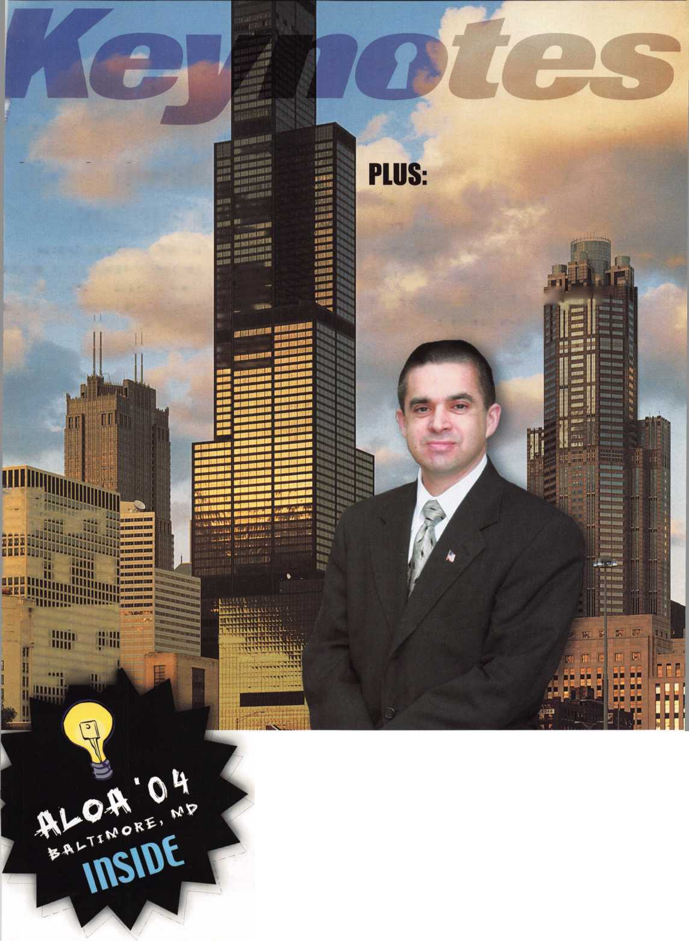

*enable com*

SKS3S-*-*

not opened!

C6I... Security Products

Security Products

301 West Hintz Road • Wheeling, IL 60090 Telephone: 800.733.8588 • Fax: 847.537.1881 [www.cclsecurity.com](http://www.cclsecurity.com)

**Travelers will now know when their SearchAlert**

**LOCKS HAVE BEEN OPENED, AND WHETHER THEIR BAGS HAVE BEEN SEARCHED BY A TSA AGENT, OR VIOLATED BY AN UNKNOWN PERSON.**

Prestolock® 8c Presto seal™

USE FOR ALL YOUR CARRY-ONS AND EVERYWHERE ELSE YOU TRAVEL

TRAVEL SENTRY

CERTIFIED

**SearchAlert**

Rs-settable combination

LOCKS ARE STRONGLY RECOMMENDED FOR ALL CHECKED LUGGAGE

Available in 4 colors:

Black: Model #7400PSB White: Model #7400PW Bright Nickel: Model #7400BN Pewter: Model #7400PTR

| SearchAlert. U.S. Patents i Pending

Know Who Searched Your Belongings

**CCL Security Products' new SearchAlert™**

RE-SETTABLE COMBINATION LOCK WAS DESIGNED WITH A SECURITY FEATURE WHICH ALLOWS TSA AGENTS, USING A SECURED ACCESS DEVICE, TO OPEN THE

**SearchAlert lock without destroying the lock.**

**The new SearchAlert Security window changes**

COLOR FROM **GREEN** TO **RED** WHEN THE TSA SECURED ACCESS DEVICE IS USED TO OPEN THE LOCK, OR WHEN AN UNAUTHORIZED PERSON HAS OPENED THE LOCK USING A COUNTERFEIT OPENING DEVICE.

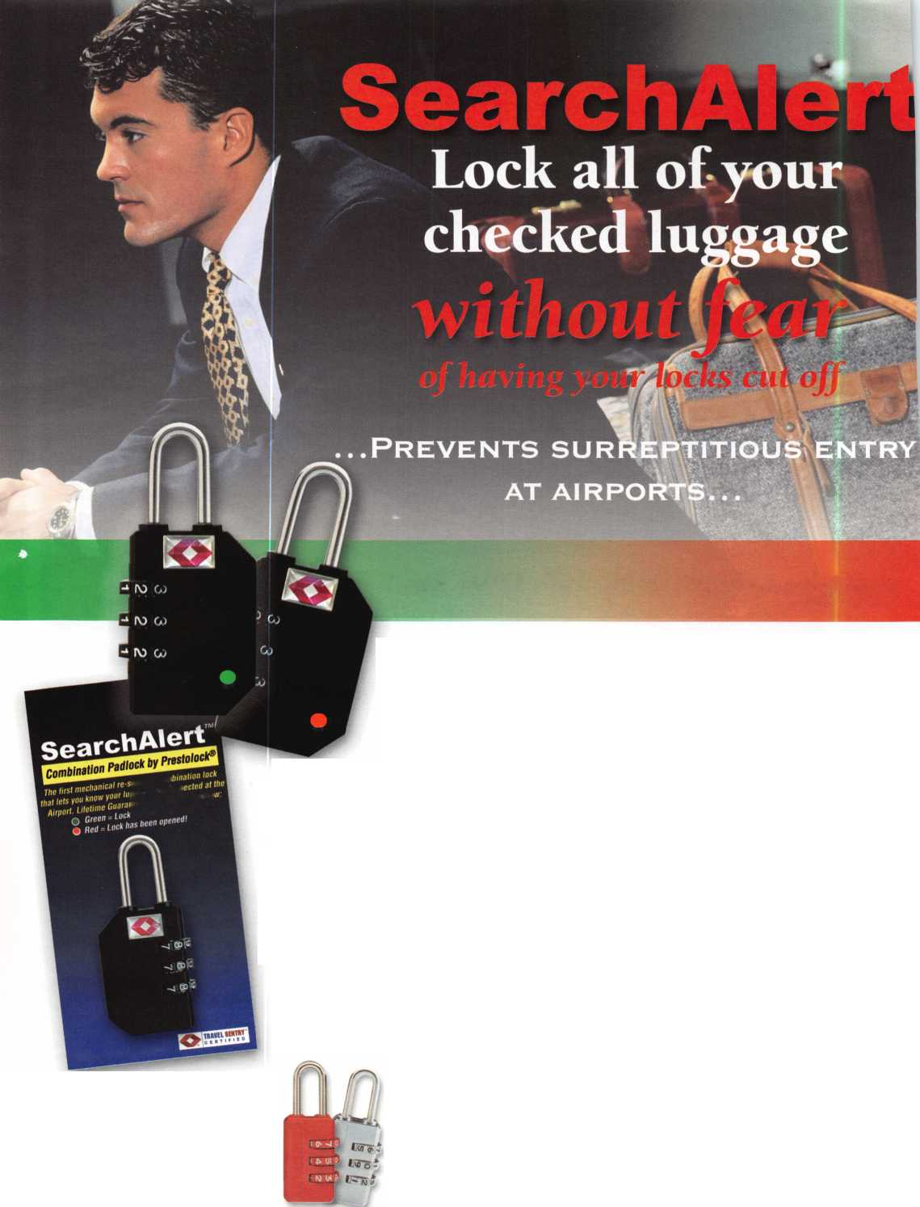

The ALOA Convention and Security Expo • Baltimore Convention Center • July 19-25, 2004  
(800)532-ALOA(2562) • [convention@aloa.org](mailto:convention@aloa.org) • [www.aloa.org](http://www.aloa.org)

Get It...  
Together

Get ready for ALOA 2004 - the biggest

security event in the world! ALOA will land in Baltimore's famed Inner Harbor to stage classes, workshops and exhibits that will help you shine in today's marketplace.

411-0* 0<f

get it ...together

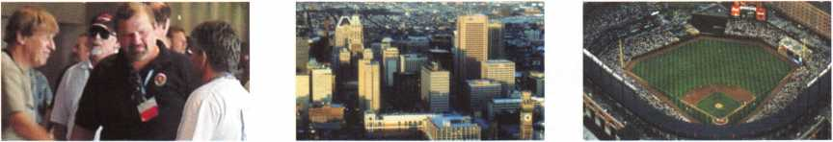

r~?Sw \ Dear Members,

I have recently returned from attending the convention of the Associated Locksmiths of Ireland, and a very educational trip it was. I was able to experience firsthand the similarities and differences between locksmiths m, * in this country and those in Europe. I was also able to experience

^m, the friendliness and hospitality for which the Irish are known.

^ jHr President Dave O'Toole and the members of ALOI were gracious ^and generous hosts.

The convention boasted educational classes, trade show and a wonderful Saturday evening din­ner/social. Basil Shannon received the Mul-T-Lock Award (ALOI's award for service, dedication and professionalism). Congratulations to Basil, who also happens to be an ALOA member.

I was invited to sit in on an automotive transponder class. There, I met and talked with several members of the ALA (Automotive Locksmith Association). The ALA is gaining influence with the automotive manufacturers, tool manufacturers and key blank manufacturers in Europe. Automo­tive locksmiths in Europe face the same problems we do, perhaps more so because of the variety of vehicles that they work on and the fact that transponders have been around longer over there. The ALA is trying to level the playing field by helping locksmiths get key codes and PIN codes for programming, much like ALOA is trying to do in its support of the Motor Vehicle Owners Right to Repair Act.

A meeting of the European Chapter of ALOA was convened by chairman Ron Cliff. I attended the meeting and listened to the concerns of our European members. Incoming chairman, Rene Andreasen, has been charged with growing the chapter's membership, and is seeking the help and support of the ALOA board, which we will make every effort to do.

I came away from this trip with a great deal of respect for the dedication and talents of the lock­smiths in Europe. Before leaving, I visited Dave O'Toole's shop on Amiens Street and was amazed by the staggering varieties of keys on the keyboards. That corresponds with the stagger­ing variety of locks on which they work.

This month's issue focuses on another group of locksmiths that I have a great deal of respect for... our institutional partners. Read on and learn what it is like to be "institutionalized."

Sincerely,

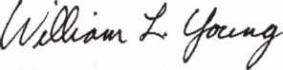

William L. Young, CML

Keynotes • April 2004

iliiwHSilH

iiil

FUNDAM£#TAIS 0FARCHITECTURAL HARDWARE

„ COPWSRHJOOS

HiiaiiBiiiiiMiiiiwariasni^

**Self-Study Course**

RLOH

SPECIRL

**Get the award-winning  
*Fundamentals of architecture  
Doors and Hardware Self-Study  
Course* at a great price!**

L DOORS AND HARDWARE FUNDAMENTALS

**SELF-STUDY GUIDEBOOK**

FUNDAMENTALS OF:

Ruailable as single  
modules (one CD and  
guidebook) or the full  
set (three CDs and  
three guidebooks).

Seruer uersions are  
also auailablel

The ultimate training tool for locksmiths... Now there is a complete in-house training

**program auailable! Order the** Fundamentals of architectural Doors and Hardware Self

**Study Course** three CD/guidebook series.

To order, call (800)532-2562 or LUimu.aloa.org

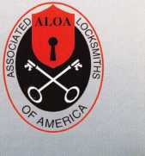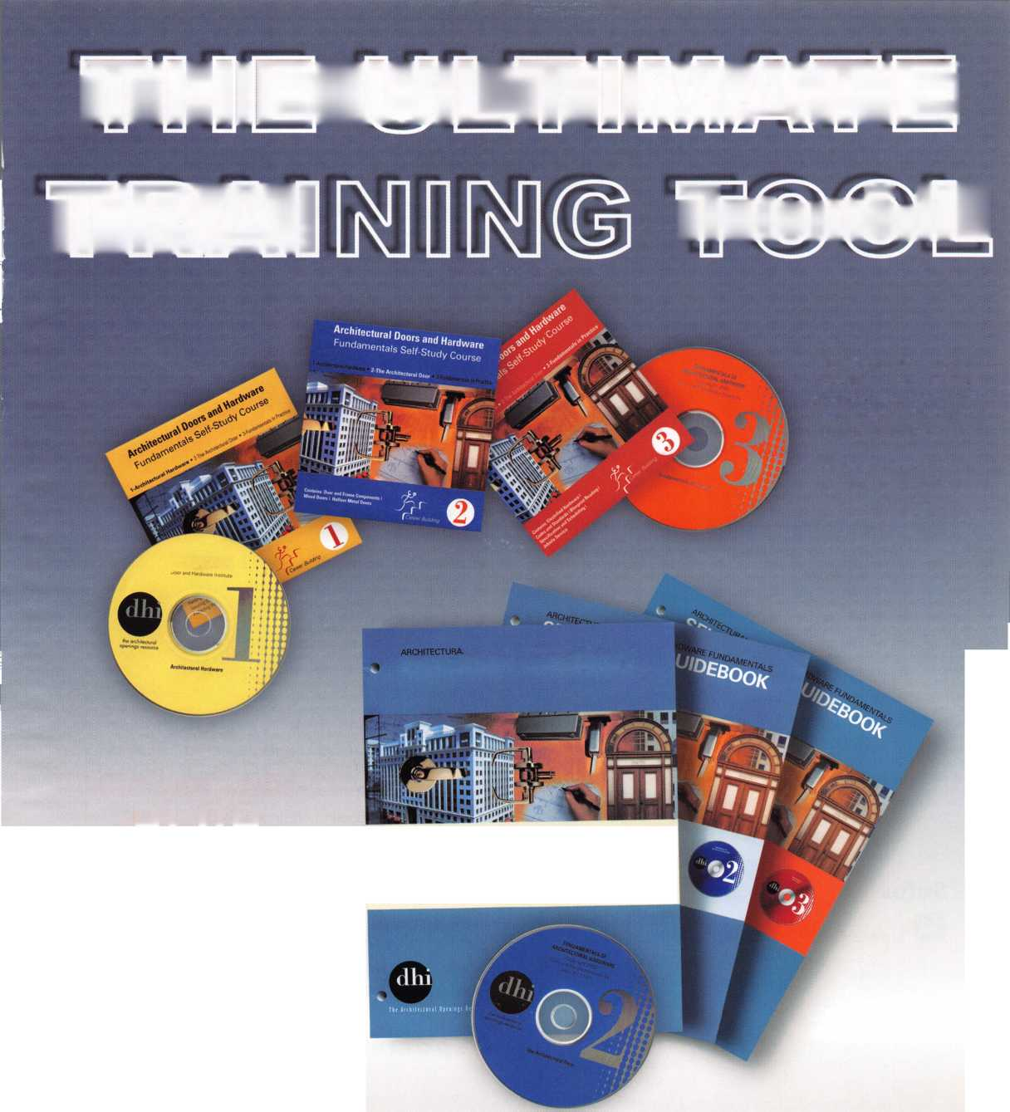

f

e

a

t

u

res

Institutional Locksmithing 2004



Sears Tower, Post 9/1 Is Interview of Sears Tower Security Chief Carlos Villareal

The career path of Sears Tower Security Chief Carlos Villareal has been deliberate, quiet, and altogether unlike the tragic events of Sept. 1 1, 2001. It took years of toiling away behind the scenes for professional praise to begin for Mr. Villareal, and even then, it came just at a trickle. And yet by vocation, he'll be forever linked with the explosion of fear that came after 9/11. He could be, in fact, that days flipped mirror image: the immovable object waiting dutifully for the unannounced arrival of the irresistible force, the soldier guarding his post, the mountain meeting the sea.t

By Jim DeSimone, Keynotes Editor

Greg's Corner: Institutional Applications - Turning Up the Heat on a Gamewell Fire Alarm

Like most of you, I don't get to pick the jobs that come in the front door. This one was one of those jobs in which I was not trained to perform. Most of the time, having to do a new job is a challenge I enjoy, but I pre­fer to start with a little information. I'd never seen the inside of a Gamewell fire alarm signaling control. The customer, a fire captain, had another lock with a differ­ent style key available, so he didn't care if the lock was destroyed, but time was of the essence. After I explained that I really wanted to see the other lock first, he said, "Destroy this one. I've seen others drilled, so just go for it."

By Greg Perry, CML, CPS

Safes

Safes: Cracking Open a MEGASAFE!

A customer called our shop - Bullet Lock and Safe out of Long Branch, NJ - because he couldn't open his Megasafe TL-30 Jeweler's safe. I called the customer and he told me that he had the combination to the safe, as well as the key, but that it still wouldn't open. He was only a couple of miles from our shop, so I stopped by his house on my way home that day. What he had was a Vector Jeweler's TL-30 box with a Mas-Hamilton 50 lock and S&G Key OP. After some troubleshooting, my conclusion was that an external relocker had fired, and I explained this to the customer. He then told me that Megasafe had warned him not to slam the door shut, then admitted to doing just that. My adventure had just begun.

By Frank Ulbin, CRL

**22**

Access Control



Access Control Made Simple

This is one of the most rewarding and confidence-build­ing parts of electronic locksmithing. We are going to jump in and experience a complete access installation while looking at some of the issues we may not have thought about when we decided to leap into this corner of our profession. This is by no means the only way, the best way or the most complete way. OK, now I'm sounding like a back-pedaling lawyer. Let's dive in and have some fun as we enter the realm of E-A-C!

By Adam Black, CRL

Autos

Autos: Exploring Ford's VCM

In following the recent and upcoming changes to the automotive technologies, it wouldn't be fair to leave out Ford Rotunda's Vehicle Communication Module, or "VCM." Like Hickok Inc.'s CAN VIM, the VCM is designed to allow the NGS to program the CAN- equipped Ford vehicles. Unlike Hickok's CAN VIM, the VCM is available through Ford dealers only, and costs from $2000 to $2500. This is nearly the price of a complete new NGS XL that includes Hickok's CAN VIM, and four times the amount of the CAN VIM purchased alone. Despite the differences in price, a few locksmiths have found the VCM beneficial enough to make the pur­chase. Let's talk about some of the major program differ­ences found between the original NGS and the NGS with the VCM.

By Tom Seroogy

**32**

Special Report

**36**

ALOA Board News

**Departments**

|  |  |  |  |
| --- | --- | --- | --- |
| Executive | 5 | Legislative |  |
| Applicants .... | 6 | Update | 38 |
| Calendar | 8 | Classifieds... | 40 |
| Core | ...10 | Associate  Members | 42 |

Visit our website

at [www.aloa.org](http://www.aloa.org)

executive

Volume 50, Issue 4



Additional contact information for the ALOA Board and most Keynotes authors is  
available through "Locksmith Search'" on the ALOA Web site- [www.aloa.org](http://www.aloa.org) or by  
contacting the ALOA office at 3003 Live Oak Street; Dallas, TX 75204; (800)532-2562;  
FAX (214)827-1810; e-mail [aloa@aloa.org](mailto:aloa@aloa.org).

|  |  |  |  |
| --- | --- | --- | --- |
| Editor |  | Operations/Membership Manager | |
| Jim DeSimone | [editor@aloa.org](mailto:editor@aloa.org) | Mary May | [mary@aloa.org](mailto:mary@aloa.org) |
| Technical Editor |  | Government Relations Manager | |
| David Lowell, CML, CMST | [david@aloa.org](mailto:david@aloa.org) | Paul Kanitra | [paul@aloa.org](mailto:paul@aloa.org) |
| Editorial Advisor |  | IT Operations Manager |  |
| John Cannon, CML | sec reta r y@a loa. o rg | Greg Jackson | [greg@aloa.org](mailto:greg@aloa.org) |
| Art Director |  | Comptroller | Kathy J. Romo |
| Betty Henderson | [betty@aloa.org](mailto:betty@aloa.org) | Membership Coordinator | Shelly Jett |
| Advertising Sales |  |  |  |
| Kim Hammond | voice: 817-645-6778 | Convention & Meetings Assistant Karen Lyons | |
|  | Fax: 817-645-7599 |  |  |
|  | e-mail: [adsales@aloa.org](mailto:adsales@aloa.org) | PRP/Education Coordinator Esperanza Rodriguez | |
| Executive Director  Charles W. Gibson, Jr., CAE. | [charlie@aloa.org](mailto:charlie@aloa.org) | Accounting Coordinator | Stephanie Brothers |
| Mail Room Coordinator | Kevin Wesley |
| Convention & Meetings Manager | | Receptionist |  |
| Jo Anne Mims | [joanne@aloa.org](mailto:joanne@aloa.org) | Bryan Dease |
| PRP/Education Manager |  |  |  |
| David Lowell, CML, CMST | [david@aloa.org](mailto:david@aloa.org) |  |  |
| Contributors |  |  |  |
| Jerome Andrews, CML | Ray D'Adamo, CML | AJ. Hoffman, CML | Greg Perry, CML,CPS |
| Paul Chandler, CRL | Sal Dulcamaro, CML | Jeff Nunberg, CML, CMST | Tom Seroogy |
| Claire Cohen, CML | Billy Edwards, CML | Randy Simpson, CML | Charles Stephenson, CPS |
| Brian Costley, CML, CMST | Dan Graffeo, CRL,CMST | Robert Stafford, CML | Dennis Watanabe, CML, CMST |
| Eric Costley, CRL | Jim Hancock, CRL | Dave Thielen, CML |  |

Mission Statement: The Associated Locksmiths of America, Inc. is dedicated to enhancing the professionalism, education and ethics among locksmiths and those in related sectors of the physical security industry. With approximately 10,000 members in the United States, Canada and the freeworld, ALOA is poised to help members obtain the knowledge, the strength, and the confidence to perform their role in the physical security field with pride and dignity. But it is only through active involvement and participation that ALOA can fully achieve its potential—and can help members to achieve theirs.

Policies: Keynotes® is the official publication of the Associated Locksmiths of America, Inc. (ALOA). Keynotes® acts as a moderator without approving, disapproving, or guaranteeing the validity or accuracy of any data, claim, or opinion appearing under a byline or obtained or quoted from an acknowl­edged source. The opinions expressed by the authors do not necessarily reflect the official views of ALOA. Also, appearance of advertisements and new products or service information does not constitute an endorsement of products or services featured by the Association. The Association does not accept responsibility for the inaccuracy of any data, claim, or opinion appearing in this publication, due to typographical errors on the part of the authors, Association staff or its agents.

Editor's Note: This publication is designed to provide accurate and authoritative information in regard to the subject matter covered. It is provided and disseminated with the understanding that the publisher is not engaged in rendering legal or other professional services. If legal advice and other expert assistance is required, the services of a competent professional should be sought.

Authors' Payment: Payment for eligible submissions to Keynotes will be based on the following criteria: topic, time spent and past contributions. Authors who regularly submit to Keynotes® are generally paid a higher rate. The latter is especially true of authors who write to fit specific editorial needs and submit said copy by Keynotes® deadlines. As a general guideline: Average payment for a 750 word, business or light' technical article would be $200. Payment for a 1500 word article involving significantly higher time and research efforts would be $400.

Payment will not be offered for articles submitted by ALOA employees or members of the ALOA Board of Directors (unless material is of a technical nature), nor for articles submitted by a company that promote that company's products or services. ALOA reserves the right not to pay for articles sub­mitted by an individual(s) that promote a particular company's products or services.

Disclaimer: The Associated Locksmiths of America, Inc., (ALOA), reserves the right to refuse any article for any reason. Additionally, ALOA reserves the right to edit, amend or modify any article submitted for publication in order to preserve technical accuracy, clarity, fairness or grammatical cor­rectness. ALOA will make the best efforts to notify the author of any changes. The extent of ALOA's liability for any article or information contained therein will be a notice of correction or retraction in the next possible issue.

Keynotes® (ISSN 0277 0792) is published monthly except for the combined June/July issue by The Associated Locksmiths of America, Inc., 3003 Live Oak St., Dallas, TX 75204-6186. Telephone: (214) 827-1701; FAX (214) 827-1810; e-mail [aloa@aloa.org](mailto:aloa@aloa.org). Subscription rates for members—$15.00 per year. Periodical class postage paid at Dallas, Texas. POSTMASTER: Send address changes to: Keynotes, 3003 Live Oak St., Dallas, TX 75204-6186. © Copyright 2003, All rights reserved. No part of the contents may be reproduced or reprinted in any form without prior written permission of the publisher.

President

William L. Young, CML  
(610)647-5042  
[president@aloa.org](mailto:president@aloa.org)

Secretary

John D. Cannon, CML  
(703) 960-6413  
[secretary@aloa.org](mailto:secretary@aloa.org)

Directors, Northeast

Robert E. Mock  
(856) 8630710

[nedirector@aloa.org](mailto:nedirector@aloa.org)

Peter Sarailian, CRL  
(973)8909797  
[nedirector@aloa.org](mailto:nedirector@aloa.org)

Y William L. Young, CML (610) 647-5042 nedirector@aloa .org

Directors, Southeast

Tom Gillingham, Jr., CML, CPS  
(615)2640747  
sed i rector@a loa .org

Ken Kupferman, CPL  
(813)961-5784  
sedtrector@aloa .org

Directors, North Central

Mark E. Blum, CML, CPS  
(517) 482-5809  
ncd i rector@aloa. org

John Soderland, CML, CMST . (414) 327-5625

[ncdirector@aloa.org](mailto:ncdirector@aloa.org)

Director, South Central

CD Lipscomb, CML, CPS  
(903)874-3522

scdi rector@a loa. org

Directors, Southwest

Gordon R. Racine, CML  
(719) 384-4707  
swdirector@aloa .org

Julie McCluney, CRL  
(714) 636-5652

[swdirector@aloa.org](mailto:swdirector@aloa.org)

Director, Northwest

Scott L. Henke, CPL, CPS  
(907) 248-3785

[nwdirector@aloa.org](mailto:nwdirector@aloa.org) ,

Director, European

Hans Mejlshede, CML  
(453)539-3939  
[eurdirector@aloa.org](mailto:eurdirector@aloa.org)

Director, Asian

JoeJ. Lee, CRL  
(215)289-2404  
[asiandirector@aloa.org](mailto:asiandirector@aloa.org)

Director, Associate

Paul M. Justen  
(800)333-6953  
asdirector@aloa .org

Trustees

[trustees@aloa.org](mailto:trustees@aloa.org)

Randy Simpson, CML

(281)240-5959

JohnJ. Greenan, CML, CPS  
(773) 486.2030

Dallas Brooks

(334) 826-8990

Past Presidents

2001-2002 Randy Simpson, CML

1999-2001 John Greenan, CML, CPS 1997-1999 Dallas C. Brooks 1995-1997 David Lowell, CML, CMST 1993-1995 Breck Camp, CML 1991-1993 Henry Printz, CML 1989-1991 Evelyn Wersonick, CML, CPS 1987-1989 Leonard Passarello, CPL 1985-1987 Joe Jackman, CML 1983-1985 Stanley Haney, CPL 1981-1983 Louis LaGreco, CPL 1979-1981 John Kerr, RL 1977-1979 Clifford Cox, CML 1974-1977 Charles Hetherington 1972-1974 Gene Laughridge 1970-1972 William,-Dutcher, RL , 1968-1970 Constant Maffey, RL 1966-1968 Harold Edelstein, RL 1964-1966 William Meacham 1962-1964 Robert Rackliffe, CPL 1960-1962 Edwin Toepfer, H 1956-1960 Ernest Johannesen

Keynotes • April 2004

applicants

for membership

|  |  |  |  |  |
| --- | --- | --- | --- | --- |
| AL | Eastman | MA |  | NV |

Florence

E M. Harrington III Amherst

Elko

James D. Peebles Jr

Sponsor: John P. Luhrs CRL Jackson

Larry Smith

Sponsor: Bruce J. Tarbet CML, CPS

*KL*

Phoenix

John W. Jarzabek

Sponsor: William Lee CRL

Patricia Lee

CA

San Jose

Waylen Fong

Sponsor: Jerrold G. Antoon RL, CPP

Randy Ngo-X

co

Colorado Springs

George G. Hruby CPL

Fort Collins

Tom Martinez

Sponsor: Wayne Younger CML

CT

North Haven

David Gardetto

Sponsor: Vincent J. Longobardi Waterford

Peter Doherty

Sponsor: James P. Radack Woodbury

Richard Stoughton

FL

Crestview

Deri Justice

Sponsor: Bruce J. Tarbet CML, CPS Loxahatchee

John W. Potts

Sponsor: Vincent L. Formon CML, CPS

Orange Park

Lisa R.B. Daugherty

Sponsor: Bruce R. Bortz CRL

GA

Columbus

Stephen Parker

East Ellijay

IA

Rein beck

Robert F. Gutknecht

Sponsor: Rick W. Barrett



Cicero

David Morin

Clare

Holly M. Bingham

Sponsor: Jerrold G. Antoon RL, CPP

Walter O. Bingham

Sponsor: Jerrold G. Antoon RL, CPP Collinsville

Stephen W. Barbee

Sponsor: William T. Beranek Countryside

Robert F. Mance

Sponsor: William T. Beranek Steger

Ronald E. Urzendowski

Sponsor: William T. Beranek

IN

Bloomington

Ian Kvale

Ligonier

Dale Boyer

KS

Kansas City

Charles E. Wendt CRL

Sponsor: Clifford D. Lipscomb CML, CPS

Overland Park

David J. Moore

Sponsor: Clifford D. Lipscomb CML, CPS

LA

Houma

John D. LeBlanc

Sponsor: Bruce J. Tarbet CML, CPS Natchitoches

Craig Bumgardner

Sponsor: Bruce J. Tarbet CML, CPS Walker

Eric E. Jones

Sponsor: Randall R. Jones CRL

Robert Osgood

Sponsor: Marcia A. Daniels Brewster

Cory Smith

Sponsor: Jeffery B. Winslow

MD

Baltimore

Ed Korenge

ME

Hallowell

Jeffrey S. Truman CRL

Ml

Comins

Paul A. Badoni

Sponsor: William T. Beranek

MN

Minneapolis

Bradley J. Freund

Sponsor: Dana L Lee CML

Dale Schaar

MO

Blue Springs

Frank L. Goetzfridt

Sponsor: Rollin R. Gilliland CPL, CPS  
Creve Coeur

Willie McConnell

Sponsor: Ron L. Scott  
Grandview

Thomas C. Healey

Sponsor: Clifford D. Lipscomb CML,  
CPS

NC

Roxboro

Steven Spencer

NJ

Florham Park

David Kormann

Sponsor: Matt Blaze Paterson

Gary Powell

Sponsor: William L. Young CML Sicklerville

Andrew Jankowski

Sponsor: Robert E. Mock

NM

Charles D. Price

Sponsor: Robert R. Hecht

NY

Brooklyn

Joseph Jankauskas

Sponsor: William L. Young CML Utica

Paul M. Sacco

Sponsor: Paul C. Sacco CRL Webster

Joel Snell

Sponsor: Steven M. Trumbull

OK

Tulsa

Erik Garner

OR

McMinnville

Jody S. Fisher CRL

PA

Chester

Michael S. Knepper

Sponsor: Robert E. Mock  
Harrisburg

John F. Shinkowsky

Philadelphia

John E. Messatzzia

Sponsor: William L. Young CML

Edward T. Walsh Jr

Sponsor: Joseph R. Reustle

Adam Bosak

Sponsor: Joe J. Lee CRL

Rl

Westerly

David D. Syren

TX

Carrollton

Chris M. Ortiz CRL

Sponsor: Dawn M. Forgey CRL Jon T. Bottoms

Kaufman

Michael T. Barker

Lake Dallas

James Forgey

Mesquite

Charlie Criswell

Richardson

Bruce N. Reagin

Sponsor: John C. Elliott Jr, CML, CPS

Albuquerque Thomas Bullock

Michael W. Trahan Sponsor: Randy L. Hutchison CRL

Wharton

Raymond I. Meleton

Sponsor: Roy W. Umfleet

VA

Charlottesville

Robert A. Marshall

Sponsor: Stewart K Brown III, CRL

David R. Handy

Sponsor: Troy G. Miller CML

wi

Beloit

John R. Stewart

Kiel

Dave W. Guckeisen

Sponsor: Jerrold G. Antoon RL, CPP Madison

**Jesse Vazquez**

Sponsor: Tom Ripp

wv

Marti nsburg

Ian A. Edwards

Sponsor: Thomas W. Oliver

Mississauga

Alvin Dorder

Sponsor: Robert E. Mock Penetany

Sean W. Baxter

Sponsor: Robert E. Mock Thornton

William A. Rawn

Sponsor: Robert E. Mock

**RiBIBIW**

Crawley West Sussex

Mark Bosher

Sponsor: Ken Dale Nottingham

Martin Pink

Sponsor: Ken Dale

Dublin

Westley Lowndes

Japan

HamakitaCityShizuok

Junichi Yaguchi

Sponsor: Tosnihiro Asano

These applicants are scheduled for clearance as members of ALOA. The names are published for member review and comment within 30  
days of this Keynotes issue date, respectively, to ensure applicants meet standards of ALOA's Code of Ethics. Protests, if any, should be  
addressed to the Membership Department and must be signed. Active Membership applicants (a) have worked in the industry two or more  
years. Allied Membership (AL) applicants are not locksmiths, but work in a security-related field. Apprentice Membership (AP) applicants

have worked in the industry less than two years.

Keynotes • April 2004



£IZE7

***Visit our Website on  
www. stamcctv. com***

**THE COMPLETE**

**CCTV PROGRAM ON CD-ROM**

**FOR STAFF TRAINING AND**

**PRODUCTIVITY ENHANCEMENT**

**W** System Drawing  
**U** Estimation

**#** CCTV Training

CCTV Reference

**%r** Sales/Demo

**—** System Design

Staff Evaluation

CCTV Content

CCTV Calculators

Demonstration Tool Estimation

Drawing

Internet Enabled

STAM **Insight** has been developed to enhance CCTV skills and productivity with many different uses.

**U** Productivity

**Sold in Over 50 Countries**

Distributed by:



3003 Live Oak Street  
Dallas,Texas 75204

■ Yes, please send me a FREE PREVIEW CD ROM $9.95 S/H

Name:

Job Title:

Organization:

Address:

Zip/Postcode

e-mail

Fax: ( )

COPYRIGHT © 1996 Security Training and Marketing Pty Ltd. All rights reserved ACN 057 006 541

Country

Tel: ( )

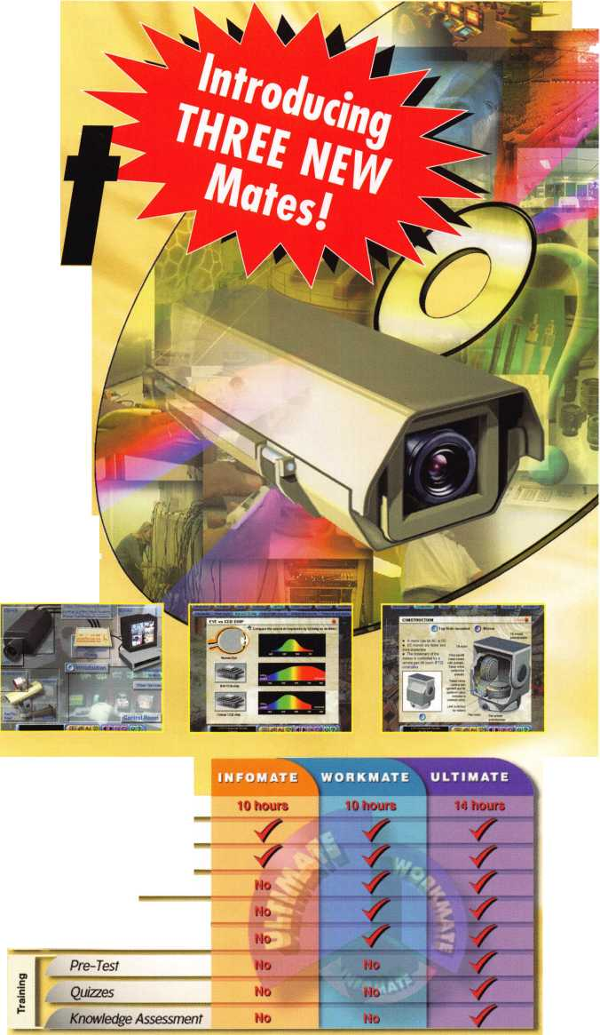

**JUNE I MAY APRIL**

upcoming events

16-18 East Coast Regional Locksmith Convention Somerset, New Jersey

24-25 Alabama Locksmith Association Membership Meeting, Dinner, Discussion & Seminars Call 1-800-893-5487

**UPCOMING PRP SITTINGS**

|  |  |
| --- | --- |
| 4/18/2004 | 8:00am • Dayton, OH • Ohio Valley Chapter of ALOA Bill Lockwood, CRL 937-836-6127 |
| 4/17/2004 | 8:00am • Moorehead, MN • Northern Prairie Chapter Todd Ladwig 701-232-9440 |
| 4/17/2004 | 11:00am • Somerset, NJ • MLANJ Convention  Bill Timmann, CML 610-253-2325 |
| 5/7/2004 | 6:00 PM • Nashville, TN • TN Tool & MTLA  Jim Windman, CRL 615-837-1264 |
| 5/13/2004 | 8:30am • Dallas, TX • ALOA  Hope Rodriguez 800-532-2562x30 |
| 5/15/2004 | 5:00pm • Seattle, WA • KDL Hardware Supply, Inc. Julie Pilgrim (800)926-7716 |
| 5/21/2004 | 6:00pm • Fort Wayne, IN • Northern Indiana Chapter Jeremy Rodocker, CML,CPS 260-459-1500 |
| 6/10/2004 | 8:30am • Dallas, TX • ALOA  Hope Rodriguez 800-532-2562x30 |
| 6/27/2004 | 8:00am • Reno, NV • Clark Security Products  Joan Emrick 619-718-7308 |
| 7/8/2004 | 8:30am • Dallas, TX • ALOA  Hope Rodriguez 800-532-2562x30 |

|  |  |
| --- | --- |
| 7/23/2004 | 6:00pm • Baltimore, MD • ALOA2004 Convention Hope Rodriguez 800-532-2562x30 |
| 8/12/2004 | 8:30am • Dallas, TX • ALOA  Hope Rodriguez 800-532-2562x30 |
| 9/9/2004 | 8:30am • Dallas, TX • ALOA  Hope Rodriguez 800-532-2562x30 |
| 10/3/2004 | 8:00am • Anaheim, CA • Clark Security Products Joan Emrick 619-718-7308 |
| 10/9/2004 | 8:00am • Omaha, NE • MINK Convention  Bernard Dobesh 308-381-4440 |
| 10/14/2004 | 8:30am • Dallas, TX • ALOA  Hope Rodriguez 800-532-2562x30 |
| 11/11/2004 | 8:30am • Dallas, TX • ALOA  Hope Rodriguez 800-532-2562x30 |
| 11/20/2004 | 8:00am • Atlanta, GA • Georgia Chapter of ALOA Kevin Wilson, CML,CPS 770-279-1161 |
| 12/9/2004 | 8:30am • Dallas, TX • ALOA  Hope Rodriguez 800-532-2562x30 |

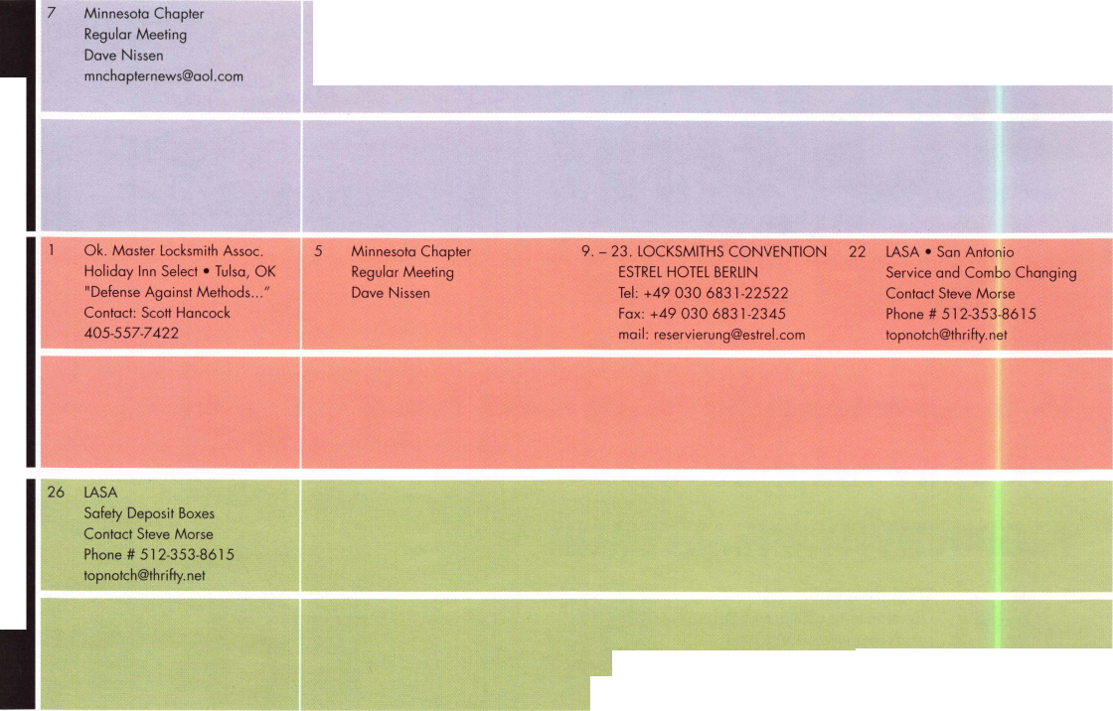

Advertise with Weatherproof Safety Labels!

Lockout your  
competition

by placing your  
calling card on  
every door you  
service! Keep

your name in front  
of every customer  
with these Durable,  
Affordable Labels  
Call & Order Today  
1-800-355-6322

(Actual Label Size 1 1/2x4 1/2)

Professional Business Products

ALOA Associate Member

Check out our competitive prices on Invoices with two color ALOA  
logo, Repair Tags/Claim Checks, Business Cards, Door Hangers,  
Shirts, Hats, Pens, Key Tags, Magnets.

[www.professionalbusinessproducts.com](http://www.professionalbusinessproducts.com)

**UPCOMING ACE CLASSES**

4/23-24/2004

5/1-2/2004

5/15/2004

5/22 - 23/2004

7/18-25/2004

9/18/2004

10/7-8/2004

10/25-30/2004

Montgomery, AL • Alabama Locksmiths Association  
Dallas Brooks 334-826-8990

Auto Lock Servicing, Defense Against Methods of Entry

White River Junction, VT • Green Mountain Locksmiths Assn.

Peter Deutsch 802-295-5242

Life Safety Codes Exit Devices & Exit Alarms

Atlanta, GA • Georgia Chapter of ALOA

Kevin Wilson, CML,CPS 770-279-1161

Small Format Interchangeable Core

Fort Wayne, IN • Northern Indiana Chapter of ALOA

Jeremy B. Rodocker, CML,CPS260-459-l 500

Hollow Metal Doors & Frames Life Safety Codes

Baltimore, MD • ALOA 2004 Annual Convention

DAVID LOWELL, CML, CMST 800-532-2562 XI8 71

ALOA ACE CLASSES and Security Expo [education@ALOA.org](mailto:education@ALOA.org)

39 Seminars and Half Day Classes

Atlanta, GA O* Georgia Chapter of ALOA

Kevin Wilson, CML, CPS 770-279-1161

PRP Prep Class

Omaha, NE • MINK Convention  
Bernard Dobesh 308-381-4440  
CPS Prep Class

APPLETON, Wl Fox Valley Technical College  
Jerry Antoon P-920/735-2406  
6 Day Basic Locksmithing Course  
Fox Valley Technical College F-920/735-2414

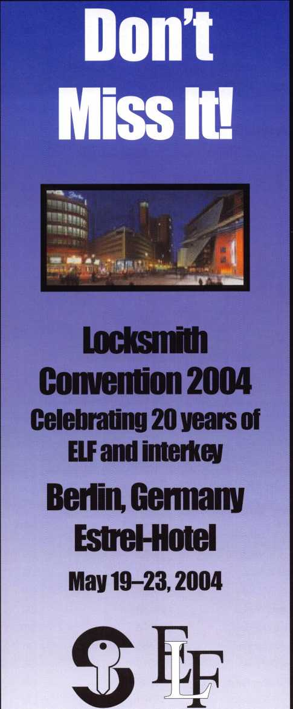

[www.elf2004.de](http://www.elf2004.de)

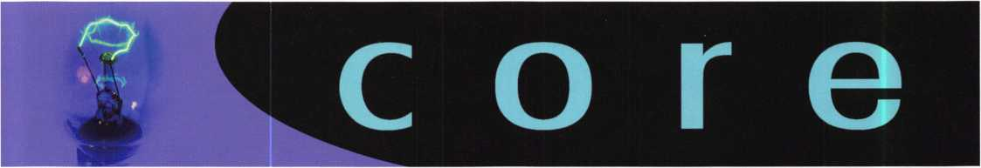

TLA PACKS GALVESTON

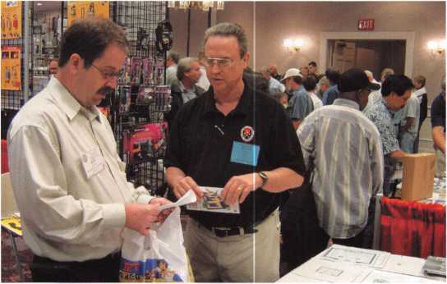

The Texas Locksmith Association's recent Convention and Trade Show was held in sunny Galveston, TX, and throngs of Texas locksmiths were there to soak up the fun. TLA's official word: "Thanks to our Sponsors (H.L. Flake Company, IDN-Acme Inc. and Clark Security Products), Exhibitors, Members, Associate Members and Attendees, the 2004 Convention and Trade Show was an overwhelming success." ALOA past presi­dent and current Education Manager David Lowell, CML, CMST (pictured in black shirt along with a TLA attendee), was one of several attendees looking for walking room in the thick crowd.

New Certifications

|  |  |  |
| --- | --- | --- |
| Name | Member # | Level |
| Kelly K. McBride | 24781 | CPL |
| Barry F. Meyer | 16285 | CPL |
| Lester B. Witty | 19229 | CPL |
| Jeanine V. Rose | 15099 | CRL |
| Wilbert Watson | 28460 | CRL |
| Alvino Mauricio | 06016 | CPS |
| Billy G. Bartram | 41586 | CRL |
| Cecil D. Neill | 26315 | CRL |
| Christopher Parks | 48349 | CRL |
| John F. Sartain | 25380 | CRL |
| Charles H. Saylor | 23886 | CRL |

ALOA Code of Ethics

All members of the ALOA by acceptance and continu­ance therein, shall be deemed to have subscribed to

the following Code of Ethics:

That the dignity of our chosen profession may be per­petuated, it is the duty of all members of the ALOA.

* To practice their profession in the spirit of fairness to their clients, with fidelity to security in confor­mance with appropriateness, and with high ideals of personal honor;
* To properly and impartially analyze security prob­lems, and to advance the best possible solution for the protection of their clients;
* To conduct themselves in a dignified manner;
* To abide by applicable licensing and business reg­ulations;
* To abstain from using improper or questionable methods of soliciting patronage, and to decline to accept such incompatible patronage;
* To refrain from associating themselves with or allowing the use of their names by any enterprise of questionable character, or in any manner coun­tenancing misrepresentation;
* To cooperate in advancing the best interest of the locksmithing industry by interchange of general information and experience with fellow locksmiths;
* To encourage and promote loyalty to the profes­sion, always ready to apply their special knowl­edge, skill and training for the use and betterment of our industry.

**Ad Index**

CCL Security

Products Inside Front Cover

DHI 3

STAM 7

Professional Business Products 9

interkey/ELF 9

Turn 10 25

A&B Safe 41

Hickok Back Cover

**MEMBERSHIP APPLICATION**



Welcome to the Associated Locksmiths of America, Inc., an association for persons involved in the security industry as  
locksmiths, security consultants, educators, manufacturers and distributors.

To apply for membership, please complete this application and submit it with the dues for the current year, and your  
business card, company letterhead, or other suitable proof of employment.

All of the following questions MUST be answered before this application may be processed. Please type or print.

TYPE OF MEMBERSHIP

Please check only one.

* ACTIVE MEMBERSHIP  
  Individuals actively engaged in  
  supplying, servicing, or installing  
  security hardware for a period of  
  not less than two years.
* APPRENTICE MEMBERSHIP  
  Individuals who are in initial train-  
  ing and meet all the requirements  
  for Active Membership except for  
  the length of time in the security  
  industry.
* ALLIED MEMBERSHIP  
  Individuals whose position in the  
  security industry relates to the  
  aims, policies and promotion of  
  the locksmith and his/her craft.

APPLICATION AND FEES

A $50 application fee, appropriate  
annual dues, and your business  
card, company letterhead, or suit-  
able proof of employment must  
accompany this application. Your  
second year's dues will be prorated  
based on the date your application  
was received by ALOA.

FINAL CHECKLIST us

Dollars

* Application Fee 50.00

ANNUAL DUES STRUCTURE

* Active/Allied Member 155.00  
  U.S. + U.S. Territories

(PR, VI, Guam)

* Active/Allied Member 1 30.00  
  Non U.S. Resident or

Non U.S. Territories

* Apprentice Member 80.00

U.S. and International

OTHER FEES

* Canadian Air Mail 20.00
* Overseas Air Mail 50.00

Total Enclosed

**Return to  
ALOA**

**3003 Live Oak Street  
Dallas, TX 75204-6185  
(214)827-1701**

CANDIDATE (PLEASE TYPE OR PRINT)

|  |  |  |
| --- | --- | --- |
| Name □ Mr. □ Mrs. □ Ms. | | |
| Business Name | | |
| Mailing Address | | |
| City | State Zip Code | Country |
| Work Phone | Home Phone | Fax |
| Email Address | Website |  |
| Date of Birth | Social Security Number |  |
| Directory Address (if different than mailing address) | | |
| City | State Zip Code | Country |
| □ Do Not List in Directory |  |  |
| PROFESSIONAL INFORMATION | |  |
| 1. Are you a...  □ Sole Owner □ Corporate Officer | 4. ALOA Sponsor | 5. Names and addresses of two industry-relat­ed references (required): |
| * Partner □ Employee □ Student  1. Are you currently employed in the security industry?  * no □ yes, years  1. How did you learn locksmithing or security work? | Sponsor's ALOA Number | Name  Address |
| Please note, if you are sponsored by an ALOA member, your application will be immediately processed with a 90-day probation period. Otherwise, final processing takes up to 120 days. | Name  Address |

6. IMPORTANT: Have you ever been convicted of a felony? □ No □ Yes

If yes, please give details on a separate sheet. All felonies are reported to the Membership Department for review.

METHOD OF PAYMENT

□ Check □ MasterCard □ Visa □ Discover □ American Express

|  |  |
| --- | --- |
| Card Number | Expiration Date |
| Please print name as it appears on card |  |

Cardholder's Signature

I certify that all statements are true and, if accepted as a member, I agree to abide by the rules, regulations, and Bylaws of ALOA, and further agree to  
adopt the Code of Ethics of ALOA as my own, and adhere to it to the best of my ability. Should my membership be discontinued, I agree to return my mem-  
bership card, and cease use of all ALOA insignia.

Signature

Date

Revised 12/03

H8H!

nrapim wrsntrw *mmmwm pmmam mmmti*mmmmn*

*ymmm •*

nsiBtiin "

i cost mm

S?iT*’

Institutional Locksmithing: Sears Tower, Post 9/11

Jim DeSimone, Keynotes Editor

**12**

Keynotes • April 2004

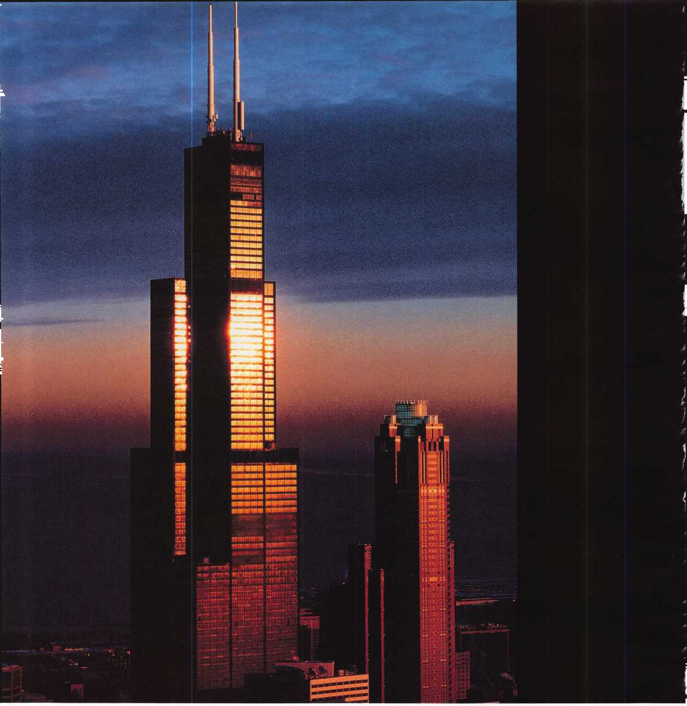

"... *This is the way the world ends Not with a bang, but a whimper” T.S. Eliot, The Hollow Men (1925)*

The career path of Sears Tower Security Chief Carlos Villareal has been deliberate, quiet, and altogether unlike the tragic events of Sept. 11, 2001. It took years of toiling away behind the scenes for professional praise to begin for Mr. Villareal, and even then, it came just at a trickle. And yet by vocation, he’ll be forever linked with the explosion of fear that came after 9/11. He could be, in fact, that day’s flipped mirror image: the immovable

object waiting dutifully for the unannounced arrival of the irresistible force, the soldier guarding his post, the mountain meeting the sea.

An eye-popping 10,000 people work in the Sears Tower, with hun­dreds (and sometimes thousands) more visiting every day. Each year, a million unknown strangers -- from all over the world — enter the building and climb to the Tower’s very ends to tour its storied Skydeck and enjoy its incredible views. Mr. Villareal’s job is to make sure it all happens safely and securely.

He gladly answers that call, armed with 25 years of high-profile institutional locksmithing experience and the hardened resolve he gained while serving in the U.S. Marine Corps. He has long since established himself as a winner in the hush-hush environment of the physical security industry. But this February, when the Illinois Security Chiefs Association announced that Mr. Villarreal was named the recipient of its 2003 “Security Man of the Year” award, the buzz grew to a bellow.

Keynotes • April 2004

It’s no cracker jack prize. The winner is selected after a thorough evaluation of new service levels provided, demonstrated program enhancements, measured results of changes and cost savings achieved. Mr. Villarreal oversaw a complete and expedited review of security procedures at Sears Tower in the hectic wake of 9/11. The result? A truly meaningful, state-of-the-art security screening and access control program that keeps the bustling Sears Tower operating smoothly in the face of daily safety concerns.

Here is what Mr. Villareal had to say when we spoke with him recently

KEYNOTES: Can you tell us about the system of locks designed at Sears Tower?

MR. VILLAREAL: Sears Tower has a master key system for the entire building, with submasters for various ten­ants around this 3.5 million-square-foot mega-structure. Individual change keys open locks for individual offices, with Schlage locks as our brand of choice. As you can imagine in a 110-story building with more than 10,000 people working for more than 100 different companies, we've got thousands of locks to keep track of. It takes a lot of coordination and logistics to make sure there are enough combinations for all the change keys in such an amazing structure.

KEYNOTES: What's a typical day at Sears Tower like for you? Always on the move, at your desk, on the phone, in meetings?

MR. VILLAREAL: It's a combination of all these things, and more. I always seem to be on the move. I've got meetings with building management, with people who work in the building and with partners who help imple­ment our security systems here. I manage a staff of more than 100 security officers, dealing with personnel issues and making sure each member of my team receives the proper training. All the while, I keep in close contact with my partners in local and federal law enforcement, to keep abreast of current issues. With the prominence and scale of Sears Tower, every day brings a new challenge. That's what I like about it. I'm never bored.

KEYNOTES: What's your favorite place in the build­ing? Why?

MR. VILLAREAL: My favorite place would definitely be the Skydeck on the 103rd floor. Up there, you get the greatest view of Chicago and the view is always changing depending on the weather and time of year. On a clear day, you can see four states. Looking out from up there never gets old.

Besides the view, I love seeing and hearing the visitors we get from all over the world. More than a million people visit the Skydeck each year - people from all corners of the earth. Many people use the Skydeck to see the city laid out before them like a giant map. It's a great first stop for people to get their bearings. You can walk around the Skydeck and hear four, five, six different languages being spoken among people as they point out everything they see and mug for pic­tures. I love to see that diversity of mankind.

KEYNOTES: Tell us about your background in security and your experience in locksmithing.

MR. VILLAREAL: I learned to set pins, wafers and springs in cylinders in 1990 after I was hired to create the security program for the new American Medical Association Building in Chicago. The lock vendor taught me, and I coordinated a master key system for the entire 800,000-square-foot tower before it opened its doors for the first day of business. I gained a real appreciation for what it takes to be a locksmith. It requires real patience and an eye for detail.



Keynotes • April 2004

KEYNOTES: Tell us about the changes you've seen in technology at Sears Tower in your years as chief of security. How have you adapted over time?

MR. VILLAREAL: I became Director of Security at Sears Tower in May of 1997, and over the past seven years, I've seen a fair number of changes. The biggest change has been the move from analog recording to digital recording of the images from the dozens upon dozens of closed-circuit security cameras positioned all over and around Sears Tower.

We used to have more than two dozen tape recorders going, requiring that tapes be changed every day. Tapes were stored for 30 days and the large tape library posed a real storage problem. Trying to track down an incident amid all that tape was a nightmare. Now that we record everything digitally, the images can be saved for 60 days and it's quick and easy to pull up an image recorded by any camera at anytime in the last two months. Our costs have gone down and the system is far more workable.



**•110 stories**

**• Highest Roof in the World, 1,450 feet**

As far as access control, the biggest change was the addition of keycard acti­vated turnstiles at the elevator lobbies downstairs, which was part of the overall package of security changes made at the building after 9/11. Everyone who worked in the building already had a security card for after-hours access. The difference is that now those cards are M

**• Highest Occupied Floor in the World, 1,431 feet**

needed during regular business hours to get to an elevator and go  
up into the office building. With that now in place, it's hard to  
believe this was ever an open office building, with anyone free to  
walk of the street and venture up into the building. This system  
restricts office floor access to people who belong there. It just  
makes sense.

Despite the expanded use of cards, we still have a lot of standard  
locks with keys and cylinders. The good old lock and key isn't  
going away anytime soon.

* **Tallest in the World to the tips of its antennas, 1,730 feet**
* **Contains 4.5 million square feet of total space, or 101 acres of space**
* **There are 2,232 steps from the ground level to the roof**
* **The foundation is made of 2 million cubic feet of con­crete**

KEYNOTES: Tell us about your project to improve security at  
the tower, post 9/11. How do you feel to be honored recently  
with the Lindberg Bell Security Man of the Year Award from  
the Illinois Security Chiefs Association?

MR. VILLAREAL: I feel tremendously honored that my peers  
recognize the hard work that went into creating a new security  
system for the Sears Tower. In that one terrible morning of

**I**

**\* It took 76,000 tons of ■  
structural steel to build  
Sears Tower, enough to  
build 52,000 cars ■**

**• Sears Tower weighs 222,500 tons**

**• There are about 2,000 miles of elec­trical wiring in the building**

**• The average monthly electric bill for Sears Tower is $671,000**

SEARS TOWER  
FAST FACTS

* **There are about 43,000 miles of tele­phone cable and 25,000 miles of plumbing in Sears Tower**
* **Sears Tower recycles more than 600 tons of paper per year, enough to save more than 11,000 trees**

9/1 1, we all realized that security in our nation would never be the same. At Sears Tower, we set out immedi­ately to completely re-evaluate the security and life safety plan for the building. Normally, such an analysis and implementation would have taken six months or more. Working with Gerald T. Brandt & Associates and Kroll Associates [two of the world's most well-respect­ed security consulting companies], we implemented many of our changes in about six weeks. From explo­sive-sniffing dogs on the loading dock to magnetome­ters and X-ray machines at the entrances, Sears Tower security is both efficient and effective - giving tenants and visitors peace of mind and the assurance that they have real security without big hassles.

KEYNOTES: Can you remember your first big security job, and if so, what can you tell us about it? What advice would you give an aspiring security pro looking to one day handle a job as big as yours?

MR. VILLAREAL: One month out of the U.S. Marine Corps, I landed my first security job at an office build­ing in downtown Chicago. That day, a man committed suicide by jumping off our building to the street below. I was assigned the task of writing up the incident report. I wondered if the job was always going to be that eventful. Thankfully, it wasn't.

As for people trying to climb the corporate real estate security ladder, I suggest they focus on networking with other security professionals through associations and trade publications like this one. Continuing education -

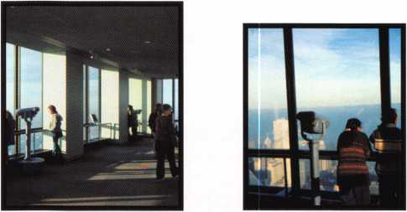

whether informal through regularly reading a magazine like this, or seminars and classes - is key to success.

And it's important that aspiring security directors understand that this is a round-the-clock job. With cell phones, pagers and wireless e-mail devices, you are always within reach of your post. And more often than not, things seem to need immediate attention on week­ends and holidays.

KEYNOTES: How do you stay abreast of new prod­

ucts and security techniques, so that you can keep delivering added value to the tower?

MR. VILLAREAL: By attending trade shows, reading industry publications and networking with other securi­ty directors at conferences, I stay up on issues and meet people with whom I can share experiences. It's vitally important that every security professional stay current with new developments in the industry. If you think you've learned all you need to know, it's time for you to retire.

You have to love the challenge of learning new things. You better, because someone with bad intentions m ight be studying ways to get ahead of you.

KEYNOTES: How do you sell security to your superiors?

MR. VILLAREAL: Trizec Properties [which manages Sears Tower for owner MetLife] understands that the professional security program at Sears Tower is a value



**16**

Keynotes • April 2004



added service that most tenants appreciate. Compared to what's in place at other downtown office buildings, this is not simply window dressing. My superiors under­stand that and value what we're doing here, so it's not a tough sell.

KEYNOTES: What do you see as the future of securi­ty? Where are we going in today's age of technology (and terrorism)?

MR. VILLAREAL: The technology trend will continue and professional security staffs will become more reliant on biometric technology and scanning devices that detect biological and chemical agents. However, while machines will continue to become more sophisti­cated, a good program will still come down to the level of training given to individual employees. Ultimately, results from a machine are subject to human interpretation.

KEYNOTES: Name one thing in your office that says

the most about you.

MR. VILLAREAL: My desk is very organized. From  
looking at it, you wouldn't realize the amount of infor-  
mation that passes across it every day. I assess  
information right away and make same-day

decisions about whether to complete some-  
thing, file it or toss it. Except for longer-term  
projects, it's rare that I set something aside  
to do it the following day. I deal with things  
and move on.

KEYNOTES: What do you like the most about your job?

MR. VILLAREAL: I enjoy the challenge I face every day to make Sears Tower -- a secure building that operates efficiently. This is the premiere business address in Chicago and one of the most prestigious addresses in the world. My challenge is to make sure the security and life safety program live up to that reputation.

KEYNOTES: How has life changed for you in the

wake of 9/1 1? Do you feel a personal responsibility for the defense of Sears Tower and its people?

MR. VILLAREAL: I feel a tremendous sense of personal responsibility. Thousands of people here depend on my staff and me for their safety at work. Being responsible

for the safety of others is a huge responsibility.

I've tried my best to rise to the occasion.

Keynotes • April 2004

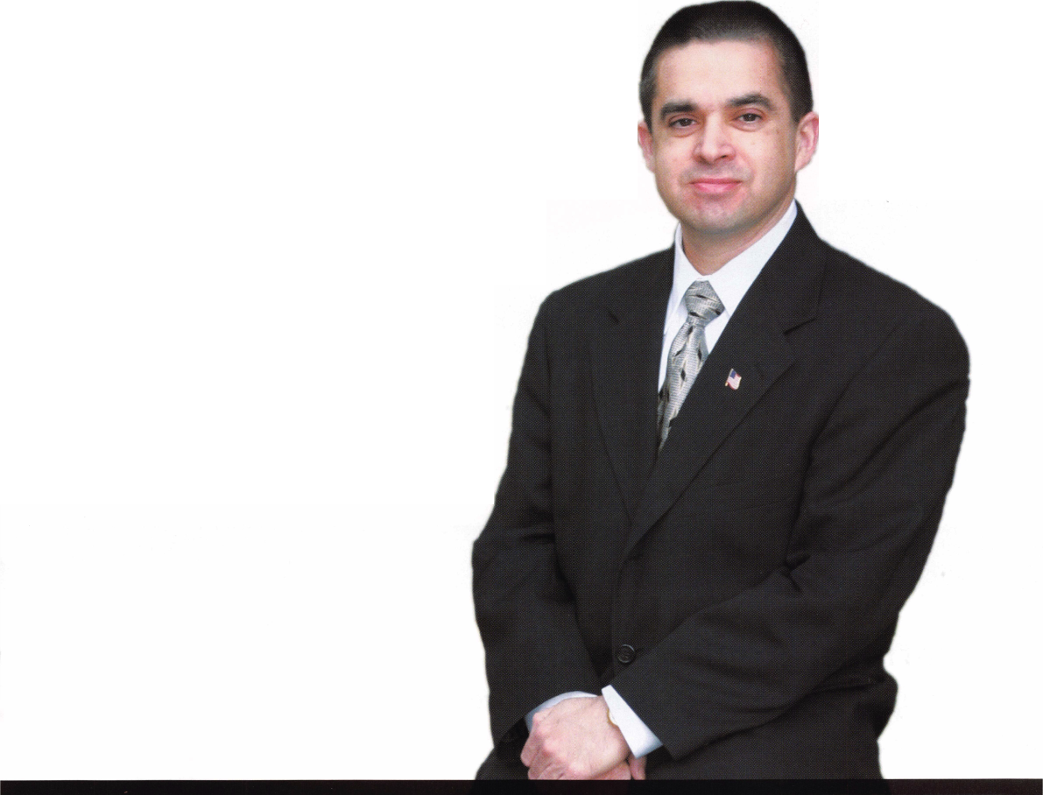

Institutional Applications:

Turning up the Heat on a Gamewell Fire Alarm Signaling Control

By Greg Perry, CML, CPS

**8**

Keynotes • April 2004

Like most of you, I don’t get to pick the jobs that  
come in the front door, or even choose when the cus-  
tomer wants the job done. When I was trained as an  
EMT, they told me, “You don’t get to pick the emer-  
gency; you just have to be ready for anything.” This  
one was one of those jobs in which I was not prepared  
or trained to perform. Most of the time, having to do  
a new job is a challenge I enjoy, but I prefer to start  
with a little information. I’d never seen the inside of a  
Gamewell fire alarm signaling control. The customer, a  
fire captain, had another lock with a different style  
key available, so he didn’t care if the lock was  
destroyed. However, the other lock was at his  
home 120 miles away, and he wouldn’t be back

)rking at our fire station for several weeks.

After I explained that I really wanted to see  
the other lock first, he said, “Destroy this  
one. I’ve seen others drilled, so just go  
for it.”

First, a little information about what  
needed to be opened. Gamewell  
made the box. This unit is  
designed to send fire alarms into a  
central station. This model is a  
pull station call box. It can also  
be hooked into fire alarm con-

J trol to send in alarm signals.

These units are a part of his-  
tory, although I’m told that at  
least one city in the United  
States is still using them.  
Inside is a spring-loaded clock  
type assembly. Whenever the

lever is pulled, or the alarm sys-  
tem trips, it sends three rounds of

information in the form of pulses via a wire loop run around the city or facility. At the other end, a ticker tape is read to see which box is reporting pulses to the central station. The newer central stations have a computer interface to read the pulses. The operator would then need to look up the location on a set of cards to send the fire crew to the box location. Firemen collect old fire equipment the way safecrack­ers collect old safe locks. This unit was mounted on a piece of Oak as a museum piece.

The nose looked like a typical lever lock, but the plug would not turn. Looking in the keyway, I could see a wafer or lever at 9 o’clock. Moving it allowed me to turn the nose, but alas, the lock did not open. However, now I could see the lever stack at 12 o’clock. I played with the lever stack and decided to pull the nose as seen in photo 2. I used the Lockmaster plastic spacer to prevent damaging the paint. The nose would not pull. The screw just stripped out, twice! Time to drill down the center of the keyway. Once the drill grabbed the nose, it started to spin. This required using a screwdriver to hold the nose in place while drilling. I finally got the nose removed to find a stub sticking up in the hole. This was a portion of the nose, and is held captive to the lock by the foot.

I grabbed it with a pair of needle nose locking pliers and drilled around the perimeter of it. After removing it, I still could not retract the bolt. Looking into the hole, I could see the lever stack; it would not move down out of the way. I drilled through the lever stack and finally could get at the bolt. Looking in with a scope pointed toward the bolt, I could see the spring, but there was nothing to grab. I played with a pull wire, attempting to grab something before following the bolt back with the scope. I found a stud on the



This one was one of those jobs in which I was

not prepared or trained to perform.

Keynotes • April 2004

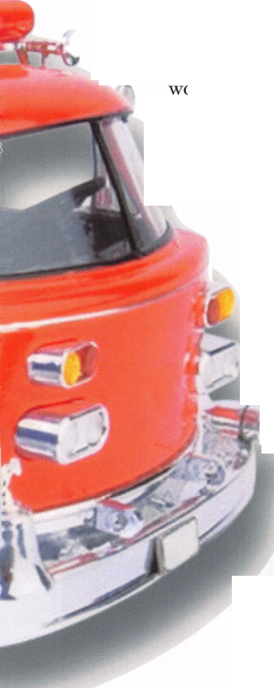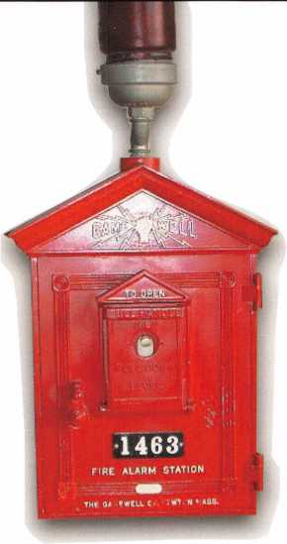

key for the lever lock looks stair- stepped and is double sided. This may account for the need to insert a key before the plug will turn. A second type requires a little more than a split screw­driver looking key. This lock can be rec­ognized by the split keyway. It’s similar to some paper towel racks. I’m told this lock can be opened with a pair of screw­drivers: one stuck in the top and one in the bottom; then turn to open.

I did a little research with a different fire department I know who used Gamewell up until a few years ago. I found they had two different types of locks used by Gamewell, although they may have used more. The first lock you’ve seen is the lever lock. The

bolt and was able to push it back to open the lock. Start to finish took over an hour.

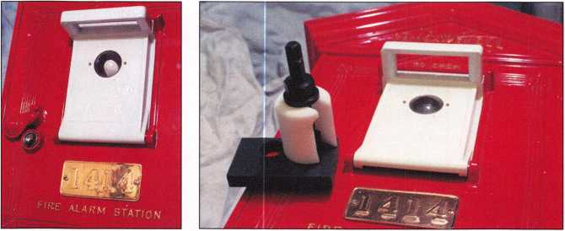

...we need to have the

ability to think as

we go.

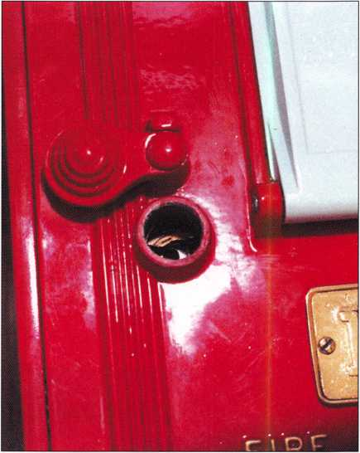

Keynotes • April 2004

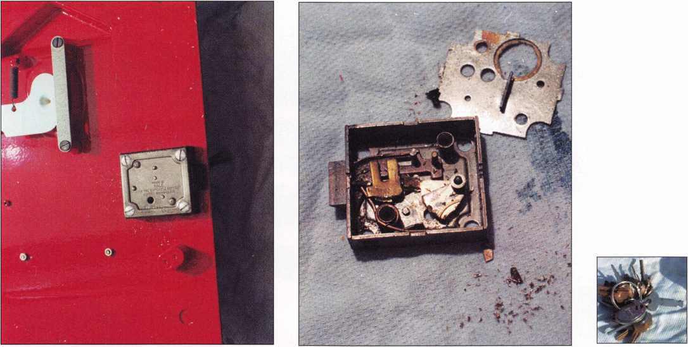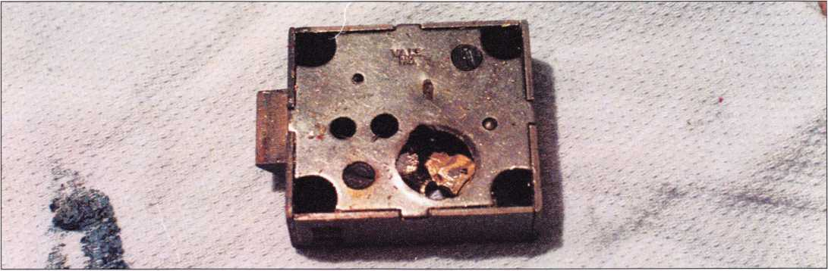

Sometimes we get the benefit of training and have reference materials and know how to do the job ahead of time. Other times, we need to have the ability to think as we go. Hindsight is 20/20, and in this case, the only part of the job I would not repeat is the

attempt at nose pulling. Looking at the pieces, if I had time, impressioning or hand fitting a key might be possible but the ends of the levers are serrated. I’m glad, in this case, that the lock could be replaced.

Keynotes • April 2004

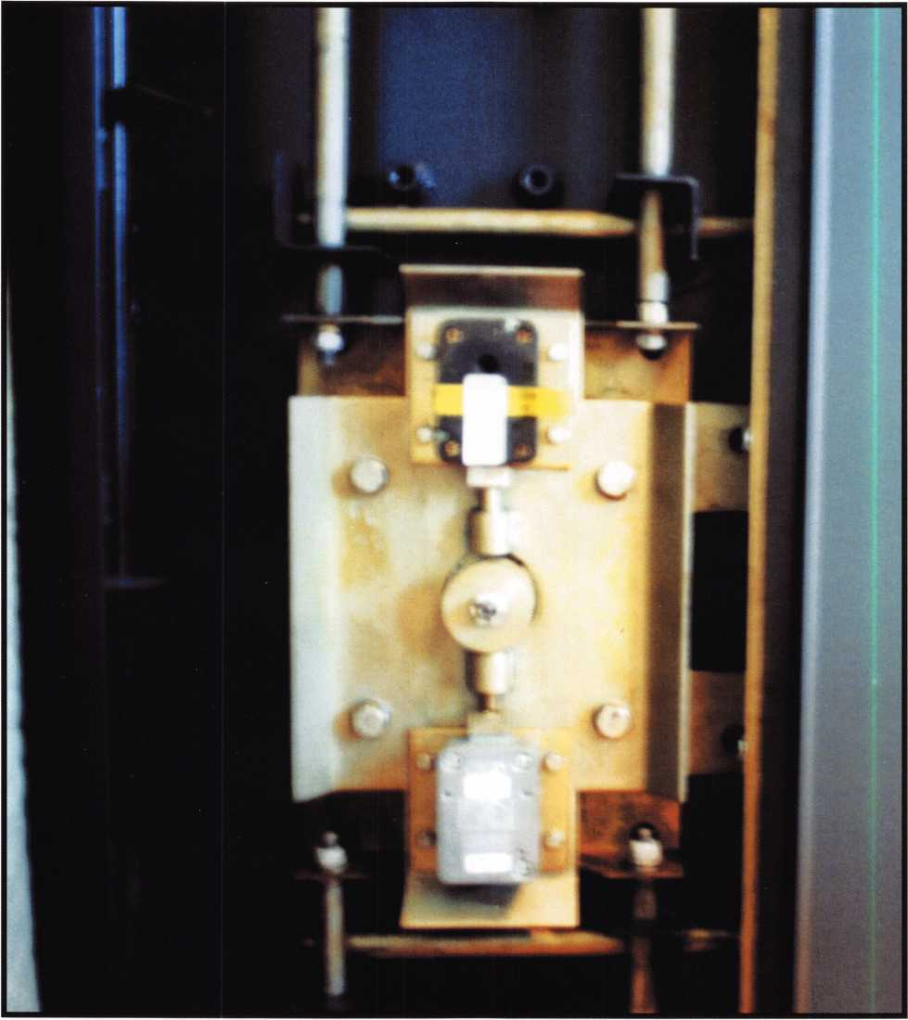

Cracking Open a MEGASAFE

By Frank Ulbin, CRL



Keynotes • April 2004



The ALOA Convention and Security Expo 2004

July 18-25,2004



ALOA'OH

MUiWore, n>5>

get it *...together*



**Sponsors:**

**(As of March 2, 2004)**

**AMSEC**

**ASSA High  
Security Locks**

The Baltimore Convention Center, one of the most well-equipped convention facilities in the  
country, stands as a jewel on the glistening Inner Harbor. The city itself sparks the imagination  
with a rich mosiac of historic tradition and modern innovation. Pillars of the city's past - such  
as Camden Yards, and the Star-Spangled Banner Flag House - are complimented by modern  
attractions including the American Visionary Art Museum and a vibrant array of markets,  
shops, restaurants and entertainment opportunities for you to enjoy.

**ClearStar**

**Security**

**Network**

**Corporate Safe  
Specialists**

**IR Security &  
Safety**

**KABA, KABA  
ILCO, KABA  
MAS**

They breathed new life into  
Baltimore's Inner Harbor.

So will we.

Join us this year at the East Coast's premiere travel destination as we set the stage for the  
biggest security event in the world. This is the place where locksmiths from all over the world  
will make their most important training and purchasing decisions of the year.

CONTENTS

**Lucky Line  
Products**

**Medeco**

**STRATTEC,**

**INC.**

**Videx**

**W-LOK Corp.**

General Information 2

ALOA Open Golf Tournament

ALOA Scholarship Foundation Kickoff Party/Live Auction

CML and Authors Breakfast

Legislative Action Network Luncheon

ALOA Dinner Banquet

Getting Around Baltimore 11

Transportation

Accommodations

Parking

Help/Questions

Daily Schedule of Events 3

Classes and Seminars 4

Registration Instructions 10

Registration Policies 10

Convention Registration Form .....12

Class and Seminar Registration 13

PRP/STPRP Registration Form ....14

Hotel Reservation Request Form 15

Car Rental Information 16

ALOA 2004 Security Expo 16

ALOA Membership Application 17

ALOA 2004 Exhibitors 18

ALOA 2004 Sponsors back cover

**YSG Door  
Security  
Consultants**

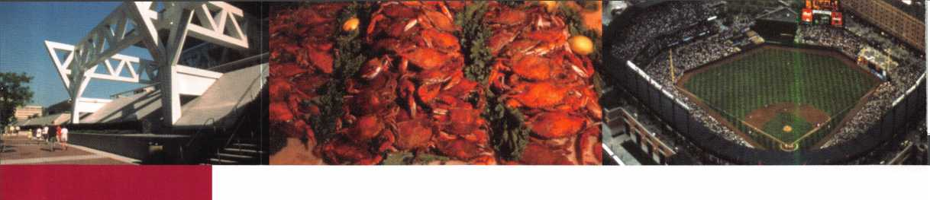

GENER4W- INFORMATION

**DAY TOUR TO "George Washington's Virginia"**

Wednesday, July 21, 2004

Today you are invited to travel along the banks of the Potomac River to enjoy an inti­mate glimpse of the 18th Century Virginia. Waiting beyond the gates of Mount Vernon stands the home of George Washington. From the gardens and greens to the original furnish­ings , you will tour the mansion and the sur­roundings. After the tour, you will board your awaiting coach for a driving tour of Alexandria, Virginia. Stop and shop along King Street in the heart of Alexandria and grab lunch.

• Complimentary pick-up and drop-off at the convention center

Tour Length: Approx 8 Hours

Price: $60 per person (lunch on your own)

**ALOA Open Golf Tournament**

Thursday, July 22, 2004 • 6:30am-3:30pm

The ever-popular ALOA Open Golf Tournament will be held at the Cross Creek Golf Club in Beltsville, MD. Transportation will depart from the convention center at 6:30am and return at 3:30pm.

Registration fee is $150 (tax deductible). This includes transportation, lunch, golf cart, bever­ages throughout the course and prizes for everyone. Proceeds benefit the ALOA Scholarship Foundation, Inc.

**KICKOFF PARTY/ LIVE AUCTION**

Thursday, July 22, 2004 Party: 7-8pm Auction 8-11 pm

ALOA Scholarship Foundation will again be the host of this year's Annual Kick-Off Party and Live Auction at the Hyatt Regency Inner Harbor. All registrants are encouraged to attend and enjoy fabulous food and fun and a special guest apperance by the Baltimore Orioles Mascot. Great items will be offered for your bidding pleasure at ALOA's 5th Annual live auction. Our usual special auction item this year is a special equipped van.

This is a great place to meet old and new friends while enjoying the opportunity to purchase fantastic items and outstanding bargains-with the proceeds going to a great cause!

**CML & AUTHORS BREAKFAST**

Friday, July 23, 2004 • 8:30-10am

ALOA will host an invitation-only breakfast honoring recipients of ALOA's highest level of locksmith certification.

**ALOA MEMBERSHIP MEETING**

Friday, July 23, 2004 • 10-11am

ALOA members are encouraged to attend the 2004 Annual Membership Meeting. The achievements of the past year will be reviewed and the goals for the future stated. Don't miss this great opportunity to be an integral part of your association! Continental Breakfast will be served.

**STATE OF THE STATES ROUNDTABLE**

**AND**

**LEGISLATIVE ACTION NETWORK "THANK YOU!" RECEPTION**

Saturday, July 24, 2004 • 11 am-Noon

This meeting is designed as a forum for ALOA chapters and local/state regional locksmith associations to share information about the state of locksmithing in their region and a dynamic way to share ideas. Primarily for the Chairman, President and Legislative represen­tative from each organization, all LAN

Members are encouraged to participate.

This is the perfect opportunity to learn about what's going on in the industry and across the nation.

As a way to say "THANK YOU" for all your hard work, ALOA is throwing a party for all members of the Legislative Action Network (LAN). This event will be the perfect way to celebrate the MANY legislative victories ALOA had this year!

**GOVERNMENT AFFAIRS BOOTH AT EXPO**

July 23-25, 2004

Noon-5pm (Noon-4pm Sunday)

On site, we'll have information on all bills, and legislation in your state. THIS IS GRASS­ROOTS LOBBYING AT ITS FINEST! Free Convention merchandise for Legislative Action Network Council ($100 and up) members.

**ALOA DINNER BANQUET**

Saturday, July 24, 2004 • 7-11 pm

Get it...together. Plug In and Get Connected I It's ALOA LIVE AT POWER PLANT LIVE! A complex so energetic it comes with its own exclamation point. Meet us for a STREET FES­TIVAL at Baltimore's newest and most excit­ing entertainment district...Our private party will create a memorable event unlike any other yo u ' ve ever experienced. Join us for wonderful food from four countries and lots of entertainment.

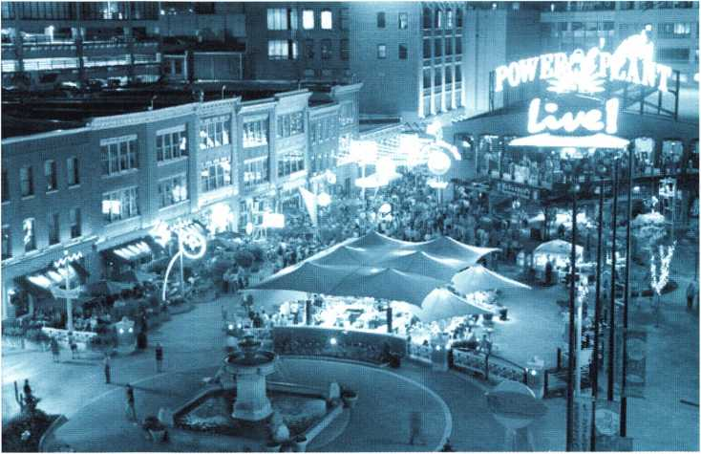

Get tickets now for ALOA LIVE AT POWER PLANT LIVE!

2

ALOA 2004 SECURITY EXPO will be located in Hall A-C off the Charles Street lobby of the Convention Center • Friday, July 23

Noon-5 pm • Saturday, July 24 • Noon-5 pm • Sunday, July 25 • Noon-4 pm

|  |  |  |  |  |  |  |  |  |  |  |  |  |
| --- | --- | --- | --- | --- | --- | --- | --- | --- | --- | --- | --- | --- |
| SUNDA'  EDUCATIONAL CLASSES 8-5P |  | MONDAY  July 19, 2004  REGISTRATION  7AM-5 PM  CONV. CENTER  FULL-DAY  EDUCATIONAL CLASSES 8-5PM  CONVENTION CENTER |  | TUESDAY  July 20, 2004  REGISTRATION  7:30AM-5:30PM  CONV. CENTER  FULL-DAY  EDUCATIONAL CLASSES  8-5PM  CONVENTION CENTER |  | WEDNESDAY  July 21, 2004  REGISTRATION  7:30AM-5:30PM  CONV. CENTER  FULL-DAY  EDUCATIONAL CLASSES  8-5PM  CONVENTION CENTER | THURSDAY  July 22, 2004  REGISTRATION  7:30AM-5:30PM  CONV. CENTER  FULL-DAY  EDUCATIONAL CLASSES  8-5PM  CONVENTION CENTER | FRIDAYJuly 23, 200  NO CLASSES TODAY • |  | SATURDAY  July 24, 2004  REGISTRATION AND EXHIBITOR REGISTRATION 7:30AM-5PM  CONV; CENTER  HALF-DAY EDU. CLASSES 8-11AM • CONV CENTER  NOON-5PM SECURITY EXPO |  | SUNDAY  July 25, 2003  REGISTRATION AND EXHIBITOR REGISTRATION 7:30AM-2PM  CONV CENTER  HALF-DAY EDU. CLASSES  8-11AM • CONV CENTER  NOON-4PM  SECURITY EXPO |
| r |  | | | | | | | </, *  7! »  S § |  | HALL A-C |  | HALL A-C |
| i * | 101 | Instructor Training (2 of 3) | 201 | Instructor Training | 301 | Medeco3 Factory Certification | 401: Millennium Electronic Locks | 5 3 | 601 | Keyless Remote Programming | |70T | ABUS Padlock Certification Course |
| Z — | 102: Fundamentals of Locksmithing | | 202: Fundamentals of Locksmithing | | 302: Fundamentals of Locksmithing | | 402: Fundamentals of Locksmithing |  | 602: l-Que Electronic Access Control | | 1702: Videx CyberLock Advanced Training | |
| 3 00  0 N |  | (Day 2 of 5) |  | (Day 3 of 5) |  | (Day 4 of 5) | (Day 5 of 5) | 5 § |  | Certification |  |  |
| Z | ■ |  |  |  |  |  |  | s 2 |  |  |  |  |
| s § | 103: Complete Door & Door Closers (P-05) | | 1203: Servicing Aluminum Storefront Doors | | 303 | Exit Devices & Exit Alarms (P-16) | 403: Hollow Metal Door & Frame Svc | ° z • ^ | 603: Mul-T-Lock | | 1703: Auxiliary Door Hardware | |
| z 2 | 104: Master Keying Methods & Formats | | 1204: Master Keying Methods & Formats | | 1304: Advanced Topics in Master Keying (P-31) | | 404: High Security Cylinder Servicing | z z | 604 | ' Medeco Keymark Factory Certification | 704: Medeco New Product Update | |
| a *  3 S |  | (Day 1 of 2) |  | (Day 2 of 2) |  |  | (P-08) | O o  2 C |  |  |  |  |
| • 2 | To? | Comprehensive Picking Techniques | 205 | Comprehensive Impressioning Techniques | 305 | Tubular Key Lock Servicing (P-12) | 405: Cabinet & Furniture LockServicing | l s | 605 | Primus & Everest Certification | 705 | Basic Exit Device Servicing |
|  | T06 | Investigative Locksmithing 1 | 206 | Investigative Locksmithing II | 3(j7 | Investigative Locksmithing III | 406: Forensic Locksmithing | i i | 606 | Electronic Locking Systems Overview | Toe | 13 Methods of Car Opening |
| = ^  * a | 1o7 | Alarm Design & Dev. (P-42) (Day 1 of 2) | 207 | Alarm Design & Dev. (P-42) (Day 2 of 2) | 307! | Comp. Access Cont. 1 (P-40) (Day 1 of 2) | 407: Comp. Access Cont. 1 (P-40) (Day 2 of 2) |  | 607: | ASSA High Security Locks Products | 7o7 | ABLOY PR0TEC High Security Locks |
| | 0 ° z | 7)8 | Thinking Outside the Box | 208 | Door Hardware 101 | 308 | Basics In Electric Locksmithing & Wiring | 408: STRATTEC 2004 Update | I a | 608 | Mechanical Closers and Door Controls | 708 | Low Energy Power Operators |
| —t  3 • | To? | Advanced Shop Management | 209 | Life Safety Codes w/ADA (P-07) | lew | S&G Group 2/2M Certification | 409: S&G Electronic Lock Certification | c o | 609 | Corbin Russwin Pyramid Cert. | 777 | Taking the Mystery out of Electrified... |
| D | 717 | Combination Lock Manipulation | 717 | Combination Lock Manipulation | 77 | CPS Prep Class | 410: NKL Safe Certification Class | w t/l  & -H | 77 | Kaba llco Transponder Forum ? | 717 | Alarm Lock Trilogy Certification |
| § 5 |  | (Day 1 of 2) |  | (Day 2 of 2) |  |  |  | ? 1 |  |  |  |  |
|  | Ill: | Defense Against Methods of Entry | 2lT: | Defense Against Methods of Entry (Day 2) | 77 | Defense Against Methods of Entry | 411: Defense Against Methods | -o O | 77 | Kaba High Security Locks | TIT | Kaba Mas Low Current Electronic |
| i. g |  | (Day 1 of 2) |  |  |  | (Day 2) | of Entry Day 2 | 3 2  w • |  |  |  | Safe Locks |
| 3 2  s 5 | 717 | Basic Automotive Lock Service | 717 | Intermediate Automotive Lock Service | 77 | Advanced Automotive Lock Svc. (P-03) | 412: Motorcycle Lock Servicing(P-22) |  | 77 | ASP Product Overview | 717 | Transponder 2004/2005 |
| Q 3^ | 717 | E-Plex Access Control Certification | 717 | Financial Management for Locksmiths | 77 | Financial Management for Locksmiths | 413: Business Planning | m ^ | 77 | Complete Guide to Electric Strikes | 717 | Automotive Picking Techniques by A4... |
| o £  ? z |  |  |  | (Day 1 of 2) |  | (Day 2 of 2) |  | Q Ol  3 5 |  |  |  |  |
| fr 51 | 717 | Key Blank Identification: | 717 | Comprehensive 1C (Day 1 of 2) (P-38) | 77 | Comp. 1C (Day 2 of 2) (P-39) | 414: The History of Locks... | CN s  1 # | 77 | Auto Opening with Hi-Tech Tools | 714: | New Schlage D Lock and F Series One... |
| T | 717 | Intermediate Locksmithing Professional | 77 | Intermediate Locksmithing Professional | 77 | Simplex Unican Certification | 415: Mechanical Push Button Lock |  |  |  |  |  |
| 3‘  (Q  "o |  | Lock Installation (P-28) |  | Lock Installation (Day 2 of 2) |  |  | Manipulation | ° O  s i |  |  |  |  |
| □ | 717 | Basic Electricity & Electric Locks (P-13) | 717  ~ | Fundamentals of Access Control | 77 | Basic Electricity & Elect. Locks (P-13) | 416: Fundamentals of Access Control | .< |  | |  | |
|  | 117 | Automotive Investigative Locksmithing |  | Automotive Investigative Locksmithing | 77 | Gardall Safe Certification | 417: AMSEC Factory Certification | a |  |  | r- |  |
| ■Hi |  |  |  | (Day 2 of 2) |  |  |  | 2  5f |  |  |  |  |
|  | 1 | | 77 | Master & American Padlock Cert. | 77 | LaGard Electronic LockCertification A | 418: LaGard Electronic Lock Cert. B | 50 |  | |  | |

*Shading denotes mulitple-day classes.

Evening Seminars 7-9pm

221: Electric Lock Site Survey & Design

222: Marketing High Security & Crime  
Prevention Awareness

223: Auto Opening Techniques 2004

Evening Seminars 7-9pm

321: Introduction to Access Control

with Cyberlock

322: The Bold New Vision of Kaba Mas

323: Replacing Lost Keyless Entry

Remotes - An Untapped Market for Automotive Locksmiths

**Visit our website for complete class descriptions and up-to-the-minute information:**

**[www.aloa.org](http://www.aloa.org) or call 800-532-ALOA for more info.**



This symbol indicates that a class is PRP certified. Students may elect to take the exam for the PRP elective designated at the end of the class for an additional fee. PRP  
Certified class exams will take place immediately following the end of class (5pm) the length of the class exam will be 20 -30 minutes depending on the number of  
questions in the exam.

PRP AND STPRP EVALUATIONS: The PRP/STRP exams will be administered Friday evening from 6-10 pm.

Sunday, July 18, 2004; 8am - 5pm

001: Instructor Training

Instructor: Monte Salway, CML and Stephen Sharpe

(3-day class)

The first step to becoming an ACE instructor. Learn standardized methods of instruction and motivation. Includes lectures, Q&A, exercises and presentations. Designed to help students organize both instruction methodology and general business career.

Students will be able to develop class outlines, lesson plans, training aids, motivate students, and effectively instruct an ACE class.

The student should not plan on an 8 a.m. to 5 p.m. class every day. This class may run into the evening, and some homework will be required.

002: Fundamentals of Locksmithing (Day 1 of 5)

Instructor: James Hancock, CPL

This is a comprehensive, five-day, hands-on course in fundamental locksmithing techniques. Identify com­mon key blanks, adjust key cutting equipment, use key duplicating and code cutting equipment, disas­semble, service and originate keys for common lock cylinders (using methods such as shimming, picking, impressioning and code cutting). Lockset servicing, functions and finishes will also be covered.

Monday, July 19, 2004; 8am - 5pm

101: Instructor Training (2 of 3)

Instructor: Monte Salway, CML and Stephen Sharpe

See class#001 for description

102: Fundamentals of Locksmithing (Day 2 of 5)

Instructor: James Hancock, CPL

See class #002 for description.

103: Complete Door & Door Closers (P-05)

Instructor: Dave Thielen, CML

"Open the doors" to a new area for your locksmith business. More than door servicing. Learn the princi­ples of door closers, especially the selection, adjust­ment and installation procedures for non-handed (reversible) surface-mounted door closers. Learn the functions, installation and servicing of door closers, hinges and commercial or heavy-duty grade door hardware.

The information presented will be useful in preparing for PRP Section L-05 and L-41.

104: Master Keying Methods & Formats

(Day 1 of 2)

(Two-day class)

Instructor: Jerome K Andrews, CML, Clyde Roberson, CML, CPS

This is a fast-paced, comprehensive course in split-pin master keying, based on the ALOA publication. Fundamentals of Master Keying. Topics include the standard key coding system, expansion specification, site survey, record keeping, selecting top master keys, the TMK register, basic mechanical and historical problems in master keying, dividing the key for symmetrical systems, use of incidental masters for asymmetrical systems, principles for cross keying, and parity.

Students will learn to perform a site survey, and to design and properly maintain a multiple level master key system.

Note: There is a $40 lab fee required for the class text to be retained by the students. If you already

have a copy of Fundamentals of Master Keying by Jerome Andrews, this fee will be waived. Students must have a copy of this text for use during class.

The information presented will be useful in preparing for PRP Section L-31

105: Comprehensive Picking Techniques

Jim Watt, CML, CPS

Lock picking is a necessary, acquired industry skill. This class will cover the theory, techniques and prac­tice of picking locks. Students will be able to apply the knowledge and techniques of lock picking using various methods on pin and disc tumbler cylinders.

The information presented will be useful in preparing for PRP Section L-00

106: Investigative Locksmithing I

(Three-Day Class)

Instructor: Jim Bickers and Dan Cunningham, CRL, CFL

Introduces students to investigative/forensic lock­smithing, its history, who/what is involved, and lock­smith possibilities. Photos and slides of various locks, pin tumblers and disc tumblers that have been picked are shown. The following are discussed, listed and detailed: field tools, forensic standards, code of ethics, the crime scene, preservation of evidence, scene documentation, working with local law enforce­ment, preservation of all evidence, the "chain of cus­tody" and appropriate packaging in evidence collec­tion. Investigative Photography is briefly discussed.

Note: A lab fee of $75 is required to cover the costs of the Forensic Locksmithing Tool Kit and Manual, which student.

Prerequisite: Basic Locksmithing.

107: Alarm Design & Development (P-42)

(Two-day class)

Instructor: Ed Streski, Jr., CML

Introduces students to aspects of burglar alarm design and development. Learn about various types of detection equipment, including contacts, glass break sensors, passive infrared detectors, dual-tech detectors, and smoke and heat detectors. Examine the applications of both hardwired and wireless sys­tems, specialized tools and labor saving devices used in burglar alarm system installation. Installation in existing applications and pre-wire for new construc­tion will be discussed. Control Panels, installation of a PC board in an enclosure; programming, communica­tion formats and monitoring station procedures will also be covered.

Students will be able to identify the various types of detection equipment and utilize tools to properly install a hard wire or wireless alarm system.

A Lab Fee of $175 includes a control panel, keypad, motion detector, interior siren and a back-up battery that the student can take home for continued learning or sell to a prospective customer to offset the cost of the lab fee.

The information presented will be useful in preparing for PRP Section L-42

108: Thinking Outside the Box

Instructor: Bill Neff, CML

This class is a potpourri of various tips, tools, tricks and techniques for the progressive locksmith who is willing and able to THINK OUTSIDE THE BOX.

Electronic security has become so prevalent, that more systems are becoming proprietary. This class is designed to show new methods of solving some of

these new challenges and provide you with methodol­ogy and tools to solve additional challenges that may not yet have been discovered. This is a hands-on class covering techniques in solving code lists, PIN codes and electronic codes. Students will learn about the operation and identification of the common electrical 1C components used in the Automotive Locksmithing & Access Control Industry.

Prerequisite: the student must bring a laptop that has a parallel printer port, CDRom drive and Microsoft Windows 95, 98, NT or XP and MS Excel installed.

A basic understanding of PC operating systems is required.

109: Advanced Shop Management

Instructor: Thomas Demont, CML, AHC

This class is a must for the management professional of the 21st Century. Learn strategies for hiring employees, dealing with drug and alcohol abuse, compensating employees, training, advertising, bids and proposals, and growth with a purpose. Hear how Tom built his company from a start-up to the area's leader in 10 years and sold it for $3 million.

110: Combination Lock Manipulation (Day 1 of 2)

Instructor: Dennis Watanabe, CML, CMST and Frances Watanabe

(Two-day class)

Get and overview of mechanical combination locks, including the theory of operation, determining the number of wheels, and how to determine the lock manufacturer. By course's end, students should not only be able to manipulate locks, but also through the knowledge gained about locks, be able to open many locks that they have not been able to, including some Group I locks. Students should have a thorough knowledge of servicing locks and combination changing prior to taking this class.

Materials students should bring to class: Medium size common and #2 Philips screwdrivers, diagonal pliers and pencil and paper for any notes they want to make.

There is a Lab Fee of $40.00 for the mounted combination lock.

Prerequisite: Combination Lock Servicing or equivalent. Students must be bonded.

The information presented will be useful in preparing for PRP Section L-33 and STPRP Section S-00.

Ill: Defense Against Methods of Entry

(Day 1 of 2)

Instructor: Harry Sher, CML, CPS

Learn specific methods of entry under the following broad categories: forced entry, surreptitious entry and covert entry. Aimed at locksmiths who need to neutralize locks, security consultants who need to identify weaknesses and recommend solutions, as well as forensic locksmiths, law enforcement, and intelligence personnel who need to make entry or identify the method of entry. Material from other classes (Professional Bypass Techniques, Tricks of the Trade and Operations Methods of Entry) will be cov­ered. Apply specific methods to safe and vault, auto­motive, residential, safe deposit, etc. Learn to identify the weak points in any locking device (including unfa­miliar locks), determine the most likely methods of attack, make entry in a professional manner and determine how to best defend against these methods of entry.

**Visit our website for complete**

**class descriptions and up-to-the-minute information**

**[www.aloa.org](http://www.aloa.org) or call 800-532-ALOA for more info.**

4

112: Basic Automotive Lock Service

Instructor: Ray D'Adamo, CML and Tom Seroogy

Students already familiar with basic lock service will  
be introduced to the tools, skills and information criti-  
cal for beginning professional automotive lock serv-  
ice. All fundamental topics will be covered. Learning  
the basic terminology and procedures of automotive  
cylinder and key service is the theme throughout the  
day. Hands-on clinics will include key blank identifica-  
tion, referencing and cutting keys by code, function  
and operation of common automotive cylinder types,  
basic lock manipulation, disassembly and re-assem-  
bly, keying and re-keying, general cylinder repair  
service, and fitting first keys.

Materials needed: selection of hand tools, such as  
screwdrivers, an awl, files, lock picks, possibly a  
small clamp-on vise, a small hammer and any addi-  
tional tool you feel will be helpful for bench work.

Prerequisites: Basic Lock Service or equivalent  
experience

The information presented will be useful in preparing  
for PRP Section L-03 & 04

113: E-Plex Access Control Certification

Instructor: Kaba Access Control

This hands-on class explores the new E-Plex electronic  
pushbutton lock, which combines the ease of use and  
reliability of Simplex with the added security and fea-  
tures of electronic access control. Students will be  
trained for installation, programming, user-friendly  
software and much more. Class limited to  
25 students.

114: Key Blank Identification:

Instructor: AJ Hoffman, CML

Get the basics of cylinder, flat, drilled and bit key  
identification. Advanced topics such as variations in  
multiplex key systems and high security key blanks  
are also covered. Students will learn to recognize  
keys by overall dimensions, milling, bow shape and  
common forms of marking, through hands-on exercis-  
es and class lecture. Original and non-original key  
blank numbering systems will be explained. Each stu-  
dent receives a set of professional handouts and vari-  
ous manufacturers' catalogs.

The information presented will be useful in preparing  
for PRP category L-00

Intermediate Locksmithing Professional  
Lock Installation (P-28)

(Two-Day Class)

Instructor: TBA

Students will learn to install locksets, auxiliary locks,  
exit devices, door closers and other door hardware  
in this two-day, hands-on workshop. Students will be  
introduced to a wide variety of methods and tools  
used in professional lock installations.

The information presented will be useful in preparing  
for PRP category L-28

Basic Electricity & Electric Locks (P-13)

Instructor: Greg Perry, CML, CPS

This course begins with fundamental electric theory  
and focuses on those aspects of electricity that apply  
to modern access control and electric locking sys-  
tems. A review of electric lock hardware is included.

Materials to bring to class: a digital multi-meter and  
small tools.

The information presented will be useful in preparing  
for PRP Section L-13.

117: Automotive Investigative Locksmithing

(Day 1 of 2)

Instructor: Bruce Sumner, CFL

Auto fraud insurance claims cost you and the insur­ance companies billions of dollars annually, making it one of the top crimes in America, and the problem is getting worse. This class is geared to assisting law enforcement agencies and insurance companies. Students already familiar with automotive lock­smithing will be introduced to the investigative princi-

115:

116:

☆

pies, procedures and the handling of evidence to determine if fraud was committed, and how it was accomplished. There will be a hands-on examination at the conclusion of the second day.

Prerequisites: Investigative or forensic locksmithing.

Tuesday, July 20, 2004; 8am - 5pm

201: Instructor Training

Instructor: Monte Solway, CML and Stephen Sharpe

See class#001 for description

202: Fundamentals of Locksmithing (Day 3 of 5)

Instructor: James Hancock, CPL

See #002 for description

203: Servicing Aluminum Storefront Doors

Instructor: Dave Thielen, CML

Learn about aluminum storefront doors and frames, and their unique hardware. Door and frame construc­tion, locks, closers, pivots, and other hardware will be presented with an emphasis on installation, servic­ing, adjustments, and retrofitting techniques.

Improving security on these doors will also be dis­cussed. Some hands-on will be involved.

Materials to bring to class: Allen wrenches and a set of screwdrivers.

Prerequisite: Basic Locksmithing

204: Master Keying Methods & Formats

(Day 2 of 2)

Instructor: Jerome V. Andrews, CML, Clyde Roberson, CML, CPS

See class #104 for description.

205: Comprehensive Impressioning Techniques

Instructor: Jim Watt, CML, CPS

Learn the theory behind impressioning, what differ­ences there are between disc and pin tumbler impres­sioning. Then, be prepared to impression the day away on disc and pin tumbler locks, domestic and foreign with discussions about those pesky high secu­rity locks. Not only will your instructor discuss all of the tools required (including types of files) but the special preparation of key blanks as well.

The information presented will be useful in preparing for PRP Section L-00

206: Investigative Locksmithing II

Instructor: Jim Bickers & Dan Cunningham, CFL

Investigative Locksmithing I is briefly reviewed. This class includes hands on exercises using a hand micro­scope to examination various locks and cylinders, to determine if they have been picked or bypassed.

Basic Macro & microphotography is discussed. The student is introduced to the Stereo Microscope and its value to examinations. Court testimony, appropriate legal and insurance terminology and demeanor in the courtroom will be covered. Developing a report of findings, building an investigative locksmithing resume (CV), marketing techniques along with some basic tricks of the trade are covered.

Prerequisite: Investigative Locksmithing I.

Note: You must have the Forensic Locksmithing Tool Kit and Manual for this class or pay a $75.00 lab fee.

207: Alarm Design & Development (P-42)

Instructor: Ed Streski, Jr., CML & Bill Neff, CML

See class #107 for description

208: Door Hardware 101

Instructor: Tom Foxwell

This class covers the various types of locks, hinges, closers, doors, frames and related hardware that a locksmith should be familiar with in order to properly service any door opening. Upon completion of this class the student will be able to identify and service the various types of hardware used on doors and frames.

The information presented will be useful in preparing for PRP Section L-05 and L-41

209:

☆

210:

211:

212:

213:

214:

☆

Life Safety Codes w/ADA (P-07)

Instructor: Thomas Demont, CML, AHC & Ed Hite, CML

This is a mandatory class for the security professional of the 21st Century. The areas covered will include the new International Code Council Model Building & Fire Code ICBO-2000, Underwriters Laboratories list­ings for hardware, Accessibility, Doors, N.F.P.A. 80- 1999, 101-2000, Door and Hardware Institute guide to the ADA Act of 1990. Lab Fee $40.00 for the class manual.

The information presented will be useful in preparing for PRP section L-07

Combination Lock Manipulation (Day 2 of 2) Instructor: Dennis Watanabe, CML, CMST & Frances Watanabe See class #110 for description.

Defense Against Methods of Entry Day 2 Instructor: Harry Sher, CML, CPS

Students will have the opportunity to have hands on experience with exotic as well as more common tools that were demonstrated on day one. Experts in the field of entry methods will instruct students in hands on use of their tools, software and methods. Authors, tool inventors and manufacturers such as Marc Tobias (Locks, Safes and Security an International Police Reference), Gale Johnson (Editor of the Locksmith Ledger), Mark Bates (MBA), Al, HPC, Lockmasters, MDS, and Peterson Tools will be available. Last minute contingences may affect the availability of individuals or companies. Class size is limited so the class will be repeated on Wednesday and Thursday.

Prerequisite: Class #111

Intermediate Automotive Lock Service Instructor: Tom Seroogy & Ray D'Adamo, CML

This course is for students already familiar with basic automotive lock service, who wish to learn about servicing the more advanced, two dimensional mechanical and electromechanical security systems found in today's vehicles. Some examples of the topics covered are system identification & electro­mechanical integration, intermediate lock, linkage & electromechanical manipulation, air bag & transpon­der service, special tools, troubleshooting, effecting repairs and fitting fully functional first keys.

Materials needed: selection of hand tools, such as screwdrivers, an awl, files, lock picks, possibly a small clamp-on vise, a small hammer and any tool you feel will be helpful for bench work.

Prerequisites: Basic Automotive Lock Service or equiv­alent experience.

The information presented will be useful in preparing for PRP Section L-03 & L-04.

Financial Management for Locksmiths (Day 1 of 2)

Instructor: Virl Mullins

(Two-Day Class)

This class is designed for those who are responsible for the financial success of the business such as own­ers or managers. However, anyone can learn much that would help him or her to understand the com­plexities of running a profitable business. You will learn: The difference between owners and managers, what is meant by "managing", how to read, under­stand and use a financial statement as a tool to make your business more profitable and how to budget.

Materials needed: Students will need a copy of their financial statements and a calculator.

Comprehensive 1C (Day 1 of 2) (P-38)

Instructor: AJ Hoffman, CML

Note: This is a two-day class. You may take Day 1 without taking Day 2, but in order to take Day 2, you must take Day 1.

This is not a master keying class. The following brands are covered in detail: Schlage, Yale, Small Format Interchangeable Core (SFIC) such as Arrow, Best (A2, A3, and A4 Systems), Falcon, Keymark and Kaba Peaks. There are extensive exercises to deter­mine the pin stacks of these cores. Core extraction.

**Visit our website for complete class descriptions and up-to-the-minute information:**

**[www.aloa.org](http://www.aloa.org) or call 800-532-ALOA for more info.**

decoding and servicing of existing systems plus parameters for establishing new systems will be cov­ered. Special hotel functions, construction keying and Kaba Gemini cores are also included. Each student receives a set of technical handouts

Prerequisite: The student must have a solid under­standing of basic master keying progression and have experience combinating conventional master keyed cylinders.

The information presented will be useful in preparing for PRP Section L-38 and L-39

215: Intermediate Locksmithing Professional Lock

Installation (Day 2 of 2)

Instructor: TBA

See #115 for description

216: Fundamentals of Access Control

Instructor: Greg Perry; CML, CPS

This course is designed to provide practical informa­tion, especially for those who are new to electronic access control. There is an overview of the features and benefits of all access control systems. Card, key­pad and biometric technologies are discussed. Hands- on exercises with single-door and multi-door products are included.

Materials to bring to class: a laptop computer is sug­gested but not required.

217: Automotive Investigative Locksmithing

(Day 2 of 2)

See class #117 for description

218: Master & American Padlock Certification

Instructor: Billy Edwards, Jr., CML

This is a hands-on factory certified training covering the complete ProSeries™ products, including the ML™ system, Python® and other new products. The class will include the laminated Weather Tough® and Shrouded locks plus all of the Brass, Aluminum and Steel solid body padlocks from both manufacturers, as well as the door hardware and SFIC versions.

Each student will receive: a copy of the new com­bined Technical Manual, & Python keying tool. Students successfully completing the test at the end of the class will be sent a certificate suitable for framing..

**ALOA 2004 EVENING SEMINARS**

Tuesday, July 20, 2004; 7:00-9:00PM

221: Electric Lock Site Survey & Design

Instructor: Mark McBroom - Securitron

This seminar is designed to cover all aspects of put­ting together an electric locking system. Topics dis­cussed are: site survey and walkthrough tips to ensure proper system design. Course attendees will leave with an understanding of problem areas, life safety code concerns and the processes of product selection for electric locking systems.

222: Marketing High Security &

Crime Prevention Awareness Instructor: Gordon Maczewski

Want some tips that will give you the edge over your competition and leverage your marketing efforts?

This seminar will teach you how to differentiate your company from the competition by providing your cus­tomers with comprehensive security solutions. You will find out how to enhance your company website by implementing, a ready to use, and professionally designed, high security flash presentation. You will learn what tools are available from the National Crime Prevention Council and how those tools can assist you in making presentations to business groups and in performing security surveys. You will also receive tips on forming a partnership with local crime prevention officials. The first 75 attendees will receive a free National Crime Prevention Partnership

booklet, a flash presentation on CD titled: "The Meaning of High Security", a booklet on "How to Protect What You Value Most" and a Workplace Safety Tips booklet.

223: Auto Opening Techniques 2004

Instructor: Lockmasters

Tired of learning how to open cars using only one technique and one tool: Join Lockmasters, Inc. for a short presentation on car opening made easy. See various approaches and tools to opening many of the latest import and domestic vehicles, including the challenging BMW high security 3, 5, 7 and 8-Series,, Lexus, Audi and Porsche and more.

Wednesday, July 21, 2004; 8am - 5pm

301: Medeco3 Factory Certification

Instructor: Medeco

This comprehensive class now includes Medeco's new patented 3rd generation product, Medeco 3 and will teach you how to quickly and proficiently service Medeco door hardware and cam lock cylinders. You will have an opportunity to take apart and reassem­ble a Medeco mortise cylinder, decode a Biaxial key, pin a switch lock plug, and master key a mortise cylinder. You will learn about key and pin specifica­tions, MACS, lubrication, rules for pinning high secu­rity 1C locks, trouble shooting and servicing tips and how to read a master key matrix. Students will receive a certificate directly from Medeco, pocket protector, screwdriver, key decoder, technical manual and product catalog. In recognition of ALOA's role in facilitating quality education, Medeco will also pro­vide each participant of this class a free Biaxial mini pin kit with a retail value of $336. Student must be present for the entire class to receive this offer.

Material required: Basic tools will be provided but you may want to bring your favorite pair of tweezers and reading glasses or a magnifier if you have trou­ble seeing small parts.

Prerequisites: Students should have a basic under­standing of how a pin tumbler lock operates and have previous experience pinning a common pin tum­bler lock.

The information presented will be useful in preparing for PRP Section L-08

302: Fundamentals of Locksmithing (Day 4 of 5)

Instructor: James Hancock, CPL See class #002 for description 303: Exit Devices & Exit Alarms (P-16)

"fif /ns#yctor; ^ave ^en' ^

This class has been updated to include delayed exit devices that comply with NFPA101. A wealth of infor­mation will be covered on exit devices including: types, functions, ratings, options, installations, repairs and servicing. Hands-on practice as well as slides, videos and handouts will be provided

Materials to bring to class: Common and Phillips screwdrivers and an Allen wrench set.

The information presented will be useful in preparing for PRP Section L-16

304:

☆

Advanced Topics in Master Keying (P-31)  
Instructor: Jerome V. Andrews, CML, Clyde Roberson, CML, CPS

Not an introductory course. Topics include: selective  
master keys, multiplex key systems, principles for  
Medeco Biaxial, designing systems for small format  
1C, Corbin Russwin, KABA and Sargent interchange-  
able cores, the rules for Corbin Russwin master ring  
and mixing master ring and conventional cylinders,  
master keying at the control shear line, tips on using  
incidental masters in standard progression format, the  
modified key coding system, and an introduction to  
positional master keying. Students are invited to bring  
their keying problems to the class.

Prerequisite: Master Keying Methods and Formats,  
MK101 or equivalent.

The information presented will be useful in preparing  
for PRP section L-31

305: Tubular Key Lock Servicing (P-12)

^ Instructor: James M. Watt, CML, CPS

The student will learn the history of the tubular key lock. Through an in-depth discussion, the student will learn what constitutes the differences in the various types of tubular key locks in common use today. Hands-on basic servicing techniques that will include disassembly, decoding, originating keys and re-assem­bly of locks as well as an introduction to impression- ing keys for tubular key locks will also be covered. Many tools for tubular key lock picking, servicing, and tubular key generation machines will be avail­able for students use during class.

Materials to bring to class: Pin tweezers, dial caliper and any optical devices to help see more clearly.

The information presented will be useful in preparing for PRP Section L-12.

306: Investigative Locksmithing III

Instructor: Jim Bickers, & Dan Cunningham, CRL, CEL

Brief review of Investigative I & II. Includes a hands- on examination of various lock cylinders (pin and disc) using a 10 X 30 power stereomicroscope to determine possible evidence of picking, etc. Tool marks and problems in examination of lock mecha­nisms are discussed along with data on arson investi­gations in both vehicle and commercial applications. Advanced by-pass methods in use, macro & microphotography of evidence that a forensic lock­smith must look for as well as report writing will be covered. A mock trial is conducted with students par­ticipating in expert witness testimony at a trial.

Prerequisites: Investigative Locksmithing I & II.

Note: You must have the Forensic Locksmithing Tool Kit and Manual for this class or pay a $75.00 lab fee.

307: Comprehensive Access Control I (P-40)

Instructor: Bill Neff, CML & Ed Streski, CML

(Two-Day Class)

Electronic access control is growing at a rate three times greater than that of mechanical locks. This is a must course for a locksmith to maintain continual growth and success. This class will consist of a half­day lecture and a day and a half of lab experience of single but mainly multiple door access control sys­tems. Students will learn about the various reader technologies (including smart card), communication formats, operating systems, integration and system designs used in access control systems. Students will receive handouts and software.

Materials to bring to class: Small narrow blade screwdriver, wire strippers and voltage ohmmeter. PC Laptop recommended.

Prerequisite: Students must have an understanding of basic electricity with some PC experience.

The information presented will be useful in preparing for PRP Section L-40

308: The Basics in Electric Locking and Wiring

Instructor: Robert Cbartrand

This hands-on training session shows individuals the basic procedures for hooking up RCI's electromagnet­ic locks and electric door strikes by personal instruc­tion with the assistance of wiring diagrams. RCI will be providing all tools, products and diagrams for this training.

309: S&G Group 2/2M Certification

Instructor: Brian Costley, CML, CMST

Safe work offers new income producing opportuni­ties, but the intricacies of combination locks can be intimidating. This one day class covers the basics of S&G Group 2 and Group 2M three wheel combina­tion locks. Installation, complete servicing, combina­tion changing, and basic through intermediate trou­bleshooting are covered. Each student keeps the tools and locks used in the class.

**Visit our website for complete class descriptions and up-to-the-minute information**

**[www.aloa.org](http://www.aloa.org) or call 800-532-ALOA for more info.**

6

310:

311:

312:

☆

313:

314:

*Hr*

315:

CPS Prep Class

Instructor: Dennis Watanabe, CML, CMST & Frances Watanabe

Students will participate in a day of fast paced instruction and hands-on training, covering a wide range of topics related to safes and safe locks. Basic and advanced, theory and operation of safes and safe locks, construction, ratings, container classifica­tions, servicing and defeat methods are just some of the subjects covered in class. Students will also learn the proper way to scope a change key hole, lock defeat methods and drill point options, how to pull various dials, locks and safe door handing, lock-out diagnostics, the correct way to drill and transfer and much more.

Lab Fee $100.00 for the class manual

The information presented will be useful in preparing for PRP section L-24, L-33 and STPRP section S-00 and S-01

Defense Against Methods of Entry (Day 2) Instructor: Harry Sher, CML, CPS

This is a repeat of class #211, See class #211 for description.

Advanced Automotive Lock Service (P-03) Instructor: Ray D'Adamo, CML & Tom Seroogy

This course is designed for students already proficient in intermediate automotive lock service, who are ready to reach beyond two dimensions and enter the world of three dimensional automotive lock service. During this course, the fuzzy realm of Lexus, Saab, Mercedes Benz, and all the others come into focus. Hands on clinic highlights include duplication a key and decoding a cylinder and fitting a fully functional first key. Students will disassemble, re-assemble, key and re-key different system cylinders and effect repairs to damaged units where feasible. Many other topics, such as alarm systems, valet systems; air bag and transponder systems will also be covered. There will be an intense product review, during which stu­dents will identify the unique characteristics of each manufacturer and practice the fastest methods of key making and service.

Materials needed: selection of hand tools, such as screwdrivers, an awl, files, lock picks, possibly a small clamp-on vise, a small hammer and any addi­tional tool you feel will be helpful for bench work.

Prerequisite: Basic & Intermediate Automotive Lock Service or equivalent experience.

The information presented will be useful in preparing for PRP Section L-03 and L-04.

Financial Management for Locksmiths (Day 2 of 2)

Instructor: Virl Mullins

See class #213 for description

Comprehensive 1C (Day 2 of 2) (P-39)

Instructor: AJ. Hoffman, CML

Corbin Russwin, Medeco (original and Biaxial),

ASSA and Sargent 6300 cores will be presented in the same detail and with the same type exercises as the major brands covered on Day 1. Dorn, Dominion, Lockwood (old), Sargent (old and Keso) cores will be shown briefly. Each student receives a set of technical handouts.

Prerequisite: Comprehensive Interchangeable Core, Day 1.

The information presented will be useful in preparing for PRP Section L-38 and L-39

Simplex Unican Certification Instructor: Thomas Nazziola

In this hands-on edition of Simplex/Unican education, we will explore the many mechanical features and troubleshooting procedures of these unique and ver­

satile keyless locksets. The class will include training on the new Simplex 5000 and 3100 series locks and will incorporate the disassembly of the Simplex NL/DL auxiliary locks and Unican 1000, 3000 and L1000 series locks and highlight applications for these in today's marketplace.

A factory certificate of achievement will be awarded to each student for the completion of this course.

Note: A $40.00 lab fee is required to cover the cost of a combination chamber that the student will retain.

The information presented will be useful in preparing for PRP Section L-00 and L-20

316: Basic Electricity & Electric Locks (P-13)

Instructor: Adam Black, CRL

Note: this is a repeat of class #116 see class #116 for description

317: Gardall Safe Certification

Instructor: Andrew Ash

This class will cover the exciting new Gardall 2-Hour UL Insulated line; the UL listed BF series and will familiarize the participants with all aspects of these and other Gardall safes. Topics include safe features, lock options and programming, mechanical combina­tion lock operation, lock troubleshooting and hands- on class penetration opening of several safes. All par­ticipants will receive a set of CAD drawings detailing lock, boltworks and relocker positions for many Gardall safes. Instructor will provide necessary tools.

318: LaGard Electronic Lock Certification A

Instructor: John Colieary, LaGard, Inc.

This new and exciting class features hands-on training on the LaGard LGBasic, LGCombo, SafeGard and ComboGard. The student will learn programming and operating procedures on the above-mentioned prod­ucts. Each student will receive a mounted sample of one of the LaGard products covered in the class. LaGard factory training binder and factory training certificate upon completion of the class. Class size is limited to 24 students.

**ALOA 2004 EVENING SEMINARS**

Wednesday; July 21, 2004;

7:00-9:00PM

321: Introduction to Access Control with Cyberlock

Instructor: Barb Newton

This seminar provides and introduction to the Videx intelligent access control systems: CyberLock and TouchAccess. The seminar will cover the basic design concepts of each system, with a detailed description of the hardware and software components. Students will see how the locks and keys are programmed, access schedules are created, and access events are downloaded and viewed on the computer.

322: The Bold New Vision of Kaba Mas

Presenting The Kaba Mas Dealer Network - an inno­vative program that includes sales support, technical support services, product development, technical training classes and rewards dealers for purchasing Kaba Mas products for safes and retrofit.

323: Replacing Lost Keyless Entry Remotes - An

Untapped Market for Automotive Locksmiths Instructor: Michael Laranang

This presentation will cover factory (OEM) keyless entry systems and opportunities for automotive lock­smiths. We will first cover both theoretical and practi­cal concepts related to the components making up an automotive keyless entry system with a primary focus

on remote transmitters and receivers. We will then discuss the current market for this service and the monopoly position enjoyed by auto dealerships.

Lastly we will reveal how automotive locksmiths can enter this market with little to no investment and pro­vide customers with a level of value and convenience unmatched by the local dealerships.

Thursday, July 22, 2004; 8am - 5pm

401: Millennium Electronic Locks

Instructor: Stephan LeGault

Covers the installation, programming and operation of the Millennium XLN and Ulix Electro-mechanical lock family. Students will disassemble locks and learn defeat methods to overcome lock malfunctions and lost combinations. Lock diagnostics, resetting factory defaults and plug-in accessories are also covered. Note: there will be a drawing from class participants for a fully functional mounted lock, complete with plug-in accessories.

402: Fundamentals of Locksmithing (Day 5 of 5)

Instructor: James Hancock, CPL

See class #002 for description.

403: Hollow Metal Door & Frame Servicing

Instructor: Dave Thielen, CML

This class will introduce the student to Hollow Metal Doors and Frames, including nomenclature, design, installation, repair, and servicing techniques of vari­ous types of doors and frames. There will be a demonstration of tools as well as lecture, discussion and videos of troubleshooting and repair techniques. The hands-on portion will give the student some valu­able experience in installing locks, repairing hinges, retrofitting hardware, preventing door collapse, cut­ting doors, and other profitable skills.

Materials to bring to class: an assortment of screw­drivers and Allen wrenches.

404: High Security Cylinder Servicing (P-08)

^ Instructor: Clyde Roberson, CML, CPS & Jerome Andrews, CML

This one-day class will present an overview of high security cylinders from around the world. Different manufacturer's unique solutions to the design, pro­duction, and distribution of high security cylinders; what constitutes "high security" and some of the advantages and disadvantages to each approach will all be discussed. North American high security cylin­ders will also be discussed as a background for com­parison and to assist in the preparation for the PRP elective. No hands-on disassembly will be done, but samples and AV material showing operation and dis­assembly will be shown.

The information presented will be useful in preparing for PRP section L-08

405: Cabinet & Furniture Lock Servicing

Instructor: Jim Watt, CML, CPS

This class that will certify the technician on Chicago, National and Fort Multi-Function Cabinet Lock Products. Hands-on instruction in re-keying, key codes, installation and servicing of cam, tubular, door and drawer, mailbox, sliding drawer and file cabinet locks will be covered. The appropriate installation tools and methods will be demonstrated. The com­plete product line will be available for students to work within the class. Each student will receive a complete catalog, price list and an assortment of locks upon completion of the class.

406: Forensic Locksmithing

Instructor: Hans Mejlshede, CML

Most forensic locksmithing is done by police techni­cians in crime labs. However, our society needs more service in this field than the police are able to give. Through your daily job, you are very skilled in pick-

**Visit our website for complete class descriptions and up-to-the-minute information:**

**[www.aloa.org](http://www.aloa.org) or call 800-532-ALOA for more info.**

ing locks, and are very familiar with the locks in your local market. The insurance companies and the court system need you, but before you can start charging them, you must learn something about the subject.

The class provides information on the equipment needed to trace lock picking in most locks and how to photograph the facts you find. Discussion will cover recording and archive systems, layouts of reports, and appearance in court. Actual experiments with picking and tracing will be done in class.

Prerequisite: Basic knowledge of lock picking.

407: Comprehensive Access Control II

Instructor: Bill Neff; (ML & Ed Streski, (ML

See class #307 for description

408: STRATTEC 2004 Update

Instructor: Joy Skowron

A full day, hands-on course with STRATTEC, covering: 2004 General Motors, Chrysler, Ford, Mitsubishi and Saturn updates. The class will also include hands-on pinning. All of the locks are yours to keep. Other top­ics include a PASSLock theory and service, transpon­der theory and service and more as time permits.

409: S&G Electronic Lock Certification

Instructor: Brian Costley, (ML, (MST

Electronic locks are becoming more and more com­mon on new safes, and present money making retrofit opportunities to the locksmith and safe technician.

This one-day class covers installation, programming, and troubleshooting of Sargent & Greenleaf's 6120 and 6123 Comptronic safe locks. The entry-level pres­entation provides everything you need to get started with electronic safe locks, and each student keeps the 6123 lock that is used in class.

410: NKL Safe Certification Class

Instructor: Lance Ponder

This one-day course, and extension of Safe College at Fire King University, covers installation and service of AuditLok XLV electronic cash handling systems for NKL Autobank and Intellisafe products, then moves quickly into configuration setup for installation. After reviewing service information, a brief sales primer is offered. Training materials include product opera­tion, installation, and service manuals, plus supporting CD-ROMS.

411: Defense Against Methods of Entry Day 2

Instructor: Harry Sher, (ML, (PS

This is a repeat of class #211, See class #211 for description.

Prerequisite 111

412: Motorcycle Lock Servicing (P-22)

Instructor: Ray D'Adamo, (ML

Students already familiar with basic automotive lock- smithing will be introduced to the tools, skills and information that are critical for beginning the practice of professional and profitable motorcycle lock- smithing. Students will disassemble, inspect, service and reassemble motorcycle ignition, helmet, tank, fork and auxiliary compartment locks. Major Asian, European and domestic motorcycle manufacturers will be covered. Students will also practice the fastest methods of key making and service for each product. The class will conclude with a short test.

Materials to bring to class: Selection of screwdrivers, lock picks, an awl, a small clamp-on vise, and any other hand tools they feel necessary for the class.

The information presented will be useful in preparing for PRP Section L-22

413: Business Planning

Instructor: Virl Mullins

Most small business owners spend more time plan­ning their vacation than planning for their business. This class will provide you with a planning model,

forms and process to make a business plan to take your business where you want it to go. Who should attend: Business owners.

Materials needed: Two years financial statements use­ful, but not required.

414: The History of Locks & Locksmithing

Instructor: AJ Hoffman, (ML

Are you fascinated by odd mechanisms? Would you like to see new and old locks and keys from all over the world that yo u ' ve never seen before? Are you interested in the history of our profession and the evolution of our products? Do you collect locks and keys? Are you confused by "who owns whom" among today's lock companies? If the answer to any of those questions is "yes" then this could be the most interesting class yo u ' ve ever taken! We cover the development of locks and keys from ancient times through modern times but focus on 19th and 20th century technology. You'll see pictures of strange locks, keys and cylinders from the instruc­tor's collection, learn about some of the worl d ' s lock museums, get a list of fascinating reference books and learn about lock collector newsletters and shows. We'll also trace the evolution of America's most significant lock companies and touch on the development of locksmith classes and associations

415: Mechanical Push Button Lock Manipulation

Instructor: TBA

This one-day class will cover the construction of the basic mechanism, operation, decoding for unknown combinations, two methods of manipulation, alterna­tive methods using the lists of available combinations and finally, the last word on half numbers.

Note: A $25 lab fee is required to cover the costs of the class text to be retained by the student.

416: Fundamentals of Access Control Instructor: Adam Black, (RL

This class is designed to give an overview of electron­ic access control. To properly understand any elec­tronics requires an understanding of terms, circuits, proper use of test equipment and the interrelationship of voltage, amperage and resistance.

The information presented will be useful in preparing for PRP section L-41

417: AMSEC Factory Certification

Instructor: Tony Maniaci

American Security Products Company (AMSEC) invites you to become a certified technician with the leader in safe technology. This class will feature the new SafeWizard Electronic Safe Access Control System. Class will also include: Discussions on mechanical and electronic lock technology; safe drill pints and opening techniques; Hardplate technology and drilling techniques, tool requirements and tricks of the trade; Star Round Door service and repair; ESL10, ESL20, KPL100, KPL2000 and Access Manager overview; Electronic safe lock evolution; Product awareness and what's new and old in safe designs; An inside look at UL standards, testing and ratings for fire and burglary safe. In addition, each student will get a special proprietary information package only available to AMSEC Certified Technicians.

418: LaGard Electronic Lock Certification B

Instructor: John (olleary, LaGard, Inc.

This new and exciting class features hands-on training on the LaGard LGAudit and SmartGard. The student will learn detailed set-up, programming and operat­ing procedures on these products. The student will also receive a LaGard factory training binder and factory training certificate upon completion of the class.

**ALOA 2004 HALF DAY CLASS DESCRIPTIONS**

Classes are from 8am - 11am (except for PRP). There are no breaks during these sessions, and no lunch is sup­plied. Students will not receive certificates from ALOA for these sessions, the individual manufacturers may furnish their factory certificates.

Saturday, July 24, 2004 - Half day classes; 8-11AM

601: Keyless Remote Certification

Students will have hands on instruction and practice programming the various types of keyless automotive remote control devices which are becoming an inte­gral part of the automotive locksmithing industry

602: l-Que Electronic Access Control Certification

This class is designed to take the participant through all aspects of the new l-Que electronic single-door access control lock by Marks USA. This is a hands-on course where you will be installing the lock on a wooden mount and using the programming functions to solve real life security situations. All necessary tools will be provided but feel free to bring your own. Door prizes and a raffle will be held at the end of class.

603: Mul-T-Lock

This class will be a hands-on certification course in the Mul-T-Lock product line. It will cover product overview, keying, master keying, and trouble-shooting. New products for the year 2004 will be introduced.

604: Medeco Keymark Factory Certification

Students will learn about a Keymark cylinder's design and operation along with pin and key specifi­cations. An overview of the product line will be given along with servicing tips. Written exercises for cylin­der pinning and hands on cylinder pinning will be covered. Students who successfully complete the class will receive a certificate direct from Medeco, a mini pin kit. Pinning block, pin ejector, capping punch, key decoder, pocket protector and screwdriver, with a retail value of over $225.00.

605: Primus & Everest Certification

This class provides information to correctly order and service Schlage's two premier cylinder products: the Primus high security cylinder and the Everest patented key cylinder. Participants will learn about changes in the product line, new service procedures, key cutting, keyway availability and related locksmith topics. Participants will have a chance to completely assem­ble and Everest conventional and Primus cylinders. Everest cylinders with open (non-restricted) keyways are now the standard furnished in Schlage locksets.

Prerequisite: Completion of the basic cylinder servic­

ing class or have basic cylinder servicing skills such as loading top pins and calculating master pin sizes. Please be prepared to work with lubricated lock parts and have (corrected) vision good enough to read "E Pluribus Unum" on a penny.

Materials in this class will be helpful in preparing for category L-08, L-11 and L-39 of the PRP

606: Electronic Locking Systems Overviews

The features and benefits of products with Locknetics on Board are presented, such as the Schlage CM lockset, Von Duprin CM993 trim, Locknetics con­trollers, RSI Hand Readers, and e-Bolt locking devices. Hands-on labs have you manually program locks to accept a variety of credentials: codes, mag cards, prox, and iButtons

**Visit our website for complete class descriptions and up-to-the-minute information:**

**[www.aloa.org](http://www.aloa.org) or call 800-532-ALOA for more info.**

8

607: ASSA High Security Locks Product Review

and Certification

This is a must class for the security professional of the 21st Century. The areas covered will include the ASSA standard Twin, Twin Exclusive, Twin Pro, and Twin V-10 keying systems. Mortise, rim, cabinet, desk, 1C, and utility lock cylinders.

COURSE MATERIAL: ASSA Technical Manual $

NC / Provided

608: Mechanical Closers And Door Controls

Featuring LCN, Dor-O-Matic, Glynn-Johnson, and Ives products, this class gives the student an overall under­standing of mechanical door closers, stops, pivots, holders, and other accessory hardware. The main focus is selecting the right product for different appli­cations. Students will be challenged by quizzes on each topic throughout the class. The quizzes also serve as a reference guide for troubleshooting these products in the field. The student will receive tem­plates, instructions, tools, catalogs, and parts lists.

609: Corbin Russwin Pyramid Certification

Students will learn Corbin Russwin Pre-system 70 specifications on key depths, spacing and progression methods for which Pyramid master key systems are built.

A hands on combinating exercise will be included, students will gauge cut Pyramid keys to determine the correct bitting. All attendees will receive a technical manual incorporating up-to-date information for all Corbin Russwin cylinder types.

Students will receive a Pyramid certification upon completion of this class

610: Kaba llco Transponder Forum

Learn first hand from locksmiths with field experience, llco factory instructors will team up with locksmiths who specialize in transponder technology service. Information on key blanks, tools and supplies as well as service techniques plus vehicle procedures will be presented. Transponder key duplication, cloning and code origination will all be covered. The class will also include Transponder technology for "On Board" Programming of a key to a vehicle as well as programming directly into the vehicle's control mod­ule

611: Kaba High Security Locks

Peaks® certification class covers the following topics: The value of patents and what they provide to patent­ed key system applications; understanding the .140" and .150" spacing systems; key cutting and MACS specifications; pinning conventional cylinders, inter­changeable cores, and removable cores to the same key; selecting top master keys (TMK) and control keys (CTR); specifying expansion issues related to key con­trol; product line and cylinder for a key system; and dealer contract obligations and key records proce­dures. Students receive technical handouts and list pricing. There is a take home exam of 30 questions. Certificates are sent from the factory upon receipt of an exam with a grade of 70% or higher.

612: ASP Product Overview.

ASP Inc. is one of the largest independent trade sup­pliers in the world specializing in replacement auto­motive keys, locks, and lock service parts. ASP sup­plies over 3,000 different lock and key related parts for over 40 different brands of Japanese, Korean, European, and American vehicles. Parts supplied by ASP are used every day by thousands of locksmiths around the world. This workshop will show you how ASP's automotive lock products can make your auto­motive locksmith service more profitable.

613: Complete Guide to Electric Strikes

This course will provide participants with a basic understanding of electric strikes and various other electronic locking devices. Typical door applications, ADA, fire and life safety codes, and electric strike standards are examined, as well as electric strike

installation and troubleshooting tips. Designed for the installer, specifier, integrator or end user, this session will furnish the skills necessary to select and install the appropriate electric strike for any access control system.

614: Auto Opening with Hi-Tech Tools

This class will cover all types of openings focusing on intermediate and advanced lockout techniques includ­ing the new 2003 vehicle lock systems. Information on side air bags, opening techniques for cabled lock systems and conventional linkage mechanisms will be presented. Emergency opening techniques will also be included.

Sunday, July 25, 2004 - Half day classes; 8-11AM

701: ABUS Padlock Certification Course

Students will be provided with in-depth hands-on knowledge of 24RK, 34, Granit 36 &38 and the 83 Series padlocks. Students will disassemble and reassemble ABUS Locks pin tumbler and rotating disc style cylinders. Students will learn sidebar construc­tion and characteristics related to the ABUS Plus Cylinder. Each student will receive service tools for the padlock covered in this class. ABUS Padlock Level 2 certificate will be given out to each student who completes the class.

Materials to bring to class: #2 Phillips, and tweezers for class participation, other tools will be supplied.

702: Videx CyberLock Advanced Training

This seminar provides advanced training on the Videx CyberLock intelligent lock system. It is recommended for students who have already taken the introductory course, or who are already familiar with CyberLock. The course will cover all CyberLock cylinders avail­able, and will thoroughly present the features of the CyberLocks, CyberKeys, and CyberAudit software. The group will create a variety of applications on the computer, program the locks and keys, and retrieve the access events.

703: Auxiliary Door Hardware

While there are many classes that focus on locks, closers and exit devices, this workshop focuses on door related hardware such as push and pull plates, door guards, silencers, gasketing, hinges and coordinators.

The information presented will be useful in preparing for PRP elective L-41.

704: Medeco New Product Update

This class will cover the design and operation of Medeco's new mechanical and electronic products developed in the last 12 months. Changes made to existing products will also be covered. This class is especially well suited for existing Medeco dealers, but all locksmiths are welcome. Students will receive the most recent catalog and price list along with a free sample lock.

705: Basic Exit Device Servicing

Featuring products by Von Duprin and Monarch, this class is for locksmiths who need to understand the cost of maintaining exit devices. The student learns basic servicing of the Von Duprin 98/99 Series and Monarch 18 Series devices. Minor servicing and lubrication of other models is also covered. A hands- on portion includes changing the hand and function of various devices and trim. Attendees receive a set of parts manuals.

706: 13 Methods of Car Opening

This class begins with a discussion on lockout ethics. The operation and function of auto door locking devices such as locks, latches and linkage work will be covered. Students will learn the correct usage of a door wedge and inspection light. Automatic relocking devices, central locking systems and deadbolt locking systems will be discussed. Students will learn eight

methods to open autos from inside the door panel as well as four different methods of opening from the inside of the car.

707: ABLOY PROTEC High Security Locks

ABLOY is proud to introduce the newly patented worldwide key and cylinder system ABLOY PROTEC. The newly patented all metal key is cut on two dimen­sions, angled cuts that are also varied in height. This factory hands-on course will cover all aspects of key­ing the easier to assemble ABLOY PROTEC cylinder, including discs, key cutting, master keying and new locksmith exclusive Elite PROTEC dealer program.

708: Low Energy Power Operators

Featuring LCN and Dor-O-Matic, products, this class is a comprehensive hands-on training session for power operator systems. Students learn installation, troubleshooting, and adjustment procedures that will be necessary for comprehensive field maintenance of an entire opening system.

709: Taking the Mystery Out of

Electrified Hardware

An introduction to electrified hardware, its advan­tages, and application and why locksmiths need not avoid this trend toward additional security. The four operating compnents , the four descriptive elements and basic electric systems are described in detail to insure proper installation. Upon completion, the attendee should be able to identify the requirements of an electrified hardware system and make appro­priate recommendations to the end-user.

710: Alarm Lock Trilogy Certification

This class will cover the application, installation, key­pad programming, software programming, time zone & holiday scheduling along with helpful tips & tricks on the Trilogy Stand Alone Access Control models.

All students attending this class will perform hands-on programming using mounted Trilogy push button locks. Alarm Locks' intuitive software, DL Windows will be presented and a mini access control system will be designed using real application scenarios.

711 Kaba Mas Low Current Electronic Safe Locks

Hands-on training in the replacement of a mechanical combination safe lock with a Kaba Mas LC Series electronic safe lock. Course will provide in-depth training in the operation of an LC Series safe lock, along with an overiew of new LC features, including our exclusive Intellibolttm technology.

Troubleshooting tips and tricks will be reviewed as well as information regarding how to purchase and sell the LC Series. Each student will receive LC docu­mentation packets in addition to a complimentary LC Series safe lock. Class size is limited to 25 students.

712: Transponder 2004/2005

This workshop provides an in-depth look at Transponder Systems in the automotive industry. How they impact the locksmith business and techniques for working with transponder systems including up to the minute applications and programming.

713: Automotive Picking Techniques by A-l

Security Manufacturing Corp.

This class features hands-on instruction for picking General Motors double-sided (in-dash and column mounted). Ford, and Chrysler. These methods cover the newest models and some older model ignitions. Specialized tools and picks will be available for the class. Students are not required to supply any tools.

714: New Schlage D Lock and F Series One Piece

Knob/Compressible Cylinder

The New Schlage D Series lock will be introduced and the students will learn the features and benefits as well as ease of installation of this new product. There will also be an overview of the new F series one-piece knob design and "compressible cylinder". Students will learn how to remove the cylinder from the knob, re-key and re-pin this unique new cylinder.

**Visit our website for complete class descriptions and up-to-the-minute information:**

**[www.aloa.org](http://www.aloa.org) or call 800-532-ALOA for more info.**

9

**REGISTRATION INSTRUCTIONS**

Registration Checklist

* Complete Form 1.
* Complete Form 2 if you are attending classes
* Complete Form 3 if you are taking the PRP or STPRP evaluations.
* Send registration Forms 1, 2, and 3 with a check to ALOA:

P.O. Box 972143

Dallas, TX 75397-2143

or if paying by credit card, fax to

214-827-1810 or mail to

3003 Live Oak St. • Dallas, TX 75204

* Complete Form 4 and submit

BY INTERNET [www.aloa.org](http://www.aloa.org) OR

BY TELEPHONE Monday-Friday, 9am-8pm Eastern Time

888/442-4372 toll free or

630/268-6580

OR

BY FAX

630/268-6575

Be sure to mention ALOA 2004 when making your travel plans.

Registration Information

Each individual locksmith, member or non­member, must fill out a separate registration form. No phone registrations will be accept­ed. Complete all applicable portions, includ­ing selection of classes and seminars. Return to: ALOA • P.O. Box 972143 • Dallas, TX 75397-2143

Applications for any classes for which a gov­ernment/institutional purchase order is sub­mitted must provide a $50 deposit at the time of registration. A check made payable to ALOA or credit card information MUST accompany this registration. Credit card reg­istrations ONLY: FAX (214) 827-1810. Registrations will not be processed without payment. Your name will appear on your badge exactly as printed on your registration form. Copy this form for additional individu­als who wish to register for convention activi­ties. Be sure to select first, second and third choice of classes for each day. Number choices in the spaces provided on the next page. CANCELLATION POLICY: Full credit will be given to cancellations received prior to June 13, 2004, and an 80% credit from June 13-20. No credit given after June 30, 2004.

All cancellations and requests for refunds must be in writing.

Explanation of Registration Packages

Harbor Package

Includes four full-day classes, breaks and lunches on full-day class days, two half-day classes, three days of the Security Expo, evening seminars, the Kick-Off party and the Dinner Banquet discount.

Camden Yards Package

Includes two full-day classes, breaks and lunches on full-day class days, two half-day classes, three days of the Security Expo, evening seminars, the Kick-Off party and the Dinner Banquet discount.

Fort McHenry Package

Includes two half-day classes, three days of the Security Expo, the Kick-Off Party and the Dinner Banquet discount.

Full-day Classes

Includes one class with lunch and break on class day, and Expo. Select the class you want to attend.

Half-day Classes

Classes start at 8am. There are no breaks during these sessions, and no lunch is sup­plied.

PRP and STPRP Evaluations

The PRP and STPRP exam will be adminis­tered on Friday, July 23, 2004 at 6pm.

Exhibits Only July 23-25, 2004

Admission to all three days of the ALOA 2004 Security Expo.

ALOA Dinner Banquet

July 24, 2004

Admission for 1 individual to the ALOA Dinner Banquet.

ALOA Open Golf Tournament

July 22, 2004

Registration fee is $150 (tax deductible). This includes transportation, lunch, golf cart, bev­erages throughout the course and prizes for everyone. Proceeds benefit the ALOA Scholarship Foundation, Inc.

RBCrlSTteJITtON fOUCtES

Cancellation of Classes

ALOA reserves the right to cancel any class that does not have a minimum of 10 partici­pants registered. Classes may not be attend­ed without registration.

ALOA Member Discounts

In order to qualify for the ALOA member dis­counted registration fee, current membership dues must be paid and you must have a valid ALOA membership number.

New Membership

All applicants for ALOA membership may take the ALOA member discounted registra­tion fee if their application is received at or before time of registration with full payment and a membership number will be assigned.

Complete All Forms

All forms must be filled out completely and legibly. Please print or type all information. If the forms are not legible, there may be a considerable delay in processing your regis­tration. Be sure to list:

* ALOA membership number, if you are a member
* Zip Code and complete address on all forms
* Phone number; including area code

You must complete the appropriate sections of the registration form in order to register for classes. Please be sure you have filled this information out completely, including your alternate choices to ensure placement in the class of your choice. *

Mail Delays

ALOA cannot be responsible for postal delays, so mail your registration forms early!

Payment

All payments to ALOA must be in U.S. Funds. Payments may be made by check or money order or charged to your MasterCard, VISA, American Express or Discover Card. Any charge received with an invalid card number or an amount over the credit limit will result in a delay in processing the registration. There is a $25 minimum on all credit card purchases. Upon receiving a check returned to ALOA for insufficient funds, registration will automatically be cancelled and will not be reinstated until a money order or cashier's check is received as replacement. This may result in the loss of original registra­tion choices. There will be a $25 service charge on all returned checks.

ALL PRE-REGISTRATIONS MUST BE PRE-PAID.

Government/

Institutional Payment

Government/lnstitutional purchase orders are acceptable. However, any classes for which a government/institutional purchase order is submitted the applicant must provide a $50 deposit at the time of registration. This amount will be refunded to the individual if:

* Cancellation is received prior to June 18, 2004 or
* If the individual attends classes covered on the government/institutional purchase order.

The amount of $50 is not refundable if the individual cancels his/her registration after June 18.

Age Requirement

All applicants for classes must be at least 16 years old for ALOA members and 18 years old for non-members. Persons under age 16 may be permitted to attend class only if approved by the Education Manager and the instructor. Admittance to the Security Expo for children under five years old is free. The fee for children ages 6-15 to the Security Expo is $5 before June 18 or $10 after June 18. An adult must accompany anyone under the age of 16.

Certificates

Certificates will be issued to all participants who complete full day classes. The certificate will be printed from the information that appears on the participant's registration form. Be sure to complete the form legibly. PLEASE PRINT OR TYPE.

Tools Needed

Students may be required to bring tools and materials to class. Be sure to read the class description for the requirements of each class. Lab fees may apply to certain classes.

Proficiency Registration Program

The Proficiency Registration Program Evaluation will be given on July 23, 2004 from 6-10pm. Pre-registration is required for the evaluation. June 18, 2004 is the deadline for receipt of PRP registration. Due to time constraints in developing the test packets, no exceptions will be made for late requests.

The ALOA PRP evaluation will be held for three levels of locksmith certifications:

CRL (Certified Registered Locksmith),

CPL (Certified Professional Locksmith) and CML (Certified Master Locksmith).

The SafeTech PRP evaluation will be avail­able at ALOA 2004. There are two levels to the STPRP. To achieve the first level certifica­tion, you must pass a written examination consisting of 17 mandatory categories on safe and vault technology. To achieve the next level you must pass the first level manda­tory test along with a second advanced test. To take either evaluation, you must submit the PRP registration form included with this brochure, in addition to completing the ALOA 2004 registration form.

Note: The deadline for all PRP registration is June 18, 2004.

ALOA Education Units

Students attending ALOA classes will earn ALOA Education Units (AEUs) based on the length of the class. Eight hour classes earn the student 1 AEU, and 16-hour classes earn 2 AEUs. The primary purpose of the AEU is to provide a permanent record of the educa­tional accomplishments of an individual. Any AEUs earned after Jan. 1, 1993 can be applied toward Registered Locksmith (RL) sta­tus. Twelve AEUs are required for the RL des­ignation.

Prerequisites

It is the student's responsibility to make sure that he or she is prepared to take a class by having fulfilled all prerequisites as stated in the class description. If an instructor deter­mines that a student is not prepared, s/he may request that the student leave the class and the student will not be reimbursed for the class or any other expenses.

* In keeping with the professional nature of this event, appropriate dress is required.

10

GETTING 4IROUNJP fcAUTl*V*ORE

Map jointly produced by Downtown Partnership and the Baltimore Area Convention and Visitors Association

Mulberry St

Saratog.

l>, Mercy,  
uJ Medical  
Center

HU1|| I

Saratoga St _L

Lexington St

Maryland

Baltimore St

1st

Mariner

Arena

**Historic**

**Jonestown**

Water St

Water St

The ^ Gallery

Harborpiace

Baltimore

Convention

Center

Oriole

Park

**Otterbelfi**

ter/ Rash Field

H Key Hwy

Hughes

**LEGEND O**

1. Days Inn Inner Harbor
2. Holiday Inn Inner Harbor
3. Hyatt Regency Baltimore
4. Wyndham Baltimore I nner Harbor

Hotels

KH Hospital  
Q[ Parking Garage  
**El Parking Lot**

AIRPORT INFORMATION

The Baltimore area is serviced by Baltimore/Washington International Airport. The Baltimore Convention Center/Inner Harbor area is about 10 miles from the air­port. Taxi is a minimum of$20 The Airport Shuttle is $12 one way. Airport Shuttle: 800- 776-0323. Use code number 100507 for a $5 discount.

AVIS CAR RENTAL

ALOA 2004 attendees receive special dis­counted rates from Avis for this convention by calling Avis at 800.331.1600 or visit the ALOA website [www.aloa.org/convention](http://www.aloa.org/convention) & Click on the AVIS Discount Link (refer to form 5). Don't forget

the ALOA Discount Code B466699 to receive your discount.

ACCOMMODATIONS

Guest room blocks with discounted guaran­teed rates have been reserved at four hotels on the Baltimore (refer to form 4) The Hyatt

Regency Inner Harbor is the official head­quarter hotel for ALOA 2004. Reservations must be made by calling the ALOA/Baltimore Housing Bureau at: 1-888-442-4372, or at 1- 630/268-6580, or you can fax the form in this brochure to the housing bureau at 630/268-6575 or make reservations online at [www.aloa.org](http://www.aloa.org). To make a reservation and receive the special rates, reservations must be made by the cutoff date of June 24th. After this date, requests will be filled on a space available basis only, and rates will be subject to change.

Hyatt Regency Baltimore

Centrally located in the Inner Harbor, the Hyatt Regency Baltimore is connected by a skywalk to the Baltimore Convention Center and Harborpiace (a glass enclosed European-style marketplace). Amenities include a health club, outdoor pool and recreation deck, concierge level, rooftop restaurant and lounge. The hotel offers both valet parking at $22 per day and self park­ing at $17.

Wyndham Inner Harbor Hotel

Close proximity to the convention center, arena and aquarium, this hotel is within walk­ing distance of many sites. Amenities include a fitness center, outdoor pool and recreation­al deck. Shula's, a famous steak house, ranked as one of America's Top 10 Steak Houses is located off lobby. The hotel offers both valet parking at $22 and self parking at $18 per day.

Holiday Inn-Inner Harbor

Convenient to many sites, this hotel is just one block from the convention center. With Baltimore's largest indoor hotel pool, the hotel offers a fully equipped exercise room and dry sauna. The hotel offers self parking at $14 per day.

Days Inn Inner Harbor

A full-service hotel, the Days Inn is located directly across the street from the convention center. The hotel's facilities include in-room coffee makers, microwaves and small refrig­erators in every room. With a great outdoor pool, the hotel also offers self parking at $11 per day.

PARKING

There is no on-site parking at the Convention  
Center. There are various parking facilities  
adjacent to the center that range from $10-  
$15 per day(no in/out privileges). Parking is  
also available at nearby hotels for various  
daily fees. Please refer to the map above for-  
various parking locations.

HELP/QUESTIONS

If you have any questions, concerns, or spe-  
cial needs, please call the Convention  
Department at (800)532-ALOA (2562) or  
(214) 827-1701 .Monday-Friday, 8am-5pm  
(Central Time)

DISABILITY INFORMATION

All hotels and the convention  
center are compliance with the  
Public Accommodation provision  
of the Americans with  
Disabilities Act (ADA)

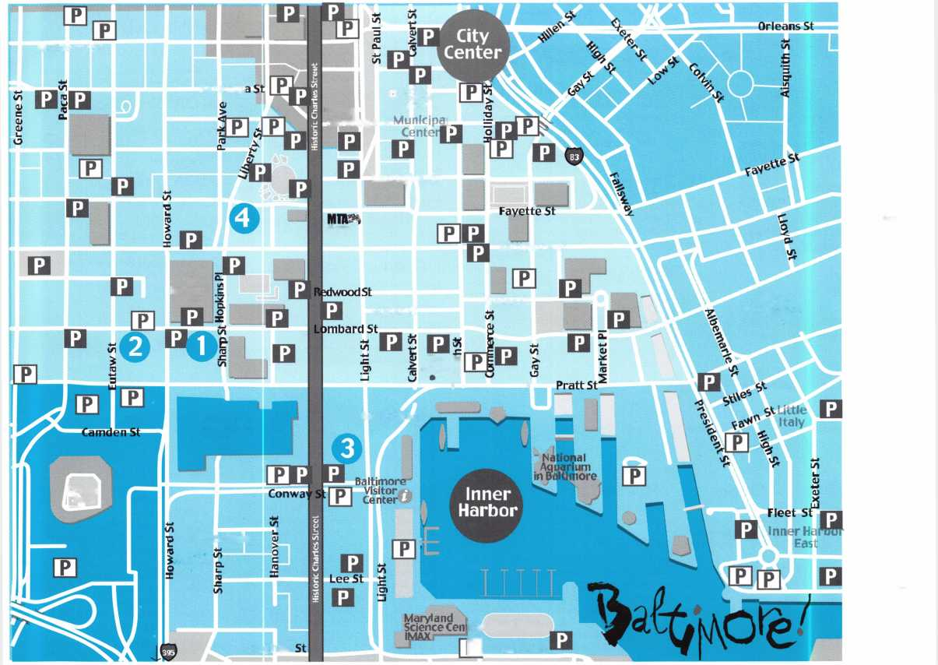

**Convention Registration Form**

**FORM**

**1**

**□ Yes!** I want to advance my career. Please process my ALOA 2004 Registration Form. I understand that ALOA 2004 is a public event and that I may be photographed while attending classes, the Security Expo, and related events.

PLEASE TYPE OR PRINT YOUR INFORMATION

* ALOA Member #
* Non-Member

PRP/STPRP Status: □ RL □ CRL □ CPL □ CML □ CPS

* CMST

Is this your first ALOA Convention? □ Yes □ No

REGISTRANT:

First Name Ml

**Last Name**

**Name for Badge** Company Name Street or PO Box

**City**

**State or Providence** **Zip/Postal Code** **Country** **Work Number** **Home Number** **Fax Number** **E-mail**

Is this an address change? □ Yes □ No

**NON "LOCKSMITH GUESTS** (complete only if attending)

**First/Last Name:**

**First/Last Name:**

Would you like information on sharing hotel room costs? □ Yes □ No

FORM OF PAYMENT:

* Check Number
* Charge: □ H □ 5 □ **m** GH

**Card Account Number:**

**Card Expiration Date:**

**Print Name:**

**Signature:**

PACKAGES/INDIVIDUAL CLASSES

|  |  |  |  |
| --- | --- | --- | --- |
| Before June 18 After June | | | |
| Harbor Package (PKG1) | | | |
| □ Member | $655 | $755 | = |
| □ Nonmember | $925 | $1025 | = |
| Camden Yards Package (PKG2) | | | |
| □ Member | $465 | $535 | = |
| □ Nonmember | $690 | $790 | = |
| Fort McHenry Package (PKG3) | | | |
| □ Member | $170 | $210 | = |
| □ Nonmember | $290 | $330 | = |
| Full-Day Classes (INDF) | | | |
| □ Member | $205 | $245 | = |
|  | x | x | = |
| □ Nonmember | $315  X | $365  X |  |
| Half Day Classes (HALF) |  |  |  |
| □ Member | $80 | $95 |  |
|  | x | x | = |
| □ Nonmember | $120 | $135 |  |

**IF PAYING BY CHECK** Send registration  
forms 1, 2, and 3 with your check to: ALOA  
P.O. Box 972143 • Dallas, TX 75397-2143

**IF PAYING BY CREDIT CARD** Send registration forms 1, 2, and 3  
with your credit card information to: ALOA • 3003 Live Oak •  
Dallas, TX 75204 **-or-** FAX registration forms 1, 2, and 3 with your  
credit card information to: ALOA 214.827.1810

EXPO, MEETINGS, EVALUATIONS AND EVENTS

Before 6/18 After 6/18

EXHIBITS ONLY

* Member (EXH) FREE $10
* Nonmember (EXH) $10 $20
* Non-Locksmith/Guest (EXG) $5 $10

PRP AFTER CLASS ELECTIVE TEST—MEMBERS ONLY

Check a box for each day that you will be taking a PRP elective test after the

class:

* Monday (PCT1) $10
* Tuesday (PCT2) $10
* Wednesday (PCT3) $10
* Thursday (PCT4) $10

PRP EVALUATION (PRP1)

FRIDAY, JULY 23, 2004 • 6-10PM

* Member $35
* Nonmember $190

STPRP Evaluation, CPS (SCPS)

* ALOA/SAVTA Member $ 80
* Nonmember $235

STPRP Evaluation, CMST (SCMS)

* ALOA/SAVTA Member $ 125
* Nonmember $280

Dinner Banquet Only

* With package (BANP) $20 x
* Member/Nonmember (BANQ) $45 x
* Child under 12 (BANC) $30 x

$15

$15

$15

$15

N/A

N/A

N/A

N/A

N/A

N/A

1

ALOA Open Golf Tournament (GOLF)

* Member/Nonmember $150 x
* Shirt Size

Tour (all prices are Per-person) (TOU1)

* George Washington's Mt. Vernon $60 x

Fees and Materials

Lab Fees

* 415 $25 x
* 104, 110, 209, 315 $40 x
* 106 or 206 or 306 $75 x
* 310 $100 x
* 107 $175 x

PRP Resource Guide (PRG)

* Member $20 x
* Nonmember $25 x

Safe Technicians Reference Manual (STRM)

* Member $135
* Nonmember $155

**Membership RENEWAL** If applying for NEW membership, please complete the application (Form 5)

Annual Dues

* Active/Allied Member (us & us **Territories)** (MEM 1) $155
* Active/Allied Int'l Member (MEM3) $130
* Apprentice Member (MEM2) $80
* Retired Member (MEMR) $40
* Canadian Air Mail (AIR1) $20
* Overseas Air Mail (AIR2) $50

Application Fee (APPL) $so **(waived)**

TOTAL AMOUNT:

PAYABLE IN U.S. FUNDS ONLY!

|  |  |  |
| --- | --- | --- |
| Class and Seminar Reaistration Form | | FORM  2 |
| SUBMIT THIS FORM WITH REGISTRATION FORM 1 |  |  |
|  | Review the class descriptions on our website ([www.aloa.org](http://www.aloa.org)) prior to indicating your selection. Due to class limits, mark your first, second and third choices. Multi-day classes are charged as separate classes unless purchased with a package. Be sure to include your lab and/or PRP fees on Registration Form 1. | |
| Name | ALOA Member Number: |  |
| Phone Number: | | |
| Fax Number: | | |
| Email: | | |

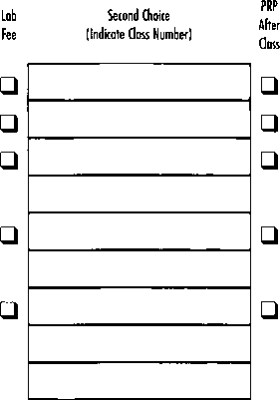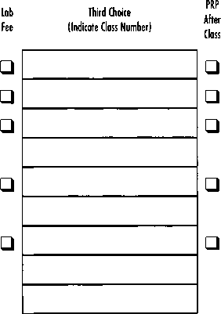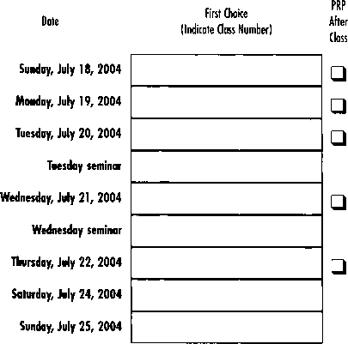

Lab

Fee

□

□

□

□

□



Students may elect to take the exam for the PRP elective designated at the end of the class for an additional fee. PRP  
Certified class exams will take place immediately following the end of class from 5-5:30 pm with 20-30 minutes of  
actual exam time allowed. The single elective exam option is available to pre-registered ALOA members only.

**Proficiency Registration Program**

SUBMIT THIS FORM WITH REGISTRATION FORM 1

**FORM**

**3**

Proof of the PRP certification assures your customer that he/she is dealing with a professional that  
has the education and technical competence to provide safe and efficient service. The PRP separates  
you from those who claim to be professionals but do not have your knowledge or training.

If you plan to participate in the PRP, include the proper PRP fee on the convention registration form,  
complete the PRP registration form.

CANDIDATE (please type or print):

|  |  |  |  |
| --- | --- | --- | --- |
| Last Name: | First Name: |  | Ml: |
| Address: | | | |
| City: | State: | Zip Code: |  |
| Work Phone: | Home Phone: |  |  |
| Social Security Number: | | | |

Have you ever taken the PRP/STPRP before? □ Yes □ No

MEMBERSHIP STATUS:

Application will not be accepted at the member rate without valid current membership  
number.

* ALOA Member Number
* SAVTA Member Number
* Non-member

EVALUATION ALOA 2004 CONVENTION

Level Testing For:

* CRL □ CPL □ CML □ CPS □ CMST

In the listings at right, place a check mark to the left of your choices. Below are descrip-  
tions of each level and its requirements.

**CRL Level:** L-00 + two (2) Electives. Choose the Mandatory and two (2) Electives.

**CPL Level:** CRL + twelve (12) Electives. If you pass the CRL in one try choose any  
twelve (12) Electives. Otherwise, choose any nine (9) Electives. Do not choose any  
Electives you have previously passed.

**CML Level:** CPL + nine (9) Electives. Choose any nine (9) Electives. Do not choose any  
Electives passed previously for CRL or CPL.

**Re-Take CRL Level:** If you did not pass the Mandatory, you must choose the  
Mandatory. You may also take one (1) or two (2) Electives if you did not pass one (1)  
or two (2) Electives, but you may not take extras.

**Re-Take Other Level:** If you passed the Mandatory, choose any nine (9) Electives.

**CPS Level (S-00):** Because of the time required this cannot be taken with any other  
selection.

**CMST Level (S-01):** The first level (S-00) of the STPRP (CPS) must be passed before  
taking the second level (S-01) of the STPRP.

IMPORTANT: PHOTO ID REQUIRED  
FOR ADMITTANCE TO EXAM ROOM.

□ Friday, July 23 • 6-1 Opm

|  |
| --- |
| Note: Application will be returned if choices are not indicated. |
| Select/CAT#/Elective Name  □ L-00: Mandatory Categories |
| □ L-03: Domestic Auto |
| □ L-04: Foreign Auto |
| □ L-05: Door Closers |
| □ L-07: Life Safety Codes |
| □ L-08: Cylinder Servicing, High Security |
| □ L-ll: Cylinder Servicing,Special Application |
| □ L-12: Cylinder Servicing, Tubular Key |
| □ L-13: Basic Electricity |
| □ L-16: Exit Hardware & Alarms |
| □ L-20: Locks, Keyless Mechanical |
| □ L-21: Locks, Lever Other Than Safe Deposit |
| □ L-22: Locks, Motorcycle |
| □ L-24: Locks, Safe Combination Type |
| □ L-25: Locks, Safe Deposit |
| □ L-26: Locks, Time |
| □ L-28: Lockset, Installation |
| □ L-31: Master Keying, Advanced |
| □ L-32: Safe Installation |
| □ L-33: Safe Opening and Servicing |
| □ L-34: Vault Installation and Service |
| □ L-38: Interchangeable Core, Small Format |
| □ L-39: Interchangeable Core, Large Format |
| □ L-40: Electro-mechanical Access Control |
| □ L-41: Hardware, Door-Related |
| □ L-42: Alarms |
| □ L-43: Locks, Detention |
| □ S-00: CPS |
| □ S-01: CMST |

**WARNING:**

**This PRP Registration must be received at ALOA no later than June 18.**

Hotel Reservation Form

**FORM**

**4**

ALOA Convention and Security Expo 2004

July 18-25 • Baltimore, MD

(For Hotel Locations see Map on page 11.

HOTEL INFORMATION:

Arrival Date Departure Date

HOTEL SELECTION: (List three choices in order of preference).

First Second Third

Reservations will be processed on a first come, first serve basis. If all three requested hotels are unavailable, please process this reservation according to:

Comparable room rate □ proximity to conference site

ROOM TYPE:

#Adults to occupy room #beds requested in room

List all room occupants (if children, list names and ages):

Non-smoking room requested □ Special Needs

SEND CONFIRMATION TO:

Last nameFirst NameMl E-mail Address

Daytime Phone Fax

(If number is not within the US, please provide the ENTIRE number the US will need to dial to reach you.)

Company/Institution (if applicable)

Address

City/State/Province Zip/Postal Code/Country

DEPOSIT INFORMATION

All hotels require a credit card guarantee or check deposit of US$160 with each reservation request. Housing Forms received without a deposit or credit card guarantee will be returned.

□ Credit Card

□ □ si □ m □

Card Account Number:

Card Expiration Date:

Print Name:

Signature:

Name of Cardholder:

□ Check enclosed made payable to ALOA 2004 Housing Bureau.

(Separate checks are required for each hotel.)

Please mail checks with an attached Housing Form to:

ALOA/BACVA Housing Bureau, 100 Light Street, 12th Floor, Baltimore, MD 21202.

ALOA 2004

To make reservations,

To reserve a room for the ALOA Meeting choose ONE  
of the following methods:

BY INTERNET

Visit the ALOA website at [www.aloa.org](http://www.aloa.org)  
OR

BY TELEPHONE  
Call the ALOA Call Center

Monday-Friday, 9am-8pm Eastern Time  
888/442-4372 toll free or 630/268-6580  
OR

BY FAX

Fax a completed Housing form to:  
630/268-6575

CONFIRMATIONS

The ALOA Call Center will send you a confirmation.

Review it carefully for accuracy.

If you do not receive a confirmation via e-mail, fax, or  
mail within 14 days after sending request, please con-  
tact the Call Center at 888/442-4372

ROOM RATES/TAXES

In order to take advantage of the special ALOA  
Convention rates, be sure to book your reservation by  
June 24. After that date, the official ALOA blocks will  
be released and the hotels may charge you significant-  
ly higher rates. All rates are per room night and are  
subject to a 12.5% tax (subject to change). Some  
hotels may charge additional fees for rooms with more  
than one occupant. When making reservations, please  
provide room and bedding preferences in the Special  
Needs section of the Housing Form. The hotels will  
assign specific room types upon check in, based upon  
availability.

DEPOSITS

All hotels require a credit card guarantee or check  
deposit of US $160 with each reservation request.  
Requests received without a credit card guarantee or  
check deposit will be returned. Please fill out the credit  
card information entirely or mail a check payable to  
the ALOA/BACVA Housing Bureau.

CHANGES/CANCELS/REFUNDS

Cancellations made after June 5 will be subject to a  
$50.00 cancellation-processing fee.

Changes and cancellations, if necessary, should be  
made through the ALOA call center. Any cancellations  
made after that time will be subject to forfeiture of the  
entire $160.00 deposit.

Only call your hotel directly for changes and cancella-  
tions after the call center closes at midnight on July 12.

Confirmation Number

Do not send this form to the Association. Send to the ALOA/BACVA Housing Bureau. Please use one form per room.  
Make copies as needed. Forms must be completely filled out. Incomplete Forms will be returned and will not be processed.



Avis is Proud to Offer  
Special Rates for:

ALOA 2004 Convention and Security Expo  
July 18-25, 2004  
Baltimore, MD

Avis Worldwide  
Discount (AWD) Number:

B466699

We want to help you enjoy your event more than ever with great  
rates and time saving services. Your special discounts are available  
on a wide selection of vehicles and are good from one week  
before to one week after your event. So take in the sights and  
explore the surroundings.

To reserve a car, contact Avis at 1-800-331-1600 and use your Avis  
Worldwide Discount (AWD) number B466699. Or reserve online  
and have your discount number automatically included in your  
reservation and receive an email confirmation.

**Order Your  
TICKETS Now!**

**ALOA DINNER BANQUET**

Saturday, July 24, 2004 • 7-11 pm

Get it...together, Plug In and Get Connected ! It's ALOA  
LIVE AT POWER PLANT LIVE! A complex so energetic it  
comes with its own exclamation point. Meet us for a  
STREET FESTIVAL at Baltimore's newest and most excit-  
ing entertainment district...Our private party will create a  
memorable event unlike any other yo u ' ve ever experi-  
enced. Join us for wonderful food from four countries  
and lots of entertainment.

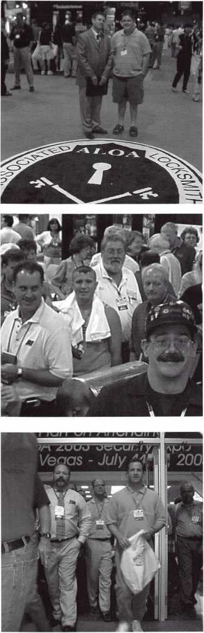

The annual Security Expo

is the icing on the cake  
for ALOA 2004. Each year,  
newly refreshed and edu-  
cated students take to the  
show floor, where hun-  
dreds of exhibitors are  
showing off their latest  
products. Pick them up,  
kick the tires and ask ques-  
tions of the exhibitors  
about their products. It's  
the perfect chance for you  
to learn about new prod-  
ucts that you may sell to  
your own customers as a  
value-added service-and  
you can even take advan-  
tage of show discounts in  
the process! Keep in mind  
all the freebies going  
around, on the show floor  
each year.

The future is unfolding  
right before your eyes.  
Don't pass up the indus-  
try's biggest and best  
show. Come to Vegas this  
year for ALOA's annual  
Convention and Security  
Expo. You won't regret it.

ALOA 2004 SECURITY EXPO

(located in Halls A-C)

**Friday, July 23 • Noon-5pm  
Saturday, July 24 • Noon-5pm  
Sunday, July 25 • Noon-4pm**

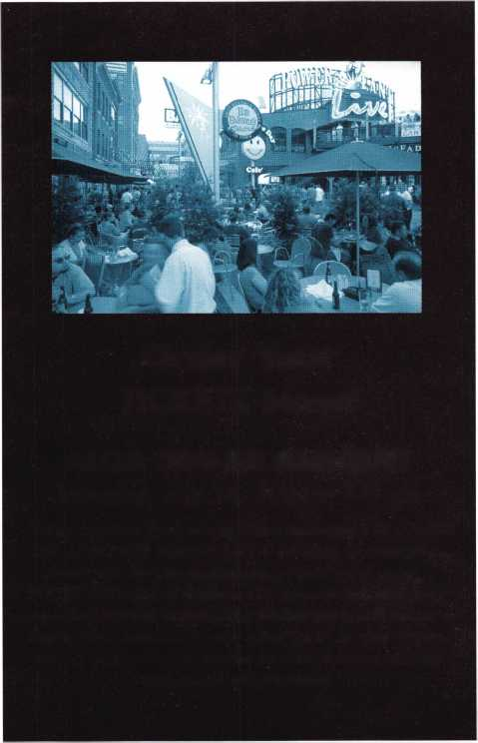

MEMBERSHIP APPLICATION

**FORM**

**5**



Welcome to the Associated Locksmiths of America, Inc., an association for persons involved in the security industry as  
locksmiths, security consultants, educators, manufacturers and distributors.

To apply for membership, please complete this application and submit it with the dues for the current year, and your  
business card, company letterhead, or other suitable proof of employment.

All of the following questions MUST be answered before this application may be processed. Please type or print.

TYPE OF MEMBERSHIP

Please check only one.

* ACTIVE MEMBERSHIP  
  Individuals actively engaged in  
  supplying, servicing, or installing  
  security hardware for a period of  
  not less than two years.
* APPRENTICE MEMBERSHIP  
  Individuals who are in initial train-  
  ing and meet all the requirements  
  for Active Membership except for  
  the length of time in the security  
  industry.
* ALLIED MEMBERSHIP  
  Individuals whose position in the  
  security industry relates to the  
  aims, policies and promotion of  
  the locksmith and his/her craft.

APPLICATION AND FEES

A $50 application fee, appropriate  
annual dues, and your business  
card, company letterhead, or suit-  
able proof of employment must  
accompany this application. Your  
second years dues will be prorated  
based on the date your application  
was received by ALOA.

FINAL CHECKLIST us

Dollars

* Application Fee WAIVED

ANNUAL DUES STRUCTURE

* Active/Allied Member 155.00  
  U.S. + U.S. Territories

(PR, VI, Guam]

* Active/Allied Member 1 30.00  
  Non U.S. Resident or

Non U.S. Territories

* Apprentice Member 80.00

U.S. and International

OTHER FEES

* Canadian Air Mail 20.00
* Overseas Air Mail 50.00

Total Enclosed

**Return to  
ALOA**

**3003 Live Oak Street  
Dallas, TX 75204-6185  
(214)827-1701**

CANDIDATE (PLEASE TYPE OR PRINT)

|  |  |  |
| --- | --- | --- |
| Name O Mr. O Mrs. □ Ms. | | |
| Business Name | | |
| Mailing Address | | |
| City | State Zip Code | Country |
| Work Phone | Home Phone | Fax |
| Email Address | Website |  |
| Date of Birth | Social Security Number |  |
| Directory Address (if different than mailing address) | | |
| City | State Zip Code | Country |
| Q Do Not List in Directory |  |  |
| PROFESSIONAL INFORMATION | |  |
| 1. Are you a...  □ Sole Owner □ Corporate Officer | 4. ALOA Sponsor | 5. Names and addresses of two industry-relat­ed references (required): |
| □ Partner □ Employee □ Student  2. Are you currently employed in the | Sponsor's ALOA Number | Name  Address |
| security industry?  □ no □ yes, years  3. How did you learn locksmithing or security work? | Please note, if you are sponsored by an ALOA member, your application will be immediately processed with a 90-day probation period. Otherwise, final processing takes up to 120 days. | Name  Address |

6. IMPORTANT: Have you ever been convicted of a felony? □ No □ Yes

If yes, please give details on a separate sheet. All felonies are reported to the Membership Department for review.

METHOD OF PAYMENT

□ Check □ MasterCard □ Visa □ Discover □ American Express

|  |  |
| --- | --- |
| Card Number | Expiration Date |
| Please print name as it appears on card |  |

Cardholder's Signature

I certify that all statements are true and, if accepted as a member, I agree to abide by the rules, regulations, and Bylaws of ALOA, and further agree to  
adopt the Code of Ethics of ALOA as my own, and adhere to it to the best of my ability. Should my membership be discontinued, I agree to return my mem-  
bership card, and cease use of all ALOA insignia.

Signature

Date

Revised 03/01/04

1

2

A customer called our shop - Bullet Lock and Safe out of Long Branch, NJ - because he couldn’t open his Megasafe TL-30 Jeweler’s safe. We were referred by Ed Lopez at Megasafe. I met Ed during the Ponderosa trip at the 2002 SAFETECH show in Reno, NV. I called the customer and he told me that he had the combination to the safe, as well as the key, but that it still wouldn’t open. He was only a couple of miles from our shop, so I stopped by his house on my way home that day. What he had was a Vector Jeweler’s TL-30 box with a Mas-Hamilton 50 lock and S&G Key OP (Photo 1). First, I tested the Mas Hamilton 50. After I entered the combo, I turned the dial to the right slow­ly and heard the solenoid make a popping noise. Then I turned the dial further until it stopped completely. I did feel before the dial stopped that it was pulling back the bolt. Next, I tested the key lock, and it sounded and felt like it was pulling back its bolt. I noticed that the three-spoke handle pulled toward me when both locks were opened. That was another sign both locks were working properly. I also noticed that when both locks were opened, the handle would turn a quarter-

inch further.

At that point, my conclusion was that an external relocker had fired, and I explained this to the cus­tomer. He told me that

Megasafe had warned him not to slam the door shut, then admitted to doing just that.

The next day, I called Ed at Megasafe and explained to him what had happened. He supplied me with infor­mation on the external relockers. There are four exter­nal relockers in this safe. My guess as to which one fired was the two farthest from the hinges, because they would be the most likely to vibrate when the door was slammed.

He told me that Megasafe had warned him not to slam the door shut, then admitted to

doing just that.

Keynotes • April 2004

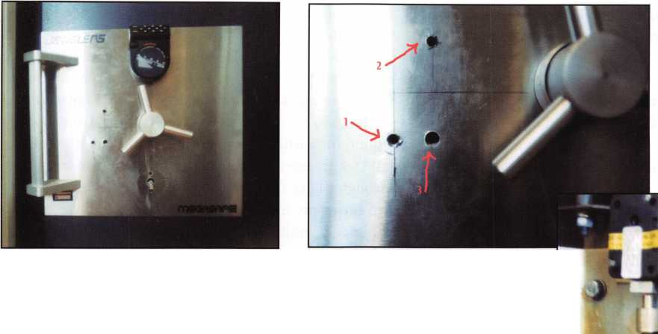

A few days later, when my schedule was free for a while, I headed out with enough equipment to open any safe. The first hole I put in the safe was 5.5 inches left han­dle center and 1.375 inches down(Photo 2, hole #1). This hole would allow us to inspect which relocker fired. I was able to see the lower and upper left relock­ers,(Photo 3) in addition to seeing the key lock and a little bit of the Mas Hamilton. The upper relocker had fired.

I couldn’t see either of the relockers to the right of the handle. On my first hole, I used a quarter-inch Strong Arm bit, and drilled about four inches deep. I decided to do the same for my next hole which I drilled 4.25 inches left handle center and 1.375 inches up to punch or pull back the relocker.(photo 2, hole #2,) Just before I reached the relocker, I hit some tough material, which snapped the tip off my quarter-inch bit. It took

a little bit longer to put this hole through than my first hole. After failing to pull the relocker back, I decided to punch it through. Before completely punching the bolt, I stopped to take a look through my scope hole. What I saw was the top halfway out, but I noticed that the bottom relocker was starting to fire. After looking around for a while, I saw a cable connecting the relock­ers. So it goes. I finished punching the top bolt through. This time, I chucked up a .375-inch strong arm bit in my lever rig and attacked the lower relock- er(photo 2, hole #3). No broken tip this time. I also didn’t attempt pulling the bolt back - just punched it through in three shots of my mallet. With that, the safe was opened.

After inspecting the two remaining relockers (photo 4), I saw what had gone wrong. The cable used was double-wrapped around the relockers. One end led to

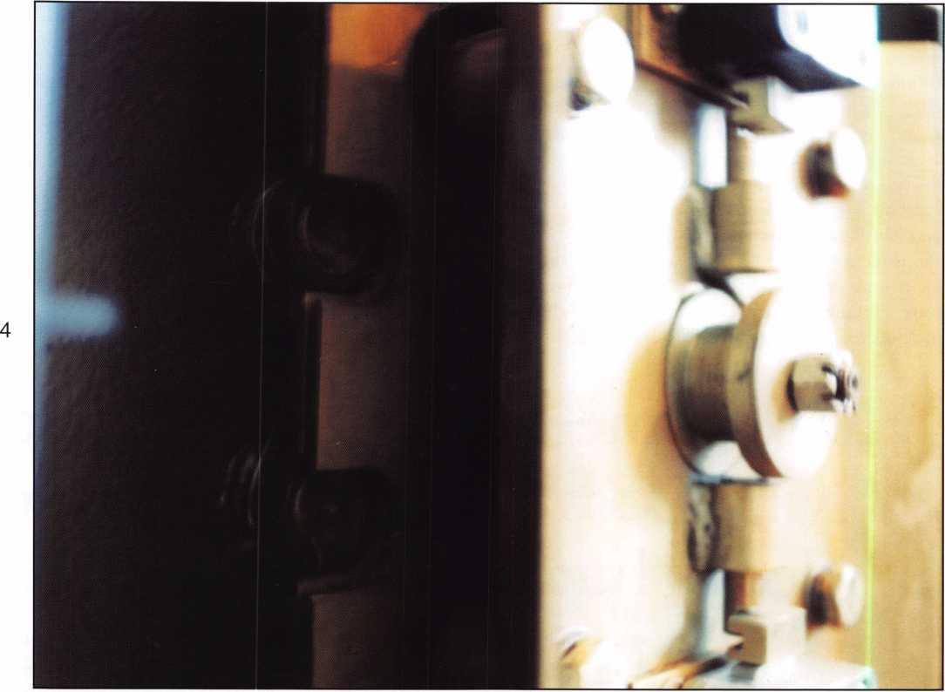

Keynotes • April 2004

the glass, and the other led to a spring, to hold tension. The weld on the spring broke, firing the top relocker. By punching the top relocker, the cable pulled the bot­tom relocker with it.

The door on this safe weighs around 500 pounds (photo 5), and once it gets moving, it is hard to slow down. After going over all the details with the owner, he understood the problem caused by slamming the door, and with that, he promised to close it as gently as possible. Aside from this one problem, I was impressed with the quality of this safe. Drilling for the relockers was time consuming, but having to attack the Mas Hamilton or key lock is a whole other ballgame.

I packed up my tools, took some pictures, collected my fee and drove back to the shop with a feeling of satisfaction - and a sore back.

Next time, maybe I’ll use a Strong Arm mini-rig and I will suggest that when presented with a fired relocker, find a way to pull back the relocker bolt.

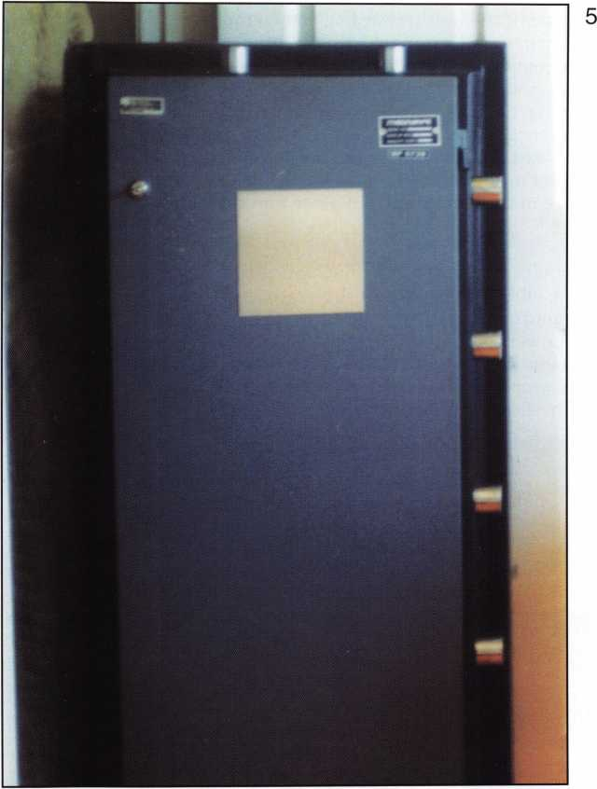

IN-STOCK...MORE SAFES

***FREE Freight Program***

***(30 States)***

AMSEC FireKing

Bavdall **haymaim**

MEILINK **y/CTOR**

**turo** 10

**WHOLESALE SERVICE**

800-848-9790

Keynotes • April 2004

This is one of the most rewarding and confidence-  
building parts of electronic locksmithing. We are  
going to jump in and experience a complete access  
installation while looking at some of the issues we  
may not have thought about when we decided to leap  
into this corner of our profession. This is by no means  
the only way the best way or the most complete way.  
OK, now I’m sounding like a back-pedaling lawyer.  
Let’s dive in and have some fun as we enter the realm  
of E-A-C!

Our client (a law firm) needs a lock on their door  
from the lobby to the back of the office, and they  
don’t want to use any keys. Our first thought is to  
install a mechanical push-button lock (fast, easy  
money) until they says that they want a different code  
for each employee. Bummer! Well, not to fear; there  
are many choices. We’ll just install an electrified push-

button lock (fast, easy and even  
more money). Good thinking,  
because that is a great solution to  
their problem. It’s a lock with  
many user codes, controlled access  
and a clean, simple installation.  
Then the client throws in another  
curve. They want a remote release  
for the receptionist. OK, now  
they’re killing us, and the head  
scratching comes into play. What  
do we do? We have a couple of  
options, with several variants for  
each. We can keep the stand-alone  
lock, but will have to get a wire to  
the lock for the release. This  
increases our time, because now  
we must core drill the door to get  
the wire to the lock. Then, we  
must get the wire over to the  
frame, up the wall and over to the  
receptionist’s desk. Core drilling -  
that causes sweaty palms. What

else can we do? Now we jump into  
our first level of Electronic Access Control (EAC) - a  
hardwired keypad/strike system. No worries, because  
if we look at the equipment and scope of work, we  
save money for the customer and time for us. As a  
bonus, we also have the beginning wiring architecture  
to expand our customers system to the next level - a  
card reader! So we tell them we would recommend a  
keypad on the wall, an electric strike and a release

button under the receptionist’s desk. We give them the price and they say, “Do it.”

NO SWEAT, CHIN UP, LET’S GET STARTED!

What do we need? The stand-alone lock has every­thing included and our recommendation does not. We need to break down the components into a parts list. First, we need a self-contained keypad. (This keypad can control a lock by itself and doesn’t need to go to another circuit board or panel.) Second, we need an unlocking device. (This is what allows us to go through the door.) We have many choices. We can use an electric strike and a storeroom function lock, an electromagnetic lock and release, or an electrified lock. The latter two are much more expensive and require more work. Let’s look at what else we need. We need to power the keypad and strike, as well as a button for the release. Last, but not least, we need wire. OK, let’s get started. Whoa! We need to discuss a couple more things before we jump into this fancy law office.

First, where is this office? Is it a stand-alone building or a high-rise? Are the ceilings in need of plenum wire or not? Do we have drop ceilings (tile)? Do we have the right tools? How does our system hook up? Let’s take these one at a time, and by understanding all aspects of an installation, it will help us in larger, more sophisticated systems. It will also help us in diagnos­ing existing problems. If the office is in a high rise, you need to check with the building management regarding wiring, and if the tenant can even do the project. (This may also be required in stand-alone buildings.) The building management can also tell you if the return air system is ducted or part of the ceiling structure. This will help determine the wire you use. Plenum wire is a special wire encased in a jacket that when burning, doesn’t release a toxic gas, which would enter the return air system and cause problems like regular PVC jacketed wire can. Plenum wire is nearly double the cost of regular wire. So, quote appropriate­ly. I highly recommend running plenum almost exclu­sively; err on the side of safety.

What type of ceiling is crucial in EAC installations?

As we get away from the door and our comfort zone, we need to think out the installation several times prior to getting started. Wire runs can really cause nightmares if we plan poorly, but with good common

Power Source

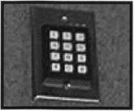

Keypad

Electric Strike

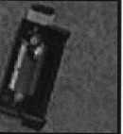

Simple Access Control

By Adam Black, CRL



Keynotes • April 2004

sense and locksmith ingenuity, we can have  
fun with wire pulls. This will also keep our  
costs down. Ceilings are usually either the lift-  
out tiles or solid drywall. (Some older build-  
ings have interlocking tiles, and I recommend  
getting help from the building maintenance  
when working with these.) Most walls in com-  
mercial buildings have metal studs with gyp-  
sum drywall, and are filled with fiberglass insu-  
lation. Interior walls do not always have insu-  
lation, so the walls are hollow. Doorframes, of  
course, are either steel or aluminum (unless  
you’re in an older building or a home remod-  
eled into a business). Looking at our site, it  
has drop ceilings, but insulation in the walls.  
(Pull a light switch cover to see what’s in the  
wall.) Are we ready now? Not quite; tools and  
wire runs are the last two areas we need to  
observe. First the tools - locksmiths love tools

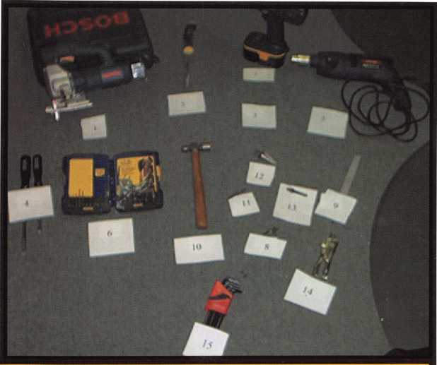

Hardware Installation Tools

i: Jigsaw (for cutting in strikes)

2: Drywall keyhole saw

(Keypad/card reader mounting)

3: Rotary grinding tool (more

tedious installations)

4: Screwdrivers

5: Drill Motor

6: Drill bits

7: Cordless drill

8: Screwdriver bits

9: Files (clean up cuts on frames)

10: Hammer

(Locksmith...enough said)

11: Counter sink bits 12: Step down bits 13: Rotary rasp bits 14: Locking pliers 15: Hex Wrenches

- it could even be said that we are a little obsessive about tools. Well, good news for us, we can tell our significant other we need more tools to start our new area of work. If you already work on safes with elec­tronic locks, you may already have a lot of these tools. Now it is time to get together a short list of the tools and supplies we will need. This list will grow, trust me (and your Visa bill). Let’s group our tools into two lists:

These tools can be found at an electrician’s warehouse or major hardware store; however, I recommend find­ing an Alarm/CCTV wholesaler and getting the tools and supplies from them. Now that we have our tools, all that is left is to write our wiring diagram down and we can finally get started. Our wiring is pretty straightforward on this job. We need a wire from our power source to the keypad, a wire from the strike to the keypad and a wire from the push-button release to the keypad.

Keynotes • April 2004

**2**

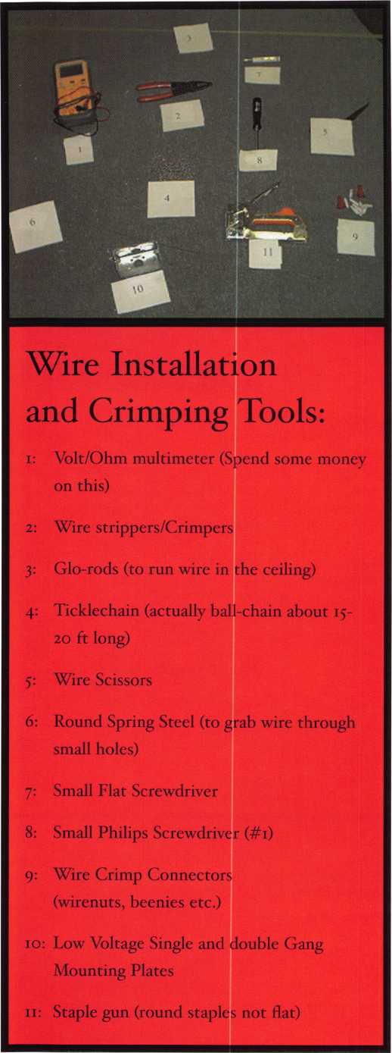

Let’s lay it  
out. What  
type of  
wire will  
we be run-  
ning?

Looking at  
our equip-  
ment, I  
think we  
can use  
two (2)  
conductor  
for all  
three runs.

Second, we need to determine where to put the power  
supply. Let’s use a plug-in transformer. We’ll pick a 1  
amp 12 Vdc transformer. As we have learned in basic  
electricity, our power supply needs to be ample to  
handle the load of all the devices. One amp should  
cover this installation. We will pick an outlet that is  
out of the way and won’t get unplugged. Our client  
has a phone room right behind the receptionist, and  
there are plenty of free outlets. (As you put in more of  
these systems, you will realize how awesome empty  
outlets in the phone room really are.) So, we need to  
run our wire (we will use 18-gauge stranded) up the  
phone room wall over the ceiling tile and down the  
wall to where the keypad will be mounted. I have  
found a clean way to do this: Cut a hole (z”x 1 1/2”)  
beside the outlet and push a Glo-Rod up the hole into  
the ceiling area. (Sometimes this requires drilling a  
hole through the 2x4 cap on top of the wall or cutting  
a hole in the wall above ceiling height if it extends  
past the tiles.) Then take the Glo-rods with the wire  
attached from the starting hole and work them over  
to the wall where the keypad goes. Repeat this  
process to get the wire down to the keypad hole.  
Ideally, we want to mount the keypad next to the  
strike so we can run a short wire to the strike horizon-  
tally instead of up the wall and down again. Finally, we  
run an 18-2 wire over to the reception desk (just like  
the power wire) and cut an access hole to pull the wire  
out from under the desk. We have all our wire run  
(sort of).

Now what? Let’s cut in the electric strike.

Locksmiths, this is what you do! Make us proud! Once

the strike is cut in, run  
your short wire over to  
the keypad hole. Let’s  
review: We have a strike  
cut in and a power wire  
sticking out of the key-  
pad hole and a release

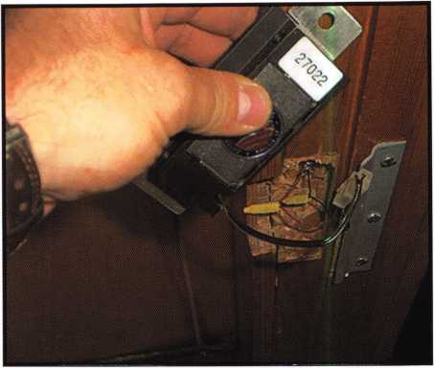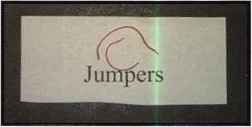

Keynotes • April 2004

.29.95

.19.95

.19.95

.29.95

.29.95

29.95

.79.00

.45.00

.85.00

.19.95

.29.95

.19.95

.29.99

.19.95

.55.00

.39.95

.89.95

.39.95

...25.00

...27.00

...19.95

...39.95

...14.95

...34.95

.45.00

...29.95

.175.00

,175.00

9.95

...99.00 .155.00 .110.00 ...59.95 .110.00 .110.00 ...95.00 ...95.00 ...39.95 ...29.95 ...29,95 ...29.95 ...29.95 ...29.95 .29.95 .29.95 ...29.95 ...29.95 ...29.95 ...29.95 ...29.95 ...99.00 ...99.00 ...29.95 .1 15.00 ...69.95 .14.95 ...27.00 ...25.00

...25.00

.529.00

of Our Titles...

Learn About Basic Electricity

Spacing and Depths, vol 1

Spacing and Depths, vol 2

Filing for Dollars

Antique Padlocks

VATS Made Simple (Revised)

Guide to Transponders

2000 Transponder Update

Bread & Butter

Locks and Lockmakers of America

Learn About Electronic Locking Devices

The Best of Locksmithing, vol 1

Logical Lock Diagnostics

How to Pick Lever Locks

Fundamentals of Master Keying

Guide to Electronic Locksmithing

Security Solutions Locksmith Marketing Program  
The Ultimate Techtips Collection

PRP Resource Guide

Locksmithing from Apprentice

to Master

Wafer Lock Reading

Door Lock Encyclopedia

Lock Repair Manual

Interchangeable Core Cylinders

Picking & Impressioning

The Lure of the Lock

High Security Safes, vol 1

High Security Safes, vol 2

Safeman's Guide, vol 1 3

Safe Deposit Depth and Space Manual

Safe Technician's Reference Manual

Modern Safe Opening

Dave McOmie on Vault Doors, vol 1, Bank Vaults

Dave McOmie on Vault Doors, vol 2, Fire and Plate Vaults ..

Modern Safe Locks

Drilling Safes

Safe Deposit Box Service

Foreign Car Impressioning Book

Impressioning Ford and GM Side Bar Locks

Automotive Lock Servicing Update #1: GM 10-Cut Locks

Automotive Lock Servicing Update #2: GM 10-Cut Locks

Automotive Lock Servicing Update #3: GM 8-Cut Locks

GM Locks: Perfect for the Beginning Locksmith!

Ford Locks: Pin Tumbler and Ten-Cut Systems

Chrysler Pin Tumbler Locks

Chrysler Double-Bitted Locks

Toyota Split-Tumbler Locks

Basic Door Panel Servicing

Advanced Door Panel Servicing

Motorcycles on CD

The Guide to Motorcycles

Japanese High Security Auto Servicing

Revised GM Steering Column Course

Foreign & Domestic Auto Service

Auto Lock Service

The Sieveking Auto Key Guide & Illustrated Cross Reference

Servicing Interchangeable Cores—Sargent

Servicing interchangeable Cores—Arrow, Best,

Eagle, Falcon, and Lockwood

The Ultimate CCTV Program on CD Rom

**Visit our website to view more available titles.**

**Place your order online or by phone today!  
[www.aloa.org](http://www.aloa.org) • (214) 827-1701 • Please allow 3-4 weeks for delivery.**



button wire sticking out as well. Hook-up time is  
upon us. Let’s cover those holes we cut at the power  
supply wire and release button wire with coax cable  
plates. (They have a 3/8” hole, which is perfect for the  
wire, and will leave it looking quite clean.) For the  
keypad mounting, we will use a single gang low voltage  
mounting plate, so we will have to cut out the drywall  
for a snug fit for the plate. With our holes either cov-  
ered or cut to the correct size, we can now connect all  
the wires. Use your new fancy wire strippers and strip  
back a couple of inches of the PVC jacket and about a  
1” of the two inner wires. Do this with all three wires  
coming into the keypad hole. Make yourself a couple  
of jumpers using about 2-3”

of the left-  
over wire  
and strip  
off 1” from  
each end  
of the  
jumper.  
Let’s start  
hooking  
up. (Oh  
boy, isn’t  
this excit-  
ing?)

At the  
strike,  
connect  
the black

wire coming from the keypad to the black wire from the strike. Or if the strike has no wire leads, connect it to the negative side. Then repeat with the red/white wire. Hook up the same at the transformer and the release button (The release button can be hooked up either way, because there is no polarity.) Once all of these are connected, we will jump into hooking up the keypad. Take a break; wipe the ceiling dust and fiber­glass insulation out of your hair. (If you have any — I don’t.)

What’s the central most important part of EAC? Relays! Relays are like light switches in that they con­trol the flow of power. Relays send or remove power to our locks. It is so important to understand relays. This will ease your fears and help troubleshoot future problems with access control. Relays generally have two options: “normally closed” and normally open.” Normally closed means the flow is “on” in its resting state and reverse for “normally open.” Which to choose? For failsafe locks (magnets and electric bolts), we use “normally closed” as they require power in the resting state (non-energized) to stay locked. For fail secure locks (electric strikes and electrified locks), we hook up to “normally open,” as they require no power

in the resting state (non-energized). Electric strikes  
and locks can be failsafe also. Our strike is fail secure,  
so we will use “normally open” on the relay. Here is  
the tricky part: If you grasp this, all access control is  
downhill from here. Most relays are dry! (OK, they’re  
all dry!) This “dry” means there is no power going  
through them. We need to add power. Wow! We hap-  
pen to have two wires giving us power from our power  
supply. Hold on folks! We need that power for our  
keypad; we should have run four conductors. Yes you  
could have, but not to worry, you made two jumpers  
just for such an occasion. Let’s hook up the red wire  
from the power supply to the positive (+) input on the  
keypad and add the red (+) from the strike to the same  
input. Let’s put the black wire from the power supply  
to the negative (-) input on the keypad and will add on  
one side of the jumper...oops. That’s why we have two  
jumpers. Take the one leg of the new jumper and put  
it on the negative (-) input on the keypad. Big fun!

Home stretch is upon us. Take the black wire from  
the strike and hook it up to the “normally open” input  
on the keypad, and take the other side of the jumper  
and attach it to the common input of the keypad.

Last, but not least, attach the two wires from the  
release button to the release inputs (commonly called  
“request to exit” or REX). Make sure all your connec-  
tions are attached tightly, and the install the keypad to  
both the wall and the strike in the frame. Plug in the  
transformer and check out the strike. It should still be  
locked. (The relay is not energized). Now try the  
default code that came with your keypad and the  
strike should release. Pretty cool, huh? Now try the  
release button and make sure everything is working  
well. (Some keypads require programming to get the  
REX to work, so check your programming directions.)  
Install your storeroom lock and boom — you have  
done it! Understanding these simple (I hope) instruc-  
tions will help you with most all of your future instal-  
lations and repairs. Even the real big jobs have very  
similar installation techniques. If we understand how

relays and strikes  
work, we can  
diagnose if either  
is malfunctioning,  
or if the cleaning  
person unplugged  
the transformer.

See you soon as  
we jump into the  
next level of  
Electronic Access  
Control.

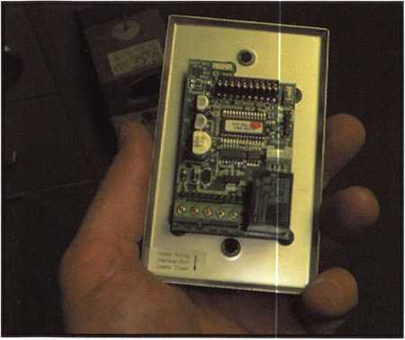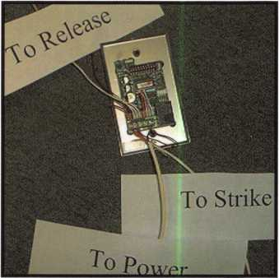

Keynotes • April 2004

LOCKS, SAFES and SECURITY Electronic Infobase now available at the ***ALOA Store*** at an ALOA member discount

LSS+ is the ELECTRONIC INFOBASE edition of Locks, Safes, and Security. Locks, Safes, and Security is a treatise on the history, technology and bypass of locks and safes. It provides extremely detailed information for locksmiths and law enforcement professionals. It is comprised of FIVE volumes (LOCKSMITH VERSION) that contain as many as 4000 new images, enhanced graphics, and approximately forty hours of audio and video.

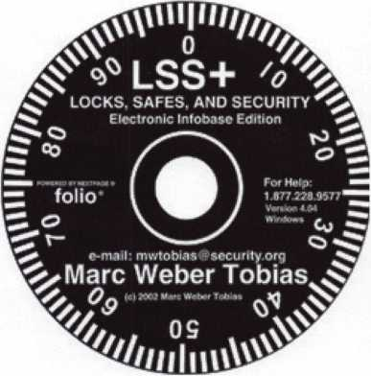

Extensive materials on forensic investigations, forced entry, and bypass of high security locks have been included. There are four books contained within the INFOBASE, including two treatises on locks and safes that were written at the height of the industrial revolution in England.

LSS+ utilizes a sophisticated search engine to instantly access the information contained within the INFOBASE. There are three security levels: PUBLIC, LOCKSMITH, and GOVERNMENT. Many chapters of the book have been expanded with text, graphics, and multimedia.

A preview copy of LSS+ is available to ALOA locksmiths. If you wish to order a preview copy, please call 800-532-2562 x23 or e- mail [orders@aloa.org](mailto:orders@aloa.org) and provide your ALOA member number. Once installed, you may view the contents for three days, without limitation. The default security level is Two, which provides access to materials restricted to locksmiths. This disk actually contains information for all security levels, but has been restricted to allow Level One and Two access only. No registration is required to preview the contents. This disk will only run on one computer after installation, without uninstalling all files. If you decide to buy the LSS+ Locksmith level collection, the other disks will be sent to you, together with a case for the preview disk. You must receive the full set prior to registration. ALOA will issue a product serial number to you prior to shipment..

After you purchase LSS+, you must pre-register at securitv.org and provide the product serial number and invoice number to prove authenticity. You can then register your copy by e-mail or by phone.

You may share your preview copy of LSS+ with others that may be interested.

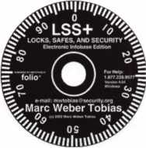

LOCKS, SAFES and SECURITY on CDRom now available at the ***ALOA Store*** at an ALOA member discount

**:i •' • <;•**

Automotive Locksmithing

Exploring Ford’s VCM

By Tom Seroogy



Keynotes • April 2004

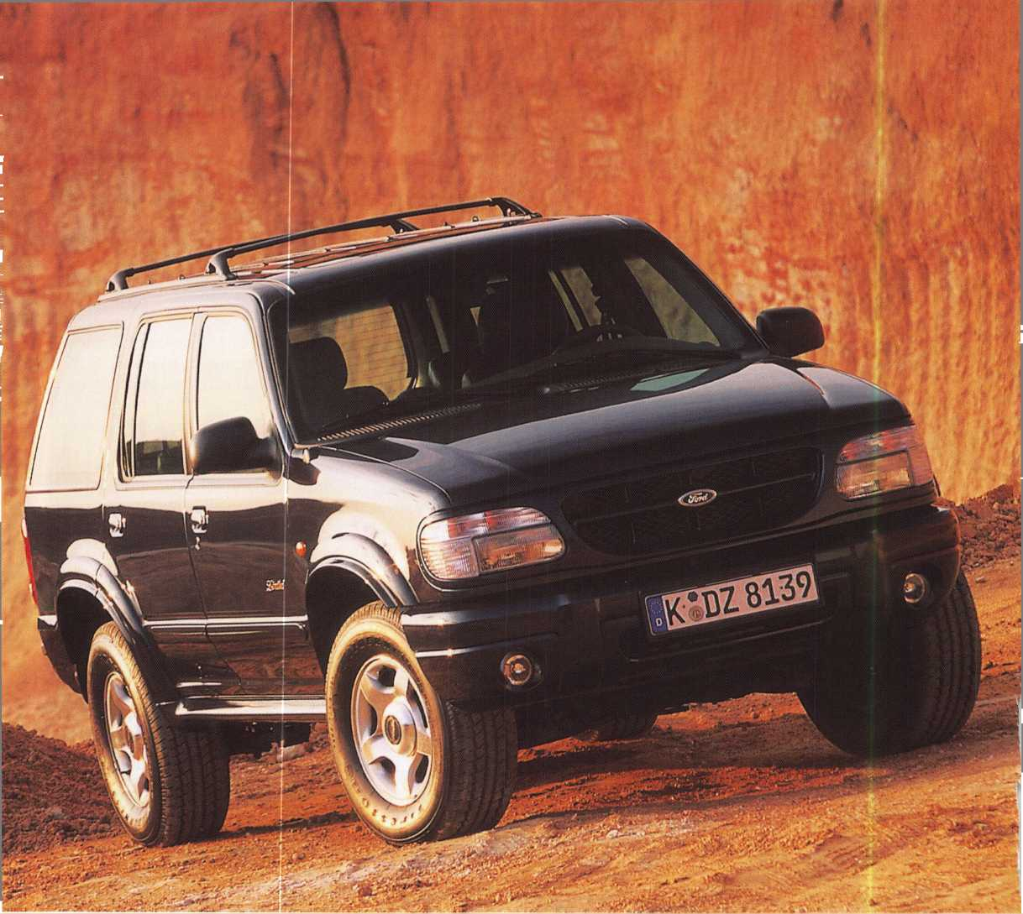

In following the recent and upcoming changes to the automo­tive technologies, it wouldn’t be fair to leave out Ford Rotunda’s Vehicle Communication Module, or “VCM.” Like Hickok Inc.’s CAN VIM, the VCM is designed to allow the NGS to program the CAN-equipped Ford vehicles. Unlike Hickok’s CAN VIM, the VCM is available through Ford deal­ers only, and costs from $2000 to $2500. This is nearly the price of a complete new NGS XL that includes Hickok’s CAN VIM, and four times the amount of the CAN VIM purchased alone. Despite the differences in price, a few locksmiths have found the VCM beneficial enough to make the purchase. Let’s talk about some of the major program differences found between the original NGS and the NGS with the VCM.

The vehicle used for our demonstration is a 2004 Ford Explorer. The only visible exterior lock on this vehicle is on the front driver’s side door (photo 3). The ignition lock is the newer style STRATTEC 707592, or BWD LC8008 (photo 4). The key is the STRATTEC 599114, commonly referred to as the “Jewel Key.” Like the CAN VIM, the VCM replaces the lower programming module of the NGS. Simply remove the old module and plug in the VCM (photos 5 and 6). Although one of the touted benefits of the Rotunda VCM is that it will program all Ford products back to 1996 (regardless of system protocol), I did not find this to be the case. In all cases, the VCM worked only where the vehicle was equipped with a CAN system, and had to be swapped with the older module when programming older protocol vehicles. Whether this fail­ure was due to a faulty machine, operator error or faulty infor­mation was not able to be determined before the printing of this article.

Programming with this tool is very similar to the standard NGS and NGS+, with the exception of menu changes and the need for only one card to perform both the SERVICE and DIAGNOSTIC functions. Until the introduction of the CAN system, programming keys required the use of the GREEN SERVICE card and the following five simple steps:

1. SERVICE BAY FUNCTION
2. Select the proper module (PATS, HEC, PCM, SCLM, ICM, or SCIL).
3. ENTER SECURITY ACCESS
4. Select the vehicle being serviced.
5. Select the desired key function

As you’ll soon see, the newer system includes a much longer menu tree.

To begin, simply plug the unit into the vehicle’s DLC. On the 2004 Explorer, the DLC has changed locations, and is now found near the left knee in a small cavity just above the engine compartment hood release (photos 7 and 8). Once connected, the NGS powers up, displaying the familiar initialization screen (photo 9). From here, however, the menus vary dramat­ically from the original and well-known NGS menus. In fact, the very first menu displays both diagnostic and service func­tions (photo 10). From there, it’s a seven-step process through the menu tree:

1. VEHICLE SYSTEM DIAGNOSTIC (photo 11)
2. SECURITY (photo 12)
3. PATS (photo 13)
4. Select module - in the case of the Explorer it’s the PCM (photo 14)
5. FUNCTION TESTS (photo 15)
6. ENTER SECURITY ACCESS (followed by 10-minute delay) (photos 16-18)
7. Key program functions (photo 19).

For the most part, the menu choices are no more difficult to follow than the older version. However, some points should be made. Under the SECURITY option, two choices were given - PATS and PERIMETER THEFT. While PATS refers to the well-known Passive Anti Theft System (or transponder sys­tem), PERIMETER THEFT refers to the keyless remote and alarm system (or Vehicle Theft System), and displays the IDs of the remotes that are programmed into the vehicle. Also, unlike the older NGS version, in which it is necessary to choose the module where the PATS function is stored, the newer system includes PATS as a menu item and the module is not chosen until later in the menu. In this case, PCM was the only module displayed in the menu, making choosing the correct module very easy. The final key program function menu is identical to the older NGS system, making program­ming a bit more familiar (photos 19-20).

1. IGNITION KEY CODE PROGRAM
2. IGNITION KEY CODE ERASE
3. SPARE KEY SWITCH ENABLE
4. SPARE KEY SWITCH DISABLE
5. SET UNLIMITED TRANSPONDER KEY
6. UNLIMITED KEY MODE ENABLE
7. UNLIMITED KEY MODE DISABLE

Keynotes • April 2004

**33**

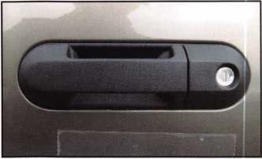

3. The only visible exterior lock is on the front driver's door handle.

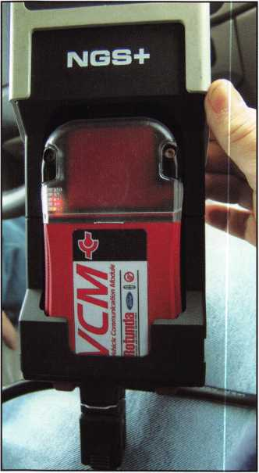

6. The Ford Rotunda Vehicle Communication Module or VCM.

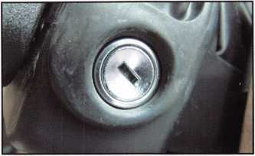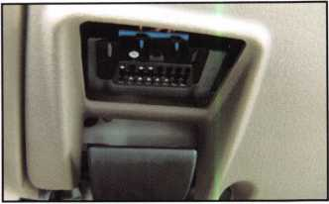

4. The ignition is the STATTEC 707592 or BWD LC8008U. The key is STRATTEC 599114

5.The DLC is located just above the engine hood release.

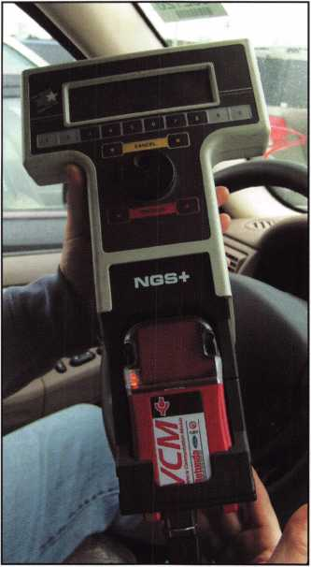

8. Connect the NGS to the DLC.

7. The VCM replaces the standard NGS base.

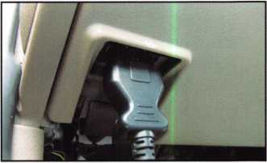

Like all newer vehicles using the STRATTEC 599114 or Jewel Key, the Unlimited Key function is available. However, while the original menu item is the same - SET UNLIMITED TRANSPONDER KEY - the following menu for choosing the Unlimited Key password is much different (photos 21-22). Finally, like all other key programming functions, if the IGNI­

TION KEY CODE ERASE option is chosen, two new keys must be programmed into the vehicle (photo 23). I hope this gives you a better understanding of the quickly-changing tech­nologies out there. See you next time.

Tom Seroogy can be contacted at [tgseroogy@hotmail.com](mailto:tgseroogy@hotmail.com).



Keynotes • April 2004

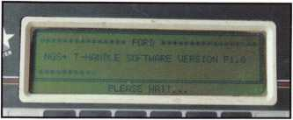

9. System initialization.

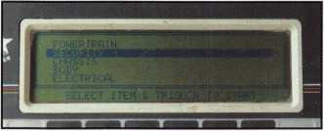

1 2. Security

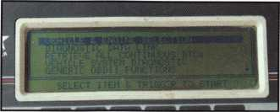

10. First menu is already different and includes both SERVICE and DIAGNOSTIC options.

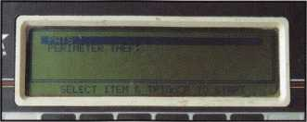

13. PATS — Passive anti-theft system

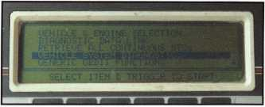

11. Vehicle System Diagnostic

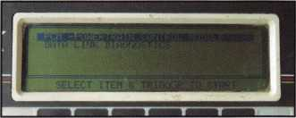

14. Select correct module. In this instance, PCM.

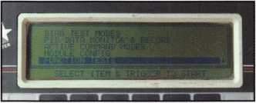

15. Function Tests

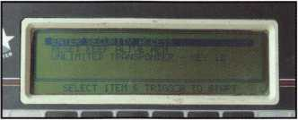

16. Enter Security Access

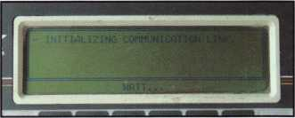

17. Initializing communication with the PCM module.

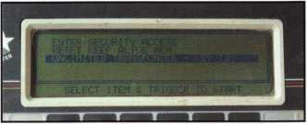

18. Enter Security Access successfully entered.

19. Well-known menu after 10-minute securi­ty delay.

21. Unlimited Key Function

22. A complete new Password menu for the Unlimited Key Function

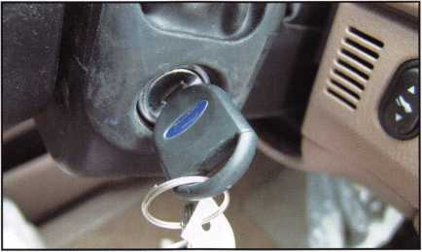

23. Completing the key programming.

Keynotes • April 2004

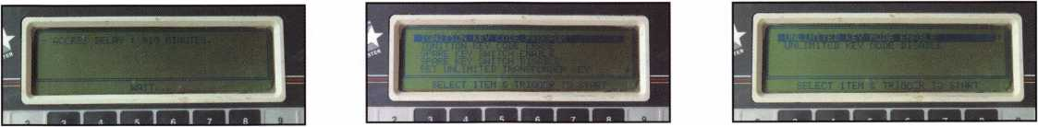

THE ALOA

IN MAY

WHAT’S IN STORE FOR MEMBERS

The ALOA Board of Directors will hold its Spring Board Meeting May 7-8, 2004, at the Sheraton Nashville, in Nashville, TN. On both days, the Board will meet at the hotel from 8 a.m. to 6 p.m., with scheduled breaks. All ALOA members are encouraged to attend. The ALOA Board Meeting will feature an agenda picking up where the last meeting left off. What follows is a full report from the last meeting:

ALOA held its Fall Board meeting in Portland, OR, last October in conjunction with the Pacific Locksmith Association’s annual Pacific Locksmith Conference. The ALOA board felt that it was important to hold the regular fall meeting at such an industry- related event so that the all could interact with the other lock­smiths attending the PLA show. Also, this allowed the local membership the opportunity to attend the ALOA meetings and observe the inner workings of our association, if they so desired.

President Bill Young, CML, famously used wise leadership and humor (in the form of a Referee’s Uniform) to lead the Board through such complex topics as shop certification, director visi­tation, communications with members, web site changes, 50th anniversary celebrations in 2006, Bylaws changes, corporate membership, hands-on PRP testing, advertising, marketing, com­mittee assignments and reports, and a brief executive session.

A report was given by Board member Tom Lynch, concerning new marketing approaches and advertising methods for ALOA. During this report, the suggestion was made to implement a new program targeting students and geared to persuading them to pursue a career in the physical security industry. This would involve educational incentives in the form of free or greatly discounted cost of ACE classes for children of members.

This proposal was taken under advisement by the staff to determine its feasibility.

Among the committee meetings held was a workshop on the proposed shop certification, chaired by committee chairman, Hans Mejlshede CML. Shop certification is a new program being considered by the ALOA Board. This proposal is well described in the October, 2003 issue of Keynotes.

Another committee report given was by Bob Mock, chairman of the ALOA Hall of Fame Committee. Bob and his committee are hard at work compiling a list of persons and their accomplish­ments that have been important to ALOA and our industry. When complete, the results will be displayed on the ALOA web site ([www.aloa.org](http://www.aloa.org)). Bob and his committee were given the addi­tional duty of planning the 50th anniversary celebration at the 2006 convention.

At the banquet for the Pacific Locksmith Conference, President Young was the keynote speaker. He spoke of what ALOA was currently doing and his vision for the future. All board members present had a great time and enjoyed the fellowship and great hospitality of the area locksmiths.

Following a short meeting to finish up some pending business, the ALOA Board attended the Pacific Locksmith Association Trade Show. The board members mixed with the many lock­smiths and vendors present. It is a policy of the ALOA board to take every opportunity to talk and listen to the members of our industry wherever we meet.

By consensus, the ALOA Board considered this meeting in Portland to be a success. Under the leadership of President Bill Young, the meeting was concluded on schedule. The common feeling among the members was that this was a most productive board meeting. All members of the board left Portland with a renewed feeling of optimism for ALOA and the physical security industry.

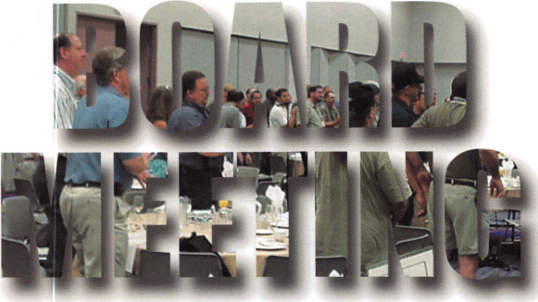

There will be a ispccial meeting ofllie membership in June of this year. The direc-

tors for the association, and to vote on proposed changes to the bylaws. The date qfThemee^ ballot­

ing will be in next month’s Keynotes, The same information will be posted on AL6l^^eb site (www.aloajg^ffhc proxy (ballot) can be printed from the web site or photocopied out of Keynotes. Ballots will be mailed to menders overseas because of the long delay in delivery of Keynotes. Candidates who have filed to fill vacande^are listed below. Ainography and picture of each candidate will be in the next issue of Keynotes, and on the ALOA web site. Jr

John Soderland

N.W. Director

Jim Jeffries

Robert "Bob" Mock Vernon Kelley John C. Magee, III Peter Sarailian

C.D. Lipscomb

Asian Director

No candidate

Director

Hans Mejlshede

Michael Elsberry

The following proposed bylaws changes will appear on the ballot for the special meeting of the membership to be held in June. An explanation of what the changes are, what they mean and why the Board thought the changes are necessary is included with each of the proposed changes.

Proposed Bylaws Change 1.

At this time, any member who has been active for the prior three years can serve as President or Secretary of the Association. The intent of this proposed change to the bylaws is to require that whoever shall serve as an officer of ALOA shall have recent experience on the Board. This will help to ensure that the officer has the ability to adequately discharge the duties for which he or she was elected.

ARTICLE V - OFFICERS, Section 2. - Election and Term of Office.

Election and Term of Office. The officers shall be elected by the voting members for a two year term. A person may serve as the President of the corporation for no more than one (1) term, and may serve as the Secretary for no more than three (3) consecutive terms. The President shall be elected in odd-numbered years and the Secretary in even- numbered years at a special meeting of the members. They shall serve until their successors have been duly elected and qualified. Candidates for offices shall be nominated in accordance with policies adopted by the Board of Directors. [The candidates for the office of President and Secretary must be a sitting Board member or must have served on the Board within the previous 3 years. - added]

Proposed Bylaws Change 2.

The current bylaws specify that the President shall preside over all meetings of the Board and shall be the Chairman of the Board. The intent of the following bylaws change is to allow the Board of Directors the ability to elect a Chairman of the Board, or presiding officer, who might, or might not be, the President.

ARTICLE V - OFFICERS, Section 5. - President.

The President shall be responsible for the integrity of the Board of Directors’ governance in accordance with policies adopted by the Board. [He or she shall preside at all meet­ings of the Board of Directors, and shall be the Chairman of the Board. - deleted] He or she may sign, with the Secretary, any deeds, mortgages, contracts, or other instruments which the Board of Directors has authorized to be executed, except in cases where the signing and execution thereof shall be expressly delegated by the Board of Directors or by these Bylaws or by statute to some other officer or agent of the corporation.”

Proposed Bylaws Change 3.

The intent of the following resolution is to reduce the term of the trustees to four years rather than the six year term that now exists. The Presidents of ALOA have typically served on the Board for a number of years prior to their election. We now require them to serve an additional six years. This is, in some cases, an excessive requirement that is difficult for the past Presidents to comply with.

ARTICLE VIII - BOARD OF TRUSTEES

The corporation shall have a Board of Trustees composed of the [three- deleted] two most recent past Presidents of the corporation. Trustees may attend all Board Meetings to serve as advisors to the Board.”

**3**

Keynotes • April 2003

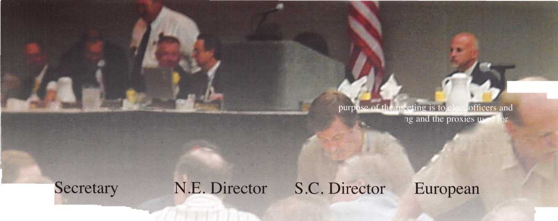

g i s I a t i date

v

e

State Legislation

Rhode Island

Senate Bill 2930 has been introduced and is currently in the Commerce, Housing & Municipal Government Committee. The bill would require the licensing of lock­smiths. ALOA is currently working to ensure the bill winds up as close to our Model Law as possible.

Ohio: I am currently working hard on House Bill 396.

This bill would seek to license contractors and license all low voltage work. It also is currently set up where coun­ties may be able to add on registration fees. I have been in contact with Representative

McGregor's office about possible amendments and will continue to monitor the situation until it is resolved in the best interest of locksmiths.

Texas

Our committee is currently working on the structure of the continuing education component located in the Texas reg­istration bill. This will be one of the major things dis­cussed in our upcoming March 25th meeting.

New Jersey

I will be in New Jersey for the East Coast Regional Locksmith Convention in mid-April. It is at this time that I will also have a meeting at the State House to show ALOA's support for the upcoming legislation and make sure all is going well.

Florida

Recently two bills were introduced in the Florida House (H 775) and Senate (S 2088). Each bill relates to fire alarm system contractors and provides criminal penalties for installing, servicing, testing, repairing, improving, or inspecting a fire alarm system without a license. ALOA is reviewing the legislation to ensure that all definitions do not effect the work that a locksmith can perform.

Federal Legislation

Motor Vehicle Right to Repair Act

I recently attended the National Automotive Service Task Force (NASTF) meeting in Detroit, Ml. The manufacturers are well aware of the locksmiths concerns and make every effort to talk about how interested they are to help us achieve our goals of duplicating and originating keys. To reach this goal, there has been a proposed meeting for early May. If all goes well, representatives from all the major manufacturers will attend. Some may not be able to make it in person, but will hopefully at least be there via teleconference or video conference. A representative

from the EPA will also be in attendance. We see this as a good chance to finally get everyone on the same page.

In other news, our coalition has recently wrapped up its 87th Co-Sponsor! After talking with Aaron Lowe of the coalition in Detroit, I have a very good feeling that The Motor Vehicle Right to Repair Act will reach the floor of the House before the end of this session.

We have also recently acquired a Senate Sponsor and have finally begun the process of adding Senators to the Co-Sponsor list.

Keynotes • April 2004

Association Health Plan Legislation

Senate Task Force on the Uninsured Deliberates

Members of the Senate Republican Task Force on the Uninsured, which was established last October to develop solutions to the problem of the more than 40 million Americans who lack health insurance coverage, contin­ued its deliberations. However, there is no firm indication from Senators or staff involved with the Task Force's activi­ties as to what type of action the Task Force may take, or when it may act. Such decisions have not yet been made by the Task Force Chair, Senator Judd Gregg (R-NH), and his colleagues. Congressional staff involved with the activ­ities of the Task Force indicate that the primary focus at this time is for the Senators to fully understand the many obstacles to obtaining health insurance. The focus is expected to shift at some point to the various options for solutions to the problem. The Association Health Plan leg­islation (Small Business Health Fairness Act of 2003 - S. 545) continues to be under consideration because of the bill's potential to expand health coverage to small employers who do not currently offer health benefits to their workers due to excessive cost. Numerous meetings have been held in Washington, DC, with Senators and staff on the Task Force to discuss the merits of the AHP legislation. However, it remains unclear as to whether the Task Force will develop a legislative proposal that would be brought up in the Senate for a vote this year, or whether it will merely issue a set of principles aimed at guiding the development of legislation.

Meanwhile, President Bush continued his efforts to get the Senate to take up and approve the AHP legislation. The President's Fiscal Year 2005 Budget Proposal to Congress, released in early February, reiterated the President's support for the bill with the following message:

Building on his success in strengthening health care secu­rity for seniors through landmark reforms in Medicare, the President remains committed to securing the enactment of Association Health Plan (AHP) legislation. By allowing small businesses to join together to purchase health cover­age, AHPs would make it easier and more affordable for small employers to provide health insurance coverage for their employees and would give millions more working Americans access to health benefits.

This is the first time that the President's formal budget pro­posal to Congress has discussed the AHP legislation. In addition, President Bush states his strong support for the AHP bill whenever he discusses his domestic health care agenda in speeches around the nation. Bush's strong sup­port for the AHP bill may be starting to pay dividends, as

more and more Republican Senators are taking a more thorough look at the legislation. ALOA's Coalition commends President Bush for his strong leadership for the cause!

LEGISLATIVE  
ACTION NETWORK

You’re a professional locksmith,  
not a professional lobbyist.

You can’t be on the steps of every state capitol and walking the halls of the federal government to protect your profession, but...

WE CAN!

The ALOA Legislative Action Network (LAN) needs Your support for the Voice of Our Profession.

The ALOA Legislative Action Network is constantly working to influence legislation that’s important to the locksmithing profes­sion. We are working in your best interests to promote legislation that will have a positive impact on our proud profession; while preventing or limiting legislative efforts that are harmful. To contin­ue, we need your help to ensure the success of our legislative program for 2004!

If you contribute $25-$99.99 to the Legislative Action Fund, you automatically become a member of the Legislative Action Network (LAN). The LAN is an important tool in raising the standards of our profession through the legislative process by making sure that locksmiths have the final say in how our industry will be run. As a LAN member, you will receive:

* The Legislative Action Network Update alerting you to impor­tant legislation in your state and around the country.
* Networking opportunities with ALOA members who share the belief that legislative involvement is important to the effective­ness of our association.
* A listing of your state representatives and senators including capital and district addresses, and phone and fax numbers on both hard copy and disk.
* A comprehensive guide to lobbying in your state capital, so you can be the "voice of ALOA" to legislators.
* LAN stationary and envelopes for sending official letters to leg­islators, lobbying on ALOA’s behalf.
* A lapel pin designating you as a special ALOA LAN member,
* Recognition in Keynotes magazine.
* An invitation to an exclusive reception at the annual ALOA con­vention for LAN members.

When you donate $100 or more, you become part of the heart of the legislative program through LAN membership and receive the following:

* A reserved place of distinction on the special LAN Council
* Discounts on ALOA bookstore items and a 10 % rebate on all ACE classes.
* Complimentary Legislative Convention merchandise.
* It’s easy to do Your part...just join TODAY!!

NOTE: Contributions or gifts to the Associated Locksmiths of America, Inc. are not tax deductible as charitable contributions or as business expenses under IRC - 162(e).



Keynotes • April 2002

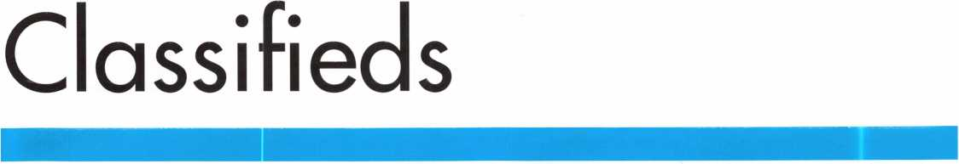

EMPLOYMENT

FKI SECURITY GROUP SEEKS QUALIFIED

TECHNICIANS FOR

NEW FIELD SERVICE DIVISION

In response to continuing and growing demand for field service, FKI Security Group has established the FKI Field Services division to support NKL Cash Handling products and is seeking qualified technicians in major metro markets. Technicians will support business development and new service contracts for NKL Cash Handling, which include electronic bill-counters or validators, dis­pensing safes and access control safes. Each field technician will be equipped with a state of the art communications system and all the necessary parts and tools to service all of FKIis securi­ty products.

The markets currently open are, Baltimore/ Washington DC, New Jersey/Metro New York, North/Central Ohio, Dallas, Houston, Orlando/ Central Florida, Northern California, Sacramento/ East Bay, Southern California, Phoenix

Highly competitive compensation and a complete benefits pack­age including health, dental, and vision insurance, 40IK plan, and fully paid expenses will be offered to qualified technicians. Technicians with the experience servicing safes, locks, ATMs or POS systems will be considered. This position can grow into a management position as the division expands.

Interested parties should contact Christina Lyell at 800-457-2424 or e-mail your resume to [chrisl@fkisecuritygroup.com](mailto:chrisl@fkisecuritygroup.com)"



SECURITY GROUP

101 Security Parkway • New Albany, IN 47150

WANTED

Experienced Locksmith. Established and expanding company in central New Jersey is seeking experienced help in residential/commercial/ auto/access control/safe work. Top pay for top mechanics along with medical, dental, paid vacation, no night calls. Call 732-970-1500, or fax resume to 732-970- 9725, attn. Andy or Jack.

PROFESSIONAL EXPERIENCED TECHNICIAN(S) WANTED:

We are in need of 1 to 2 technicians with the ability to Sell, Install, and Service all major mfg. Hardware. We are located in Knoxville, Tennessee and service all areas of east and middle Tennessee. Must have a clean criminal and driving record.

Must have professional attitude and appearance. Background check and References must be supplied. Must be experienced in commercial, industrial, and residential hardware sales, service and installations. Access and other areas is a plus.

Paid Holidays, Retirement, Health insurance,

uniforms, tools and truck supplied. 8-5pm Monday thru Friday.

Ph# 800-484-5577, pin 0841

Fax# 865-637-2359

E-Mail: [info@fmgeorge.com](mailto:info@fmgeorge.com)

STOP LOOKING!!

EXPERIENCED TECHNICIANS WANTED

Lock into your future now! If you are experienced, intelligent, and desire a secure future, come join our team. We are a full service commercial/residential security service (locks, keys, safes, CCTV, access control, door-related hardware). We offer top wages, company vehicle, 401k, paid vacation, paid holi­days, new uniforms, cross training, and job satisfaction. We are looking for the best techs, who are ready to be treated and com­pensated as professionals.

Bass Security Services, Inc.

216-755-1200, XI28

Fax 216-755-1220

e-mail: [rmesnick@bass-security.com](mailto:rmesnick@bass-security.com)

EXPERIENCED LOCKSMITH WANTED

Harris County is seeking an experienced Locksmith For informa­tion please see website

<http://co.harris.tx.us/hrrm>

Or call (713) 755-5906 all applications must be applied in per­son • 1310 Prairie, 2nd floor, Houston, Texas 77002

LIVE AND WORK IN PARADISE!

A 20-year-old mobile business that has not yet peaked - owner retiring. Located in beautiful Lake Arrowhead, CA. State-of-the-art 2003 GMC AWD 2500 Savannah Van. ITL950C computerized code key machine. Rytan RY100 high-speed key machine. Office furniture, notebook, computer and equipment. Commercial and residential accounts. Can also include 3BR/3BA lake view home. Serious inquiries only, please. I AM NOT PARTING THIS OUT. 909/337-8254 cell 909/295-3310

BRANCH MANAGEMENT MANAGER

Safemasters, an established company, has an outstanding oppor­tunity in the Boston area for a results driven manager with a proven record. Preferred candidate will have, supervisory and admin skills, strong people skills, P&L exp.& sales ability. Responsibilities include directing & motivating a growing team including locksmiths and dispatch & inventory, and growing the market through sales, productivity & profits.

Prior experience in physical security, alarms, access control, or locksmith field helpful.

Our associates enjoy an equitable salary plan plus generous incentive and bonus plans for results oriented managers, and comprehensive benefit plans including 401 (k) and company matching plan. If you have a proven record and are looking for a company that both supports and encourages associates, forward your resume with salary history today.

Safemasters - Operations #93 Email: [hr2@safemasters.com](mailto:hr2@safemasters.com) FAX: 800-233-2454 attn. Bryan Shaffer - #93 Voice Mail: 800-295-4702 xl54

JOIN OUR PROUD TEAM!

The Broward County Sheriff's Office Is Hiring in Sunny South Florida!

Besides our location in paradise, South Florida is a mecca of cul­ture, beautiful beaches, and recreational advantages. Join our 5,000-member team, America's largest nationally accredited Sheriff's department, and enjoy the excitement and benefits of South Florida living including No State Income Tax!

MAINTENANCE SPECIALIST (Locksmith)

$29,731 - $43,926

In this position, you will perform a wide variety of locksmith and general trade related duties in a detention facility environment. This may include installation, maintenance and repair work involving highly sophisticated state-of-the-art systems designed to support effective and efficient corrections operations. Qualifications include a high school diploma or equivalent (GED), three years experience and/or training in locksmith work, a valid Florida's driver's license.

Department of Motor Vehicles certified seven (7) year driving his­tory dated within one month of application date required with application. If you're qualified and interested in building a great career in South Florida, please contact us at 888-BSO-STAR or visitvrww.sheriff.org. EOE M/F/D/V DFWP

BSO is an equal opportunity employer and does not discriminate based on age, citizenship status, color, disability, marital status, national origin, race, religion, sex, or sexual orientation. Veterans' preference per Florida law.

Classified Advertising Policy

Classified advertising space is provided free of charge to ALOA members, and for a fee of $.60 per word, $15 minimum for non-members. Classified ads may be used  
to advertise used merchandise and overstocked items for sale, "wanted to buy" items, business opportunities, employment opportunities/positions wanted and the like.  
Members or non-members wishing to advertise services or new merchandise for sale may purchase a "Commercial Classified Ad," for a fee of $1.30 per word, with a  
minimum of $40. Each ad will run for two issues. For blind boxes there is a $5 charge to members and non-members. All ads must be submitted in writing to the ALOA  
office by the fifteenth of the month, two months prior to issue date. Send to Keynotes Classifieds, 3003 Live Oak St., Dallas TX 75204-6186. ALOA reserves the right to  
refuse any classified advertisement that it deems inappropriate according to the stated purpose of the classified advertising section.

FOR HIRE

Product Manager

Kaba llco Corp., the world leader in the manufacture of key blanks, key cutting machines, and replacement cylinders, is seeking a Product Manager, responsible for the strategic direc­tion and marketing of automotive transponder keys and equip­ment. The ideal candidate will possess a strong understanding of automotive diagnostics and automotive key generation and programming.

Responsibilities:

Direct and perform all aspects of product development, prod­uct changes and product promotions.

Manage and communicate sales and technical information for internal and external business customers.

Develop and maintain a pricing program that balances com­petitive challenges and at the same time meets revenue growth and profit objectives.

Prepare the marketing plans for assigned product lines and recommend changes to meet market and competitive condi­tions.

Conduct field test of product software and hardware to insure market needs are met and design training programs for distri­bution and end users to understand the applications of each.

Leads internal research efforts to identify automotive and secu­rity trends pertaining to the product line.

Managing all elements of the product line support require­ments including merchandising, advertising, literature, website information, etc.

Skills/Education:

* Four year degree in Business Administration, Marketing or related technical field.
* Minimum of four years experience as Product/Brand Manager/Engineer for a technical product related to auto­motive diagnostics or automotive security.
* Strong written and oral communication skills.
* Proven ability to prepare and implement business plans and strategic assessments.
* Must have proficient Microsoft Office Suite experience in Excel, Word, PowerPoint

Interested candidates may send their resume with salary histo­ry in confidence to:

Human Resource Department, Kaba llco Corp., P.O. Box 2627, Rocky Mount, NC 27802, fax: 252-446-4702, or e- mail to [resume@irm.kaba.com](mailto:resume@irm.kaba.com) An EOE M/F/H/V.

WANTED TO BUY/SELL

FOR SALE

Original Schlage blanks in 5-pin EF keyway or 6-pin in CE, EF, FG or G keyway at $12.50 per box of 50. Contact George Thomas at 218-724-3416 or write to 825 Woodlandd Ave., Duluth MN 55812-2168

WANTED TO BUY

Safemasters Co. Inc. is seeking to acquire an additional locksmith business in the greater Boston area. If you are an owner and would like to explore the possibility of selling your business, we would be interested in talking with you. Confidentiality assured. Contact Bryan Shaffer at [hr2@safemasters.com](mailto:hr2@safemasters.com), or voicemail 800.295.4702 (ext. 154).

WHOLESALE SAFE DEPOSIT LOCKS

Allied, Diebold, Herrin, Hall & Mavin, llco, Lefabure, Mosler, Precission, S&G, Security Corp., Yale. Locks from early 1900s to current. Call or email for lock type and pricing sheet. Quantity discounts. Call WBI at (954)484-2404 or email: [sales@wbi.us](mailto:sales@wbi.us)

FOR SALE

Mobile Locksmiths Business. 2002 Freightliner Sprinter. HPC Code Machine and code books, extra cutters. Lots of tools. Many years in area. Growing business. Buy and go to work, completely ready. Located in NE Maryland. Call 888/339-5625.

Priced to sell quickly. ALOA Member.

FOR SALE

Owner retired. Framon Model 2 w/ manual and Scotsman Model 747XU w/ manual.

Like new. Reed code books 1, 2, 3, 4 and 5. Call 919/676- 8490.

WANTED TO BUY

Automotive transponder equipment wanted. Triax machine, T- Code, TCL, EDTJr., RW2,

A-l Pack-a-Punch. Call 877/41 1-5397 and ask for Bob.

FOR SALE

Abloy Dislock key machine and all equipment needed to serv­ice Abloy locks and padlocks. Included are discs, master discs and spacers for rekeying; service kits; books, instruction books, and misc. info is also included. Abloy Dislock locks, new and used, with key blanks and many parts and service equipment too numerous to mention. Please call for details: 267-337-0975. E-mail: [bdstevenso@aol.com](mailto:bdstevenso@aol.com).

FOR SALE

Used Equipment. Here is just a sample (call for dimensions of items): Tann TL-30 Composite, RS, $1000. Two Major TL-30 plate safes with small interior safe right swing, $500. Collier TL-15 plate left swing, empty, $1000. Mosler UL Class 350 fire door right swing, $950. Mosler TR TL, interior has five lockers and two shelves, $2500. Collier Class 2 vault door, right swing, $2000. Diebold Cash Guard, TL-15 with four lockers, $600. Used night depositories, safe deposit boxes, lockers, etc. Prices do not include shipping. [www.thistlesafe.com](http://www.thistlesafe.com). Call 781-324-1600. E-mail [thistlenl@aol.com](mailto:thistlenl@aol.com). Service and rigging available to manufac­turers and dealers for the greater Boston area.

FOR SALE: FULLY-EQUIPPED LOCKSMITH VAN

1998 Ford Encoline E-150, 81,679 miles, new tires, tinted windows. Key machines, inverter, wooden workbench, cabi­nets, pegboard, basic locksmithing tools and complete set of car opening tools, all included. Call 319-266-7486 for more info, or e-mail [polkslock@cfu.net](mailto:polkslock@cfu.net).

FOR SALE

28 year-old established, well-equipped mobile locksmith busi­ness available due to age and health. Metro Denver. Contact for details: phone: 303-759-75000 • Fax: 303-730-2264 e- mail: [stanl926@gwest.net](mailto:stanl926@gwest.net)

BLUE PUNCH

key machine #BP201, set up to cut Best "A" key blanks. Like new. $375. Call 972/727-2780.

BUSINESS FOR SALE

BUSINESS FOR SALE

A small, quite successful business for sale in south Orange County, California. Three Rytan machines, three HPC code machines, HPC code books, coding program, tools for "luxu­ry" vehicle lockouts - all parts, tools and supplies to keep two trucks on the road full time. One truck on the road provides $10-1 IK per month. Truck, which is the Ford F250 van with advertising signage, built-in work areas and cabinetry - can be part of the package or purchased separately. Low operating costs after 10 years of building the business. Advertising expenses 10 years ago? $4K per month. Now we pay a fifth of that. This is a nice set-up for someone to step in and take over. Existing accounts (which bring in about $8200/month include three in property management and eight auto dealer­ships. We'll work to set you up with our existing accounts.

All reasonable offers will be considered.

Call 949/370-9619, or fax 949/458-1733.

MOBILE LOCKSMITH BUSINESS FOR SALE

Speedex duplicator, van, tools, code books, two HPC code machines (Blitz), inventory, some hardware. $6000 (firm).

Call 601/916-6448.

LOCKSMITH FRANCHISE AVAILABLE

Low cost, complete training, national Franchise call (925) 260-7373 • [www.SpeedyLocksmiths.com](http://www.SpeedyLocksmiths.com) .

CENTRAL OREGON COAST

Well-established Lock Shop with 50 -mille AAA Contract, 24- hour Mobile Van Service, Commercial, Residential and Turn- Key Auto Shop. No pun intended! Owners will train and/or assist with the transition of this busy shop with a great location on Highway 101 in the heart of Coos Bay. Cash or contract terms. Call Realty Solutions LLC • Ellie Cairy 503-620-5533

SMALL MOM-AND-POP

locksmith and glass business for sale in Golden Valley, AZ. Retirement is forced for health reasons.

On busy US Highway 68. Golden Valley is between Kingman, AZ, and Laughlin, NV. In fast-growing Mohave County. Leased shop. Dodge Ram Van 2500. Both well-equipped and stocked. $65K plus equipment and inventory. Asking $48,900. All rea­sonable offers will be considered. New money only. Call 928/565-2294 or e-mail inquiries to [lmburks@ctaz.com](mailto:lmburks@ctaz.com).



SAFE CORPORATION

MANUFACTURES OF QUALITY DEPOSITORY SAFES AND CHESTS

DISTRIBUTING FROM

WAREHOUSES IN

* LOS ANGLES, CA
* CHICAGO**>,** IL
* GLASSBORO, NJ

A & B is now a stocking distributor

for Mutual Safes

featuring

AB-4-30-3S AB-9-2 WS 10-2

Chose from over 75 models in stock

We ship your order within

24 hours

See us

*at [www.a-bsafecorp.com](http://www.a-bsafecorp.com)*800-253-1267  
Fax 856-863-1208

CALL FOR YOUR  
CATALOG TODAY

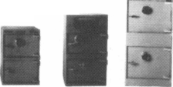

Distributor

**ADi Inc**

Phone: 631-692-1000 Fax: 631-692-301 1

**Accredited Lock Supply Co.**

Phone: 201-865-5015 Fax: 201-865-0030 [www.acclock.com](http://www.acclock.com)

**Ace Lock &**

**Security Supply**

Phone: 908-688-7666 Fax: 908-688-2442 [www.acelock.com](http://www.acelock.com)

**Andrews Wholesale Lock Supply**

Phone: 717-272-7422 Fax: 717-274-8659 [www.andrewslock.com](http://www.andrewslock.com)

**Boyle & Chase Inc.**

Phone: 800-325-2530 Fax: 800-205-3500 [www.boyleandchase.com](http://www.boyleandchase.com)

**Chinrose International**

Phone: 503-357-7553 Fax: 503-357-5522 [www.chinrose.com](http://www.chinrose.com)

**Clark Security Products**

Phone: 800-854-2088 Fax: 619-974-5284 [www.clarksecurity.com](http://www.clarksecurity.com)

**Cook's Building Specialties**

Phone: 505-883-5701 Fax: 505-883-5704

**Dire's Lock & Key Company**

Phone: 303-294-0176 Fax: 303-294-0198

**Direct Security Supply Inc.**

Phone: 800-252-5757 Fax: 800-452-8600

**Doyle Security Products**

Phone: 800-333-6953 Fax: 612-521-0166 [www.doylesecurity.com](http://www.doylesecurity.com)

**Dugmore and Duncan, Inc.**

Phone: 888-384-6673 Fax: 888-329-3846

**E. L. Reinhardt Co., Inc.**

Phone: 800-328-1311 Fax: 651-481-0166 [www.elreinhardt.com](http://www.elreinhardt.com)

**Ewert Wholesale Hardware**

Phone: 800-451-0200 Fax: 708-597-0881

**Fairway Supply, Inc.**

Phone: 214-350-0021 Fax: 214-352-4299 [www.fairwaysupply.com](http://www.fairwaysupply.com)

**Foley-Belsaw Company**

Phone: 800-821-3452 Fax: 816-483-5010 [www.foley-belsaw.com](http://www.foley-belsaw.com)

**Fried Brothers Inc.**

Phone: 800-523-2924 Fax: 215-592-1255 [www.fbisecurity.com](http://www.fbisecurity.com)

**H L Flake Co.**

Phone: 800-231-4105 Fax: 713-926-3399 [www.hlflake.com](http://www.hlflake.com)

**H.S. & S. Wholesale Distrib.**

Phone: 313-342-6777 Fax: 313-342-7580

**Hans Johnsen Company**

Phone: 214-879-1550 Fax: 214-879-1530 [www.hjc.com](http://www.hjc.com)

**Hardware Agencies, Ltd.**

Phone: 416-462-1921 [www.hardwareagencies.com](http://www.hardwareagencies.com)

**IDN Incorporated**

Phone: 817-421-5470 Fax: 817-421-5468 [www.idn-inc.com](http://www.idn-inc.com)

**Intermountain Lock & Supply**

Phone: 800-453-5386 Fax: 801-485-7205 [www.intermountainlock.com](http://www.intermountainlock.com)

**Jo Van Distributors**

Phone: 416-752-2238 Fax: 416-752-7282 [www.jovanlock.com](http://www.jovanlock.com)

**KeylessRide**

Phone: 877-619-3136 Fax: 409-216-5058 [www.keylessride.com](http://www.keylessride.com)

**Lockmasters, Inc.**

Phone: 859-885-6041 Fax: 859-885-7093 [www.lockmasters.com](http://www.lockmasters.com)

**Locks Company**

Phone: 800-288-0801 Fax: 305-949-3619

**Locksmith Ledger international**

Phone: 770-886-0800 Fax: 770-889-7703 [www.lledger.com](http://www.lledger.com)

**M. Zion Company**

Phone: 212-349-8677 Fax: 212-964-0495 [www.mzion.com](http://www.mzion.com)

**McDonald Dash Locksmith Supply**

Phone: 800-238-7541 Fax: 901-366-0005 [www.mcdonalddash.com](http://www.mcdonalddash.com)

**McManus**

**Locksmith Supply, Inc.**

Phone: 704-333-9112 Fax: 704-332-8664

**Monaco Lock Co.**

Phone: 800-526-6094 Fax: 800-845-5625 [www.monacolock.com](http://www.monacolock.com)

**Omaha**

**Wholesale Hardware**

Phone: 800-238-4566 Fax: 402-444-1664 [www.omahawh.com](http://www.omahawh.com)

**Phoenix Safe International LLC**

Phone: 765-483-0954 Fax: 765-483-0962 [www.phoenixsafeusa.com](http://www.phoenixsafeusa.com)

**Professional Business Products**

Phone: 248-360-3979 Fax: 248-360-3982 [www.professionalbusinessprod- ucts](http://www.professionalbusinessprod-ucts).

**RA-Lock Company**

Phone: 972-775-6301 Fax: 972-775-6316 [www.ralock.com](http://www.ralock.com)

**S J Hope Products**

Phone: 702-260-7645 Fax: 702-837-1465

**SNA Inc.**

Phone: 678-206-0381 Fax: 678-206-0382 [www.sungil-safe.com](http://www.sungil-safe.com)

**SecureRite.Com**

Phone: 800-241-3930 Fax: 858-974-5269 [www.SecureRite.Corn](http://www.SecureRite.Corn)

**Security House**

Phone: 905-669-5300 Fax: 905-660-6313 [www.securityhouselock.com](http://www.securityhouselock.com)

**Security Lock Distributors**

Phone: 800-847-5625

Fax: 800-878-6400

[www.securitylockdistributors.com](http://www.securitylockdistributors.com)

**Sentry Security Fasteners**

Phone: 309-693-2800 Fax: 800-693-2872

**Somerset Security Products**

Phone: 800-881-5206 Fax: 800-206-9949

**Southern Lock and Supply Co.**

Phone: 727-541-5536 Fax: 727-544-8278 [www.southernlock.com](http://www.southernlock.com)

**Stone & Berg Wholesale**

Phone: 800-225-7405 Fax: 800-535-5625

**The Locksmith Store Inc.**

Phone: 847-364-51 1 1 Fax: 847-364-5125 [www.locksmithstore.com](http://www.locksmithstore.com)

**Timemaster Inc.**

Phone: 859-259-1878 Fax: 859-255-0298 [www.time-master.com](http://www.time-master.com)

**Top Notch Distributors, Inc.**

Phone: 800-233-4210 Fax: 800-854-4146 www. 4 to p n otc h. co m

**Turn 10 Wholesale**

Phone: 800-848-9790 Fax: 800-391-4553

**U.S. Lock Corp.**

Phone: 800-925-5000 Fax: 800-338-5625 [www.uslock.com](http://www.uslock.com)

**Wilco Supply**

Phone: 800-745-5450 Fax: 510-653-5397 [www.wilcosupply.com](http://www.wilcosupply.com)

Manufacturer

**A & B Safe Corporation**

Phone: 800-253-1267 Fax: 856-863-1208 [www.a-bsafecorp.com](http://www.a-bsafecorp.com)

**ABUS Lock Company**

Phone: 800-352-2287 Fax: 602-516-9934 [www.abus.com](http://www.abus.com)

**Abloy Door Security**

Phone: 800-465-5761 Fax: 514-335-0430 [www.abloy.com](http://www.abloy.com)

**Adams Rite Mfg Company**

Phone: 800-872-3267 Fax: 800-232-7329 [www.adamsrite.com](http://www.adamsrite.com)

**Adesco Safe Mfg. Company**

Phone: 800-694-9340 Fax: 562-408-6427 [www.adesco.com](http://www.adesco.com)

**Adrian Steel Company**

Phone: 800-677-2726 Fax: 517-265-5834 [www.adriansteel.com](http://www.adriansteel.com)

**Alarm Lock Systems Inc.**

Phone: 800-252-5625 Fax: 516-789-3383 [www.alarmlock.com](http://www.alarmlock.com)

**All Five Tool Company, Inc.**

Phone: 860-583-1691 Fax: 860-583-4516 [www.all5tool.com](http://www.all5tool.com)

**American Lock Company**

Phone: 708-534-2000 Fax: 708-534-0531 [www.armericanlock.com](http://www.armericanlock.com)

**American Security Products**

Phone: 909-685-9680X1083 Fax: 909-685-9685 [www.amsecusa.com](http://www.amsecusa.com)

**BWD Automotive**

Phone: 334-872-6524 Fax: 334-874-6011 [www.bwdautomotive.com](http://www.bwdautomotive.com)

**Baldwin Hardware**

Phone: 610-796-4012 Fax: 610-796-4493 [www.baldwinhardware.com](http://www.baldwinhardware.com)

**Be-Tech Security Systems Ltd.**

Phone: 852-231-67447 [www.be-tech.com.hk](http://www.be-tech.com.hk)

**Bianchi USA, Inc.**

Phone: 800-891-2118 Fax: 216-803-0202

**Buddy Products**

Phone: 800-886-8688 Fax: 312-733-8356 [www.buddyproducts.com](http://www.buddyproducts.com)

**CCL Security Products**

Phone: 800-733-8588 Fax: 847-537-1800

**COMPX Security Products**

Phone: 864-297-6655 Fax: 864-297-9987 [www.nclnet.com](http://www.nclnet.com)

**Curtis Industries,**

**A Barnes Distr.**

Phone: 800-555-5397 Fax: 800-867-6020 [www.curtisindustries.com](http://www.curtisindustries.com)



Keynotes • April 2004

associate

members

**D&D Technologies (USA), Inc.**

Phone: 714-677-1300X292 Fax: 714-677-1299 [www.ddtechusa.com](http://www.ddtechusa.com)

**DETEX Corporation**

Phone: 800-729-3839 Fax: 830-620-6711 [www.detex.com](http://www.detex.com)

**DORMA Architectural Hardware**

Phone: 717-336-3881 Fax: 717-336-3500 [www.dorma-usa.com](http://www.dorma-usa.com)

**Datakey Electronics**

Phone: 800-328-8828 Fax: 866-289-4212 [www.datakeyelectronics.com](http://www.datakeyelectronics.com)

**Don-Jo**

**Manufacturing, Inc.**

Phone: 978-422-3213 Fax: 978-422-3467 [www.don-jo.com](http://www.don-jo.com)

**Door Controls International**

Phone: 800-742-3634 Fax: 800-742-0410 [www.doorcontrols.com](http://www.doorcontrols.com)

**ESP Lock Products Inc.**

Phone: 978-562-3481 Fax: 978-562-9859

**FireKing Security Products**

Phone: 800-457-2424 Fax: 800-896-6606 [www.fireking.com](http://www.fireking.com)

**Framon Manufacturing Company Inc**

Phone: 989-354-5623 Fax: 989-354-4238 [www.framon.com](http://www.framon.com)

**HES, Inc.**

Phone: 623-582-4626 Fax: 623-582-4641 [www.hesinnovations.com](http://www.hesinnovations.com)

**HPC, Inc.**

Phone: 847-671-6280 Fax: 847-671-6343 [www.hpcworld.com](http://www.hpcworld.com)

**HY-KO Products Co.**

Phone: 440-232-8223X3095 Fax: 440-232-8227

**Hongtai Lock Co Ltd**

Phone: 137-238-1414 Fax: 208-793-3856

**INTELLIKEY Corp.**

Phone: 800-226-0703 Fax: 321-724-081 1 [www.intellikey.com](http://www.intellikey.com)

**Jet Hardware Mfg., Co.**

Phone: 718-257-9600 Fax: 718-257-0973 [www.jetkeys.com](http://www.jetkeys.com)

**KABA High Security Locks**

Phone: 860-621-3601 Fax: 860-621-9727 www. kabausa .com

**KABA ILCO Corp.**

Phone: 252-446-3321 Fax: 252-446-4702 [www.kaba-ilco.com](http://www.kaba-ilco.com)

**KEY-BAK/West Coast Chain Mfg**

Phone: 909-923-7800 Fax: 909-923-0024 [www.keybak.com](http://www.keybak.com)

**Keri Systems Inc**

Phone: 408-451-2520 Fax: 408-441-0309 [www.kerisys.com](http://www.kerisys.com)

**Knaack Manufacturing Co.**

Phone: 800-456-7865 Fax: 815-459-9097 [www.weatherguard.com](http://www.weatherguard.com)

**LAB Security**

Phone: 800-243-8242 Fax: 860-583-7838 [www.labpins.com](http://www.labpins.com)

**LCN Closers/**

**Div. of Ingersoll**

Phone: 815-875-331 1 Fax: 815-879-1497 [www.lcnclosers.com](http://www.lcnclosers.com)

**La Gard Inc.**

Phone: 310-325-5670 Fax: 310-325-5615 [www.lagard.com](http://www.lagard.com)

**Lock America, Inc. Dba**

1. **A.I. Gro**

Phone: 714-373-2993 Fax: 714-373-2998 [www.laigroup.com](http://www.laigroup.com)

**Lucky Line Products, Inc.**

Phone: 858-549-6699 Fax: 858-549-3241 [www.luckyline.com](http://www.luckyline.com)

**M.** **A.G. Security**

Phone: 714-891-5100 Fax: 714-892-6845 [www.magsecurity.com](http://www.magsecurity.com)

**MARKS, U.S.A.**

Phone: 516-225-5400 Fax: 516-225-6136 [www.marksusa.com](http://www.marksusa.com)

**MARRAY ENTERPRISES**

Phone: 408-970-0213 Fax: 408-970-8767 [www.marray.com](http://www.marray.com)

**MCS Communication Systems**

Phone: 450-444-2040X225 Fax: 450-444-4856 [www.mcscommunication.com](http://www.mcscommunication.com)

**MMD, Inc.**

Phone: 865-428-361 1 Fax: 865-453-4136

**MUL-T-LOCK USA, Inc.**

Phone: 800-562-351 1 Fax: 973-778-4007 [www.mul-t-lock.com](http://www.mul-t-lock.com)

**Master Lock Company**

Phone: 414-444-2800 Fax: 414-444-0322 [www.masterlock.com](http://www.masterlock.com)

**Medeco Security Locks**

Phone: 540-380-5000 Fax: 540-380-5010 [www.medeco.com](http://www.medeco.com)

**Mustang Company**

Phone: 574-674-0053 Fax: 574-675-9603

**NKL Industries Inc.**

Phone: 800-528-9900 Fax: 757-485-0271 [www.nklindustries.com/prod- ucts_NK](http://www.nklindustries.com/prod-ucts_NK)

**OSI Security Devices**

Phone: 619-628-1000 Fax: 619-628-1001 [www.omnilock.com](http://www.omnilock.com)

**Pro Steel**

Phone: 801-373-2385 Fax: 801-373-2399 [www.prosteel.us](http://www.prosteel.us)

**ROFU International Corp.**

Phone: 800-255-7638 Fax: 253-922-1728 [www.rofu.com](http://www.rofu.com)

**Rutherford Controls Int'l. Co.**

Phone: 757-427-1230 Fax: 757-427-9549 [www.rutherfordcontrols.com](http://www.rutherfordcontrols.com)

**STRATTEC Security Corp.**

Phone:414-247-3415

Fax:414-247-3692

[www.strattec.com](http://www.strattec.com)

**Sargent & Greenieaf, Inc.**

Phone: 859-885-941 1 Fax: 859-885-3063 [www.sargentandgreenleaf.com](http://www.sargentandgreenleaf.com)

**Sargent**

**Manufacturing Co.**

Phone: 203-562-2151 Fax: 203-776-5992 [www.sargentlock.com](http://www.sargentlock.com)

**Schlage Lock Co.**

Phone: 719-264-5300 Fax: 719-264-5382 [www.schlagelock.com](http://www.schlagelock.com)

**Schwab Corp.**

Phone: 765-447-9470 Fax: 765-447-8278 [www.schwabcorp.com](http://www.schwabcorp.com)

**Secure-UR-Home**

Phone: 905-771-7300 Fax: 905-771-7304

**Securitron Magnalock Corp.**

Phone: 775-355-5625 Fax: 775-355-5636 [www.securitron.com](http://www.securitron.com)

**Security Door Controls**

Phone: 805-494-0622 Fax: 805-494-8861 [www.sdcsecurity.com](http://www.sdcsecurity.com)

**Security Solutions**

Phone: 405-376-1600 Fax: 405-376-6870 [www.securitysolutions-usa.com](http://www.securitysolutions-usa.com)

**Sully Tools Inc.**

Phone: 703-689-3416 Fax: 703-787-0869 [www.sullytools.com](http://www.sullytools.com)

**Sun Safes Manufacturing Co.**

Phone: 823-194-59300 Fax: 823-194-59400 [www.eaglesafes.com](http://www.eaglesafes.com)

**Taylor Security & Lock**

Phone: 410-646-9900 Fax: 410-646-0045 [www.taylorsecurity.com](http://www.taylorsecurity.com)

**Taymor Industries, Inc.**

Phone: 800-388-9887 Fax: 800-288-8133

**Townsteel, Inc.**

Phone: 626-858-5080 Fax: 626-858-3393

**Trine Access Technology**

Phone: 718-829-2332 Fax: 718-829-6405 [www.trineonline.com](http://www.trineonline.com)

**Victor E-lok, Inc**

Phone: 949-916-1200 Fax: 949-916-1300 [www.victorelok.com](http://www.victorelok.com)

**Videx Inc**

Phone: 541-758-0521 Fax: 541-752-5285 [www.videx.com](http://www.videx.com)

**W-LOK Corporation**

Phone: 616-355-4015 Fax: 616-355-4295 [www.wlokcorp.com](http://www.wlokcorp.com)

**YSG Door Security Consultants, In**

Phone: 800-438-1951 Fax: 800-338-0965

Service

Organization

**1-800 Locksmith 1994 Inc.**

Phone: 800-562-5764 Fax: 718-236-4504 www. 1 800locksmith.net

**Allstate Insurance Company**

Phone: 800-859-0247 Fax: 847-326-7509 [www.allstate.com](http://www.allstate.com)

**Cross Country Automotive Services**

Phone: 800-541-2262 Fax: 781-393-0256 [www.argosi.com](http://www.argosi.com)

**Emergency Road Service Inc.**

Phone: 888-839-5386 Fax: 678-277-8105

**Massglass & Door Service**

Phone: 888-742-8837 Fax: 805-497-2255 [www.massglass.com](http://www.massglass.com)

**The National Locksmith**

Phone: 630-837-2044 Fax: 630-837-1210 [www.thenationallocksmith.com](http://www.thenationallocksmith.com)

**The Security Professionals**

Phone: 866-486-1938 Fax: 856-486-0401 [www.thesecurityprofessionals.c](http://www.thesecurityprofessionals.c) om

**Webster Safe & Lock Co., Inc.**

Phone: 901-332-291 1 Fax: 901-332-2878 [www.webstersinc.com](http://www.webstersinc.com)

Keynotes • April 2004

The Curious Curator Presents

Byron Phelps (1842-1934)

Mr. Phelps combined a career as a politician and inventor. He left his imprint on both the political and lock hardware landscapes.

In brief, he was elected mayor of Seattle in 1894, and he patented the “Unit Lock” in 1899.

Born in Forest, IL, in 1842, he participated in the Civil War, enlisting as a private in the Third Illinois Cavalry in 1861, at the age of 19. Four years later, he was discharged as a First Lieu­tenant. His political career started as town clerk in 1868. This was followed by a four-year position as county clerk of Livingston County, IL. Moving west, he was appointed deputy county treas­urer of King County, WA (1888). This was followed by election as King County Treasurer in both 1890 and 1892. The city of Seat­tle’s charter prohibited a two-term mayor, so in his one term as mayor, he made at least one outstanding contribution to Seattle’s future: The Cedar River Water Ordinance (3990). Mr. Phelps was instrumental in guiding this legislation through the council and the popular vote. This ordinance created the Cedar River water system, which is still a major part of Seattle’s water supply today.

But politics did not dominate his life. In 1898, he visited P&F Corbin in New Britain with his invention, the “Unit Lock.” The following year, he received his first patent on this lock, with P&F Corbin being the first manufacturer. Later, Russwin and Yale & Towne also paid royalties to Mr. Phelps. He received a total of 20 patents on the Unit Lock, which, as well as being a factory- assembled mechanism, was the first ever “key-in-knob” lock.

Byron Phelps has the unusual honor of having huge impacts on both a major American city’s development (Seattle), and the physical security industry’s development (the “Unit Lock,” our first ever key-in-knob).

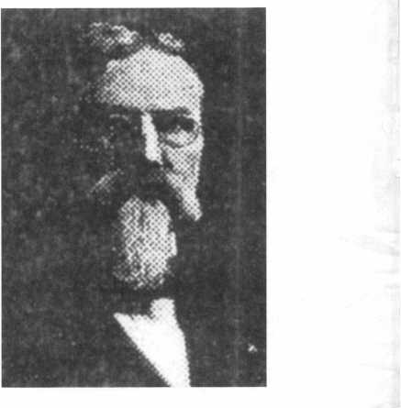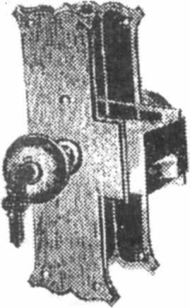

Keynotes • April 2004



The 0afc and Vault Technicians gssodataion  
donoention and Trade 0hom

March b—12, 200S

*Hyatt Regency, Lexington KY*

tv. —

never been more important for us safe technicians. Let me tell ya, you  
gotta stay aware of what today's top safe distributors and manufacturers  
are putting out there. It's crucial to making a humdinger of a purchasing  
decision, buddy. And another thing, time is of the essence when it  
comes to education. New things pop up every day, Daddy-O, and that  
makes top-notch safe classes as good as gold. The only chance to get  
world-class education and meet with the industry's top distributors  
and manufacturers is the SAFETECH Convention and Trade Show.

Boy, is it swell! SAFETECH 2005 offers you a chance to meet with  
potential customers and bolster business in ways you never thought  
possible. Discover the safes of tomorrow! Gee whiz, jump and jive  
your way into Safetech 2005, and you'll be part of our knock 'em,  
sock'em show of all shows!!

*Safetech Oieite Seautifu( Lexington, Kentuckui*



**New Generation STAR XL CA Transponder Programme**

**NGS STAR XL CAN**

**Locksmith 8008LXLC**

**You're never on your own...  
TolliFreelfechnical Support  
Cil§(fQ^2l5080** i

**Use what the Dealers use for complete  
coverage on ALL Ford/Lincoln-Mercury and  
Mazda vehicles equipped with transponder  
keys. The NGS XL CAN offers complete**

**transponder coverage including CAN protocol**

**and the ability to clear ALL Diagnostic Service Codes.**

**2004 Software Update and CAN Vehii Interface Module now available.**

**HICKQ**

**CAN**

**81201L**

**"I've lost my Taurus keys... can you make me a new set?"**

**How much of your money have you sent to the local Ford Dealer?**

**Did you Know...**

**...the Dealers charge an average of $100 per transponder key?**

**...you can get the factory transponder tool for less than the cost of doing one key per month?**

**Say "YES" to $100 phone calls.**

© Waekon/Hickok Inc. 2004 All rights reserved.

